UNITED STATES
SECURITIES AND EXCHANGE COMMISSION
Washington, D.C. 20549
FORM 8-K
CURRENT REPORT
Pursuant to Section 13 OR 15(d) of the Securities Exchange Act of 1934
Date of Report (Date of earliest event reported): September 11, 2026
Starz Entertainment Corp.
(Exact name of registrant as specified in its charter)
British Columbia, Canada |  |  |  |  |  | 1-14880 |  |  |  |  |  | N/A
(State or other jurisdiction  of incorporation) |  |  |  |  |  | (Commission File  Number) |  |  |  |  |  | (I.R.S. Employer  Identification No.)
250 Howe Street, 20th Floor
Vancouver, British Columbia V6C 3R8
1647 Stewart Street
Santa Monica, California 90404
(Address of principal executive offices) (Zip Code)
(604) 648-6559
(Registrant’s telephone number, including area code)
N/A
(Former name or former address, if changed since last report)
Check the appropriate box below if the Form 8-K filing is intended to simultaneously satisfy the filing obligation of the registrant under any of the following provisions:
☐ |  |  |  |  |  | Written communications pursuant to Rule 425 under the Securities Act (17 CFR 230.425)
☐ |  |  |  |  |  | Soliciting material pursuant to Rule 14a-12 under the Exchange Act (17 CFR 240.14a-12)
☐ |  |  |  |  |  | Pre-commencement communications pursuant to Rule 14d-2(b) under the Exchange (17 CFR 240.14d-2(b))
☐ |  |  |  |  |  | Pre-commencement communications pursuant to Rule 13e-4(c) under the Exchange Act (17 CFR 240.13e-4(c))
Securities registered pursuant to Section 12(b) of the Act:
Title of each class |  |  |  |  |  | Trading Symbol(s) |  |  |  |  |  | Name of each exchange on which registered
Common Shares, no par value per share |  |  |  |  |  | STRZ |  |  |  |  |  | The Nasdaq Stock Market LLC
 |  |  |  |  |  |  |  |  |  |  |  | (Nasdaq Global Select Market)
Indicate by check mark whether the registrant is an emerging growth company as defined in Rule 405 of the Securities Act of 1933 (§230.405 of this chapter) or Rule 12b-2 of the Securities Exchange Act of 1934 (§240.12b-2 of this chapter).
Emerging growth company ☐
If an emerging growth company, indicate by check mark if the registrant has elected not to use the extended transition period for complying with any new or revised financial accounting standards provided pursuant to Section 13(a) of the Exchange Act.
☐

Item 5.02. Departure of Directors or Certain Officers; Election of Directors; Appointment of Certain Officers; Compensatory Arrangements of Certain Officers.

On September 11, 2026, Starz Entertainment, LLC, a wholly owned subsidiary of Starz Entertainment Corp., a corporation organized under the laws of the province of British Columbia, Canada (the “Company”), entered into a new employment agreement (the “Agreement”) with Alison Hoffman, President, Starz Networks. The Agreement supersedes Ms. Hoffman’s prior employment agreement with Starz Entertainment, LLC, dated as of February 27, 2023, as previously amended.

The term of the Agreement commenced on August 6, 2026 (the “Effective Date”) and continues through December 31, 2029, unless earlier terminated in accordance with its terms. Pursuant to the Agreement, Ms. Hoffman will continue to serve as President, Starz Networks and report to the Company’s Chief Executive Officer.

Pursuant to the Agreement, Ms. Hoffman is entitled to receive an annual base salary of $1,485,000 and remains eligible to receive an annual bonus with a target opportunity equal to 150% of her base salary, subject to achievement of performance criteria and goals as determined by the Compensation & Talent Committee of the Board of Directors of the Company (the “Compensation Committee”). In the event Ms. Hoffman experiences a qualifying termination during the term of the Agreement, or her employment does not continue beyond the term, she will be eligible to receive a prorated annual bonus for the fiscal year in which such termination occurs based on actual performance.

The Agreement also provides that, during the term, the Company will request that the Compensation Committee approve annual equity awards following each of April 1, 2027, April 1, 2028 and April 1, 2029, with a target grant date value equal to 100% of Ms. Hoffman’s base salary then in effect. Such awards may consist of time-based restricted share units, performance-based restricted share units, stock options, or other equity awards as determined by the Compensation Committee, provided that Ms. Hoffman receives a mix of awards that is the same as provided to similarly situated senior executives of the Company. Unless otherwise determined by the Compensation Committee, time-based awards vest ratably over three years and performance-based awards become eligible to vest ratably over three years based on achievement of performance goals established by the Compensation Committee and the Company’s Chief Executive Officer. Each annual equity award remains subject to Compensation Committee approval and funding.

If Ms. Hoffman’s employment is terminated in a qualifying termination during the term of the Agreement, and subject to her execution and non-revocation of a customary release of claims and compliance with certain post-employment obligations, she will be entitled to receive (i) cash severance equal to the greater of (x) her base salary for the remainder of the term of the Agreement or (y) eighteen months of base salary and (ii) payment of COBRA premiums for up to eighteen months. In addition, if Ms. Hoffman experiences a qualifying termination within the period beginning 30 days prior to and ending 12 months following a change in control of the Company, she will be entitled to an additional lump-sum payment equal to 70% of the applicable severance payment. Further, if a change in control occurs during the term of the Agreement and Ms. Hoffman experiences a qualifying termination on or within six months following such change in control, the portions of her annual equity awards that are then outstanding, unvested and scheduled to vest during the twelve months following her termination (and otherwise scheduled to vest prior to expiration of the term of the Agreement) will accelerate and vest, with performance-based awards vesting based on actual performance.

If the term of the Agreement expires and Ms. Hoffman continues employment with the Company without entering into a new employment agreement, her employment will become at-will. If she subsequently experiences a qualifying termination during such at-will period, she will be entitled to cash severance equal to twelve months of base salary, subject to the release requirement described above.

The Agreement also includes restrictive covenants, including confidentiality and a non-solicitation of Company employees for twelve months following termination.

The foregoing description of the Agreement does not purport to be complete and is qualified in its entirety by reference to the full text of the Agreement, which is attached hereto as Exhibit 10.1, and incorporated herein by reference.

Item 9.01. Financial Statements and Exhibits.
(d) Exhibits
Exhibit  Number |  |  | Exhibit Description
10.1 |  |  | Employment Agreement, executed September 11, 2026 between Starz Entertainment, LLC and Alison Hoffman.
104 |  |  | Cover Page Interactive Data File – the cover page from this Current Report on Form 8-K, formatted as Inline XBRL

SIGNATURES
Pursuant to the requirements of the Securities Exchange Act of 1934, the Registrant has duly caused this report to be signed on its behalf by the undersigned hereunto duly authorized.

 |  |  |  |  |  |  |  |  | Starz Entertainment Corp.
Date: |  |  | September 15, 2026 |  |  |  |  |  | By: |  |  | /s/ Scott Macdonald
 |  |  |  |  |  |  |  |  |  |  |  | Scott Macdonald
 |  |  |  |  |  |  |  |  |  |  |  | Chief Financial Officer

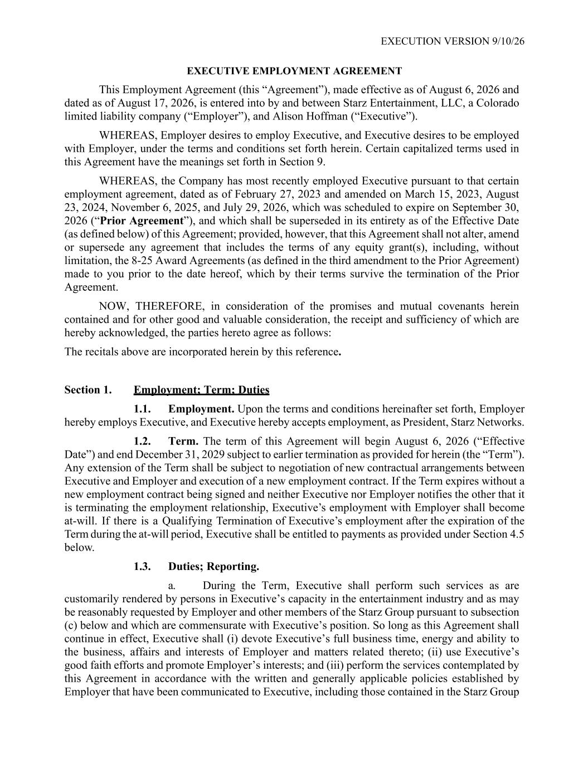

EXECUTION VERSION 9/10/26 EXECUTIVE EMPLOYMENT AGREEMENT This Employment Agreement (this “Agreement”), made effective as of August 6, 2026 and dated as of August 17, 2026, is entered into by and between Starz Entertainment, LLC, a Colorado limited liability company (“Employer”), and Alison Hoffman (“Executive”). WHEREAS, Employer desires to employ Executive, and Executive desires to be employed with Employer, under the terms and conditions set forth herein. Certain capitalized terms used in this Agreement have the meanings set forth in Section 9. WHEREAS, the Company has most recently employed Executive pursuant to that certain employment agreement, dated as of February 27, 2023 and amended on March 15, 2023, August 23, 2024, November 6, 2025, and July 29, 2026, which was scheduled to expire on September 30, 2026 (“Prior Agreement”), and which shall be superseded in its entirety as of the Effective Date (as defined below) of this Agreement; provided, however, that this Agreement shall not alter, amend or supersede any agreement that includes the terms of any equity grant(s), including, without limitation, the 8-25 Award Agreements (as defined in the third amendment to the Prior Agreement) made to you prior to the date hereof, which by their terms survive the termination of the Prior Agreement. NOW, THEREFORE, in consideration of the promises and mutual covenants herein contained and for other good and valuable consideration, the receipt and sufficiency of which are hereby acknowledged, the parties hereto agree as follows: The recitals above are incorporated herein by this reference. Section 1. Employment; Term; Duties 1.1. Employment. Upon the terms and conditions hereinafter set forth, Employer hereby employs Executive, and Executive hereby accepts employment, as President, Starz Networks. 1.2. Term. The term of this Agreement will begin August 6, 2026 (“Effective Date”) and end December 31, 2029 subject to earlier termination as provided for herein (the “Term”). Any extension of the Term shall be subject to negotiation of new contractual arrangements between Executive and Employer and execution of a new employment contract. If the Term expires without a new employment contract being signed and neither Executive nor Employer notifies the other that it is terminating the employment relationship, Executive’s employment with Employer shall become at-will. If there is a Qualifying Termination of Executive’s employment after the expiration of the Term during the at-will period, Executive shall be entitled to payments as provided under Section 4.5 below. 1.3. Duties; Reporting. a. During the Term, Executive shall perform such services as are customarily rendered by persons in Executive’s capacity in the entertainment industry and as may be reasonably requested by Employer and other members of the Starz Group pursuant to subsection (c) below and which are commensurate with Executive’s position. So long as this Agreement shall continue in effect, Executive shall (i) devote Executive’s full business time, energy and ability to the business, affairs and interests of Employer and matters related thereto; (ii) use Executive’s good faith efforts and promote Employer’s interests; and (iii) perform the services contemplated by this Agreement in accordance with the written and generally applicable policies established by Employer that have been communicated to Executive, including those contained in the Starz Group

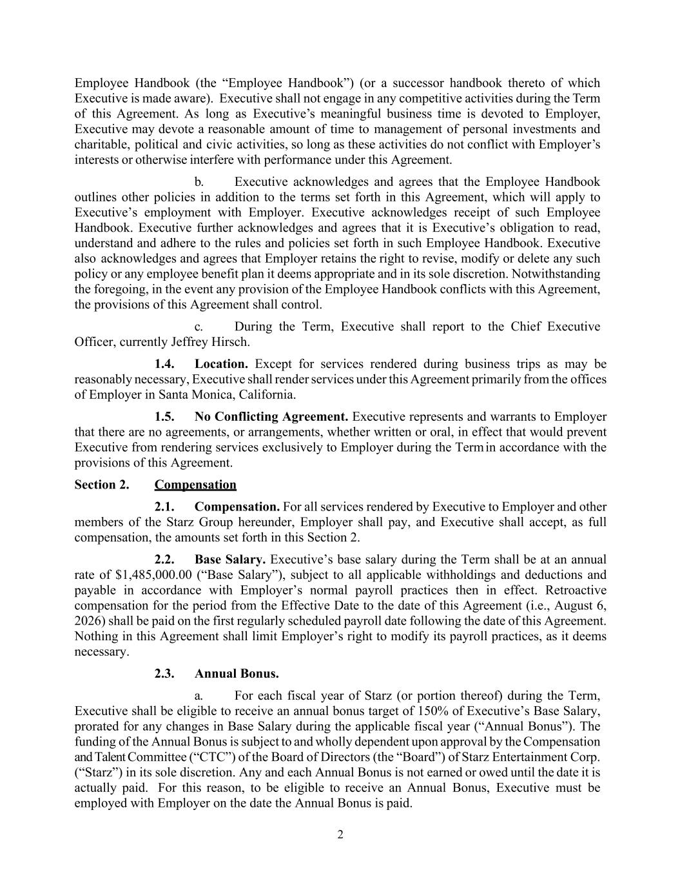
2 Employee Handbook (the “Employee Handbook”) (or a successor handbook thereto of which Executive is made aware). Executive shall not engage in any competitive activities during the Term of this Agreement. As long as Executive’s meaningful business time is devoted to Employer, Executive may devote a reasonable amount of time to management of personal investments and charitable, political and civic activities, so long as these activities do not conflict with Employer’s interests or otherwise interfere with performance under this Agreement. b. Executive acknowledges and agrees that the Employee Handbook outlines other policies in addition to the terms set forth in this Agreement, which will apply to Executive’s employment with Employer. Executive acknowledges receipt of such Employee Handbook. Executive further acknowledges and agrees that it is Executive’s obligation to read, understand and adhere to the rules and policies set forth in such Employee Handbook. Executive also acknowledges and agrees that Employer retains the right to revise, modify or delete any such policy or any employee benefit plan it deems appropriate and in its sole discretion. Notwithstanding the foregoing, in the event any provision of the Employee Handbook conflicts with this Agreement, the provisions of this Agreement shall control. c. During the Term, Executive shall report to the Chief Executive Officer, currently Jeffrey Hirsch. 1.4. Location. Except for services rendered during business trips as may be reasonably necessary, Executive shall render services under this Agreement primarily from the offices of Employer in Santa Monica, California. 1.5. No Conflicting Agreement. Executive represents and warrants to Employer that there are no agreements, or arrangements, whether written or oral, in effect that would prevent Executive from rendering services exclusively to Employer during the Term in accordance with the provisions of this Agreement. Section 2. Compensation 2.1. Compensation. For all services rendered by Executive to Employer and other members of the Starz Group hereunder, Employer shall pay, and Executive shall accept, as full compensation, the amounts set forth in this Section 2. 2.2. Base Salary. Executive’s base salary during the Term shall be at an annual rate of $1,485,000.00 (“Base Salary”), subject to all applicable withholdings and deductions and payable in accordance with Employer’s normal payroll practices then in effect. Retroactive compensation for the period from the Effective Date to the date of this Agreement (i.e., August 6, 2026) shall be paid on the first regularly scheduled payroll date following the date of this Agreement. Nothing in this Agreement shall limit Employer’s right to modify its payroll practices, as it deems necessary. 2.3. Annual Bonus. a. For each fiscal year of Starz (or portion thereof) during the Term, Executive shall be eligible to receive an annual bonus target of 150% of Executive’s Base Salary, prorated for any changes in Base Salary during the applicable fiscal year (“Annual Bonus”). The funding of the Annual Bonus is subject to and wholly dependent upon approval by the Compensation and Talent Committee (“CTC”) of the Board of Directors (the “Board”) of Starz Entertainment Corp. (“Starz”) in its sole discretion. Any and each Annual Bonus is not earned or owed until the date it is actually paid. For this reason, to be eligible to receive an Annual Bonus, Executive must be employed with Employer on the date the Annual Bonus is paid.

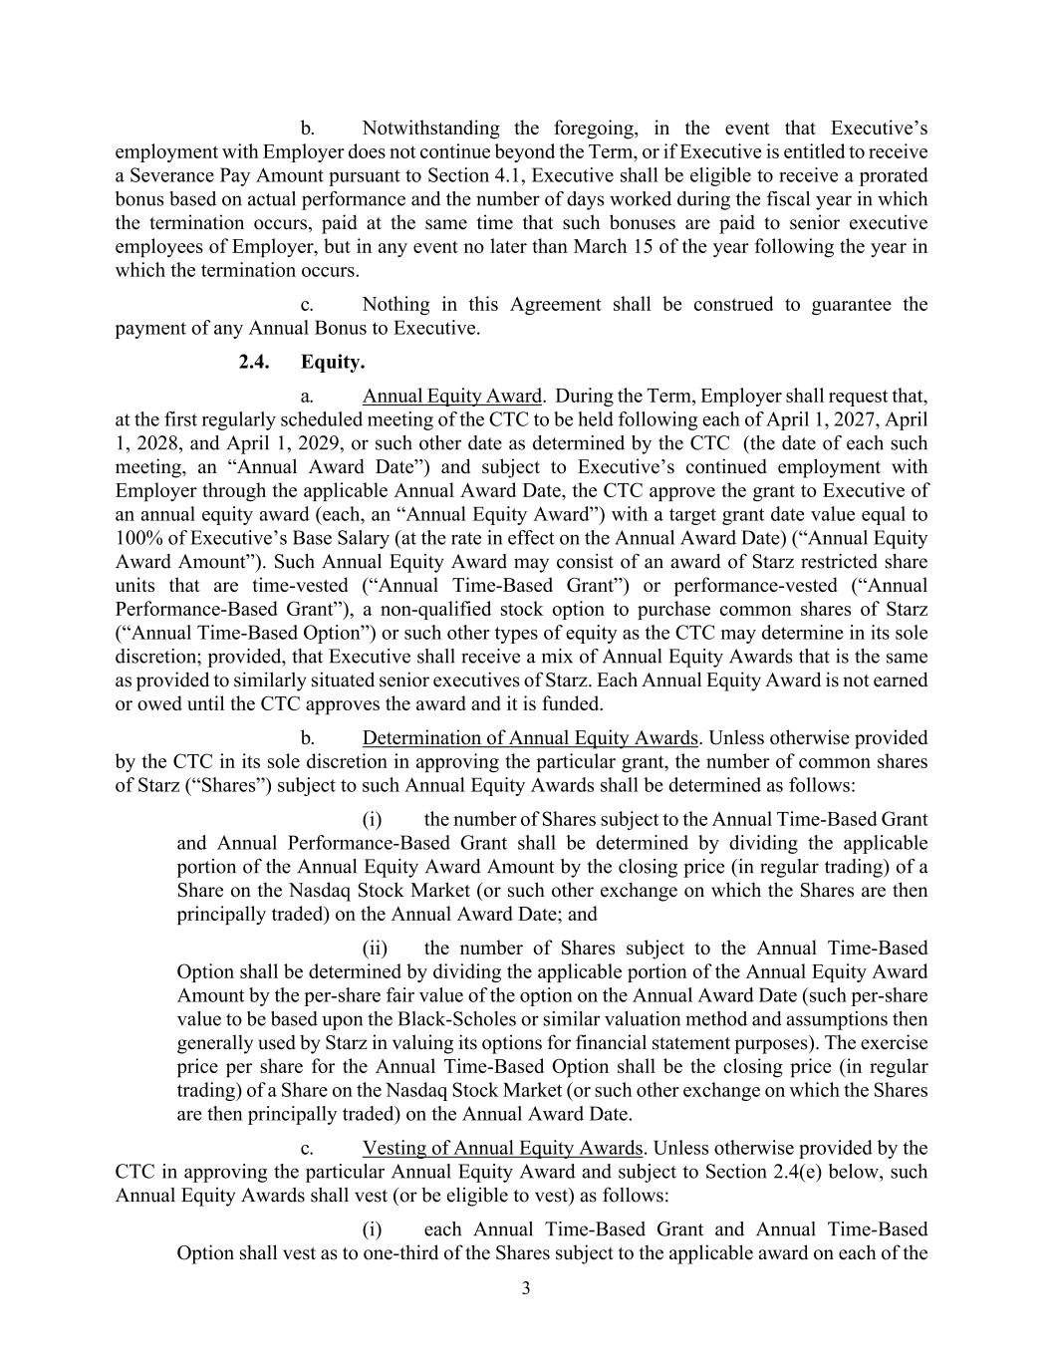
3 b. Notwithstanding the foregoing, in the event that Executive’s employment with Employer does not continue beyond the Term, or if Executive is entitled to receive a Severance Pay Amount pursuant to Section 4.1, Executive shall be eligible to receive a prorated bonus based on actual performance and the number of days worked during the fiscal year in which the termination occurs, paid at the same time that such bonuses are paid to senior executive employees of Employer, but in any event no later than March 15 of the year following the year in which the termination occurs. c. Nothing in this Agreement shall be construed to guarantee the payment of any Annual Bonus to Executive. 2.4. Equity. a. Annual Equity Award. During the Term, Employer shall request that, at the first regularly scheduled meeting of the CTC to be held following each of April 1, 2027, April 1, 2028, and April 1, 2029, or such other date as determined by the CTC (the date of each such meeting, an “Annual Award Date”) and subject to Executive’s continued employment with Employer through the applicable Annual Award Date, the CTC approve the grant to Executive of an annual equity award (each, an “Annual Equity Award”) with a target grant date value equal to 100% of Executive’s Base Salary (at the rate in effect on the Annual Award Date) (“Annual Equity Award Amount”). Such Annual Equity Award may consist of an award of Starz restricted share units that are time-vested (“Annual Time-Based Grant”) or performance-vested (“Annual Performance-Based Grant”), a non-qualified stock option to purchase common shares of Starz (“Annual Time-Based Option”) or such other types of equity as the CTC may determine in its sole discretion; provided, that Executive shall receive a mix of Annual Equity Awards that is the same as provided to similarly situated senior executives of Starz. Each Annual Equity Award is not earned or owed until the CTC approves the award and it is funded. b. Determination of Annual Equity Awards. Unless otherwise provided by the CTC in its sole discretion in approving the particular grant, the number of common shares of Starz (“Shares”) subject to such Annual Equity Awards shall be determined as follows: (i) the number of Shares subject to the Annual Time-Based Grant and Annual Performance-Based Grant shall be determined by dividing the applicable portion of the Annual Equity Award Amount by the closing price (in regular trading) of a Share on the Nasdaq Stock Market (or such other exchange on which the Shares are then principally traded) on the Annual Award Date; and (ii) the number of Shares subject to the Annual Time-Based Option shall be determined by dividing the applicable portion of the Annual Equity Award Amount by the per-share fair value of the option on the Annual Award Date (such per-share value to be based upon the Black-Scholes or similar valuation method and assumptions then generally used by Starz in valuing its options for financial statement purposes). The exercise price per share for the Annual Time-Based Option shall be the closing price (in regular trading) of a Share on the Nasdaq Stock Market (or such other exchange on which the Shares are then principally traded) on the Annual Award Date. c. Vesting of Annual Equity Awards. Unless otherwise provided by the CTC in approving the particular Annual Equity Award and subject to Section 2.4(e) below, such Annual Equity Awards shall vest (or be eligible to vest) as follows: (i) each Annual Time-Based Grant and Annual Time-Based Option shall vest as to one-third of the Shares subject to the applicable award on each of the

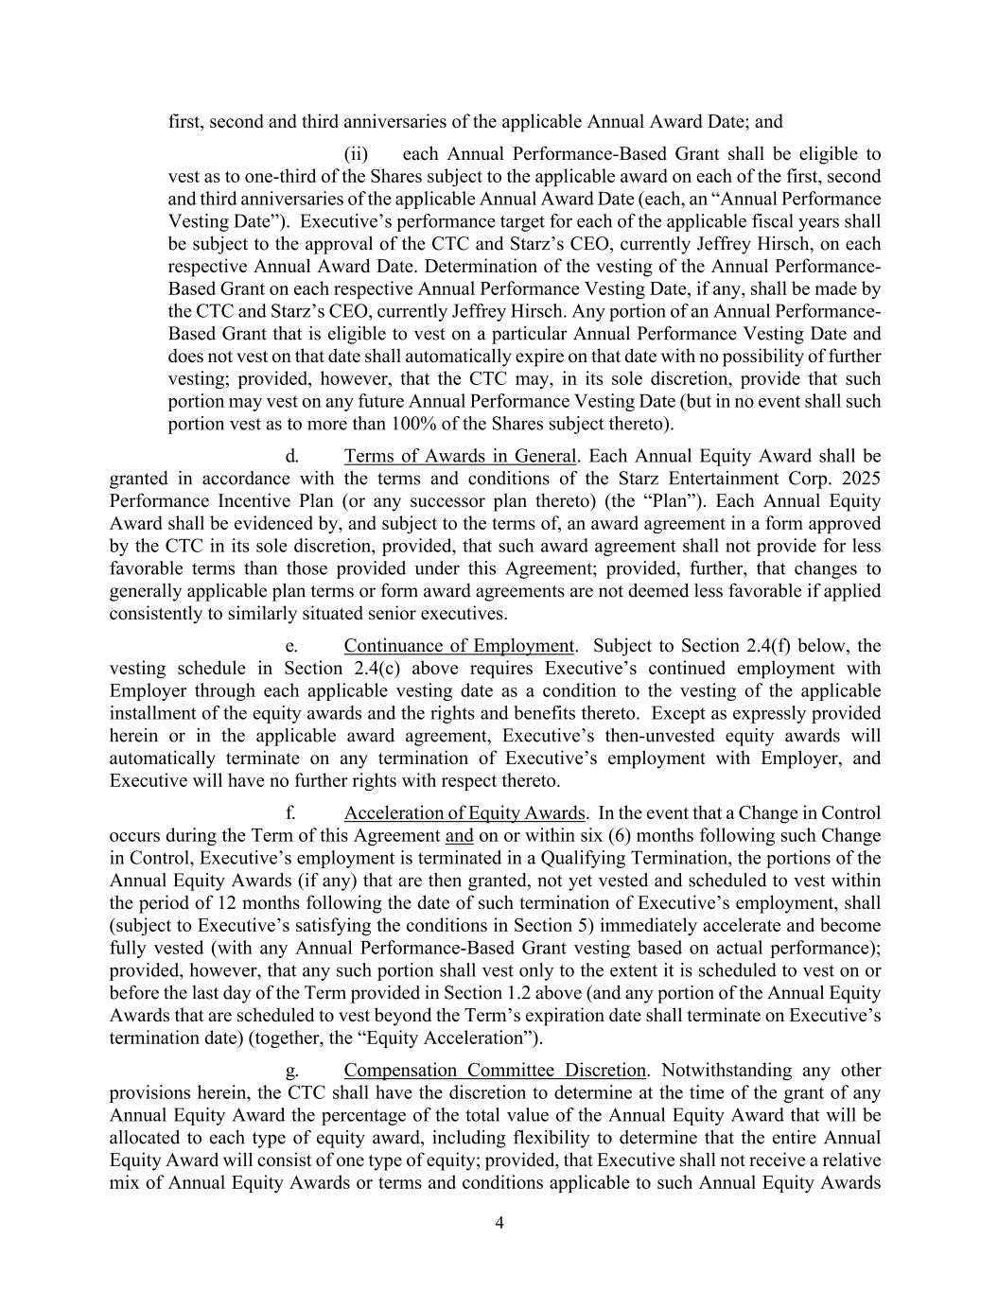
4 first, second and third anniversaries of the applicable Annual Award Date; and (ii) each Annual Performance-Based Grant shall be eligible to vest as to one-third of the Shares subject to the applicable award on each of the first, second and third anniversaries of the applicable Annual Award Date (each, an “Annual Performance Vesting Date”). Executive’s performance target for each of the applicable fiscal years shall be subject to the approval of the CTC and Starz’s CEO, currently Jeffrey Hirsch, on each respective Annual Award Date. Determination of the vesting of the Annual Performance- Based Grant on each respective Annual Performance Vesting Date, if any, shall be made by the CTC and Starz’s CEO, currently Jeffrey Hirsch. Any portion of an Annual Performance- Based Grant that is eligible to vest on a particular Annual Performance Vesting Date and does not vest on that date shall automatically expire on that date with no possibility of further vesting; provided, however, that the CTC may, in its sole discretion, provide that such portion may vest on any future Annual Performance Vesting Date (but in no event shall such portion vest as to more than 100% of the Shares subject thereto). d. Terms of Awards in General. Each Annual Equity Award shall be granted in accordance with the terms and conditions of the Starz Entertainment Corp. 2025 Performance Incentive Plan (or any successor plan thereto) (the “Plan”). Each Annual Equity Award shall be evidenced by, and subject to the terms of, an award agreement in a form approved by the CTC in its sole discretion, provided, that such award agreement shall not provide for less favorable terms than those provided under this Agreement; provided, further, that changes to generally applicable plan terms or form award agreements are not deemed less favorable if applied consistently to similarly situated senior executives. e. Continuance of Employment. Subject to Section 2.4(f) below, the vesting schedule in Section 2.4(c) above requires Executive’s continued employment with Employer through each applicable vesting date as a condition to the vesting of the applicable installment of the equity awards and the rights and benefits thereto. Except as expressly provided herein or in the applicable award agreement, Executive’s then-unvested equity awards will automatically terminate on any termination of Executive’s employment with Employer, and Executive will have no further rights with respect thereto. f. Acceleration of Equity Awards. In the event that a Change in Control occurs during the Term of this Agreement and on or within six (6) months following such Change in Control, Executive’s employment is terminated in a Qualifying Termination, the portions of the Annual Equity Awards (if any) that are then granted, not yet vested and scheduled to vest within the period of 12 months following the date of such termination of Executive’s employment, shall (subject to Executive’s satisfying the conditions in Section 5) immediately accelerate and become fully vested (with any Annual Performance-Based Grant vesting based on actual performance); provided, however, that any such portion shall vest only to the extent it is scheduled to vest on or before the last day of the Term provided in Section 1.2 above (and any portion of the Annual Equity Awards that are scheduled to vest beyond the Term’s expiration date shall terminate on Executive’s termination date) (together, the “Equity Acceleration”). g. Compensation Committee Discretion. Notwithstanding any other provisions herein, the CTC shall have the discretion to determine at the time of the grant of any Annual Equity Award the percentage of the total value of the Annual Equity Award that will be allocated to each type of equity award, including flexibility to determine that the entire Annual Equity Award will consist of one type of equity; provided, that Executive shall not receive a relative mix of Annual Equity Awards or terms and conditions applicable to such Annual Equity Awards

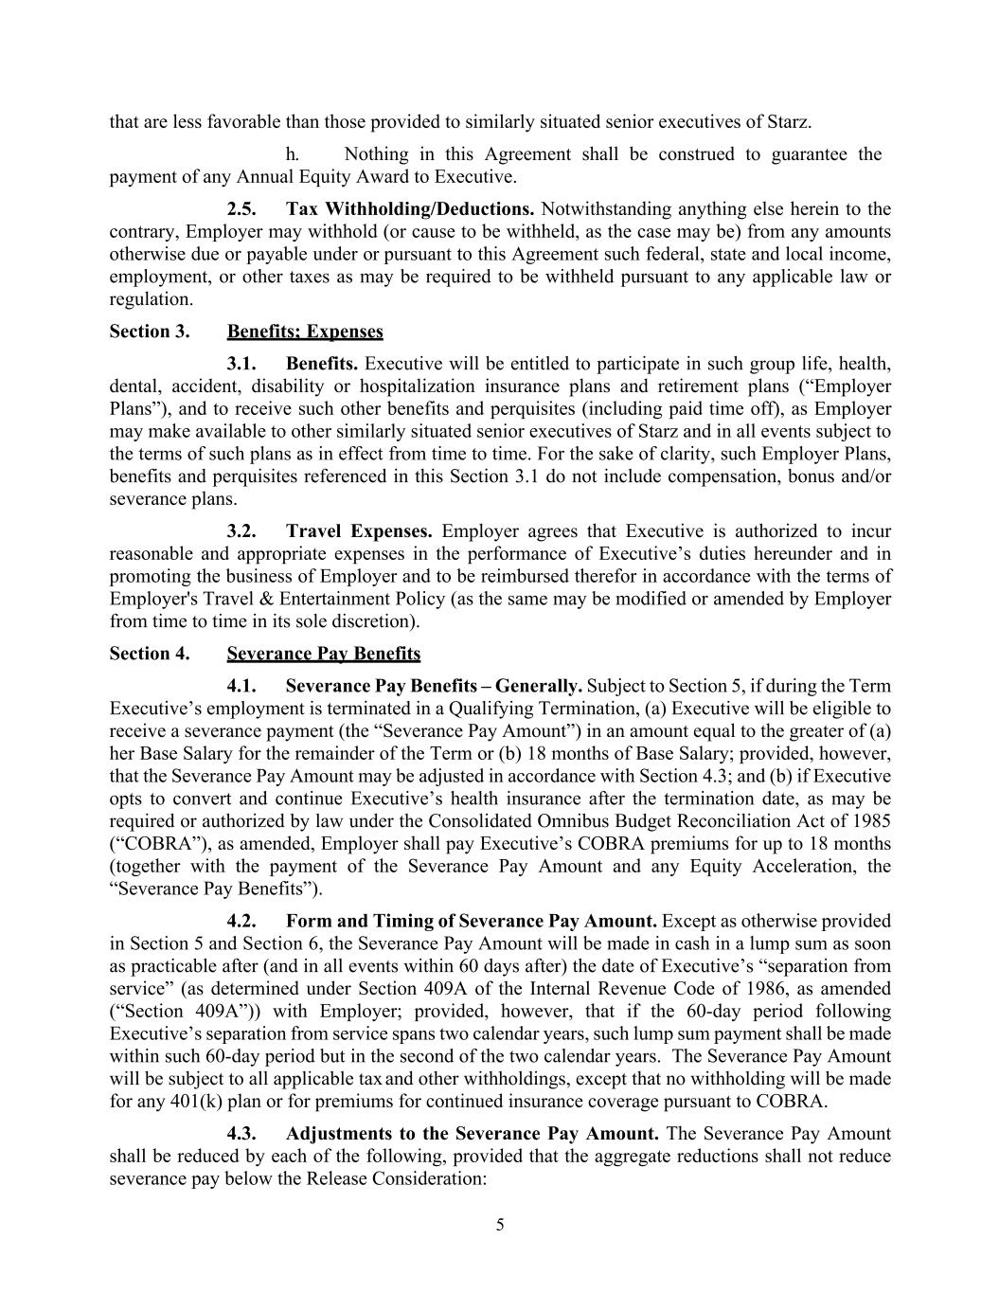
5 that are less favorable than those provided to similarly situated senior executives of Starz. h. Nothing in this Agreement shall be construed to guarantee the payment of any Annual Equity Award to Executive. 2.5. Tax Withholding/Deductions. Notwithstanding anything else herein to the contrary, Employer may withhold (or cause to be withheld, as the case may be) from any amounts otherwise due or payable under or pursuant to this Agreement such federal, state and local income, employment, or other taxes as may be required to be withheld pursuant to any applicable law or regulation. Section 3. Benefits; Expenses 3.1. Benefits. Executive will be entitled to participate in such group life, health, dental, accident, disability or hospitalization insurance plans and retirement plans (“Employer Plans”), and to receive such other benefits and perquisites (including paid time off), as Employer may make available to other similarly situated senior executives of Starz and in all events subject to the terms of such plans as in effect from time to time. For the sake of clarity, such Employer Plans, benefits and perquisites referenced in this Section 3.1 do not include compensation, bonus and/or severance plans. 3.2. Travel Expenses. Employer agrees that Executive is authorized to incur reasonable and appropriate expenses in the performance of Executive’s duties hereunder and in promoting the business of Employer and to be reimbursed therefor in accordance with the terms of Employer's Travel & Entertainment Policy (as the same may be modified or amended by Employer from time to time in its sole discretion). Section 4. Severance Pay Benefits 4.1. Severance Pay Benefits – Generally. Subject to Section 5, if during the Term Executive’s employment is terminated in a Qualifying Termination, (a) Executive will be eligible to receive a severance payment (the “Severance Pay Amount”) in an amount equal to the greater of (a) her Base Salary for the remainder of the Term or (b) 18 months of Base Salary; provided, however, that the Severance Pay Amount may be adjusted in accordance with Section 4.3; and (b) if Executive opts to convert and continue Executive’s health insurance after the termination date, as may be required or authorized by law under the Consolidated Omnibus Budget Reconciliation Act of 1985 (“COBRA”), as amended, Employer shall pay Executive’s COBRA premiums for up to 18 months (together with the payment of the Severance Pay Amount and any Equity Acceleration, the “Severance Pay Benefits”). 4.2. Form and Timing of Severance Pay Amount. Except as otherwise provided in Section 5 and Section 6, the Severance Pay Amount will be made in cash in a lump sum as soon as practicable after (and in all events within 60 days after) the date of Executive’s “separation from service” (as determined under Section 409A of the Internal Revenue Code of 1986, as amended (“Section 409A”)) with Employer; provided, however, that if the 60-day period following Executive’s separation from service spans two calendar years, such lump sum payment shall be made within such 60-day period but in the second of the two calendar years. The Severance Pay Amount will be subject to all applicable tax and other withholdings, except that no withholding will be made for any 401(k) plan or for premiums for continued insurance coverage pursuant to COBRA. 4.3. Adjustments to the Severance Pay Amount. The Severance Pay Amount shall be reduced by each of the following, provided that the aggregate reductions shall not reduce severance pay below the Release Consideration:

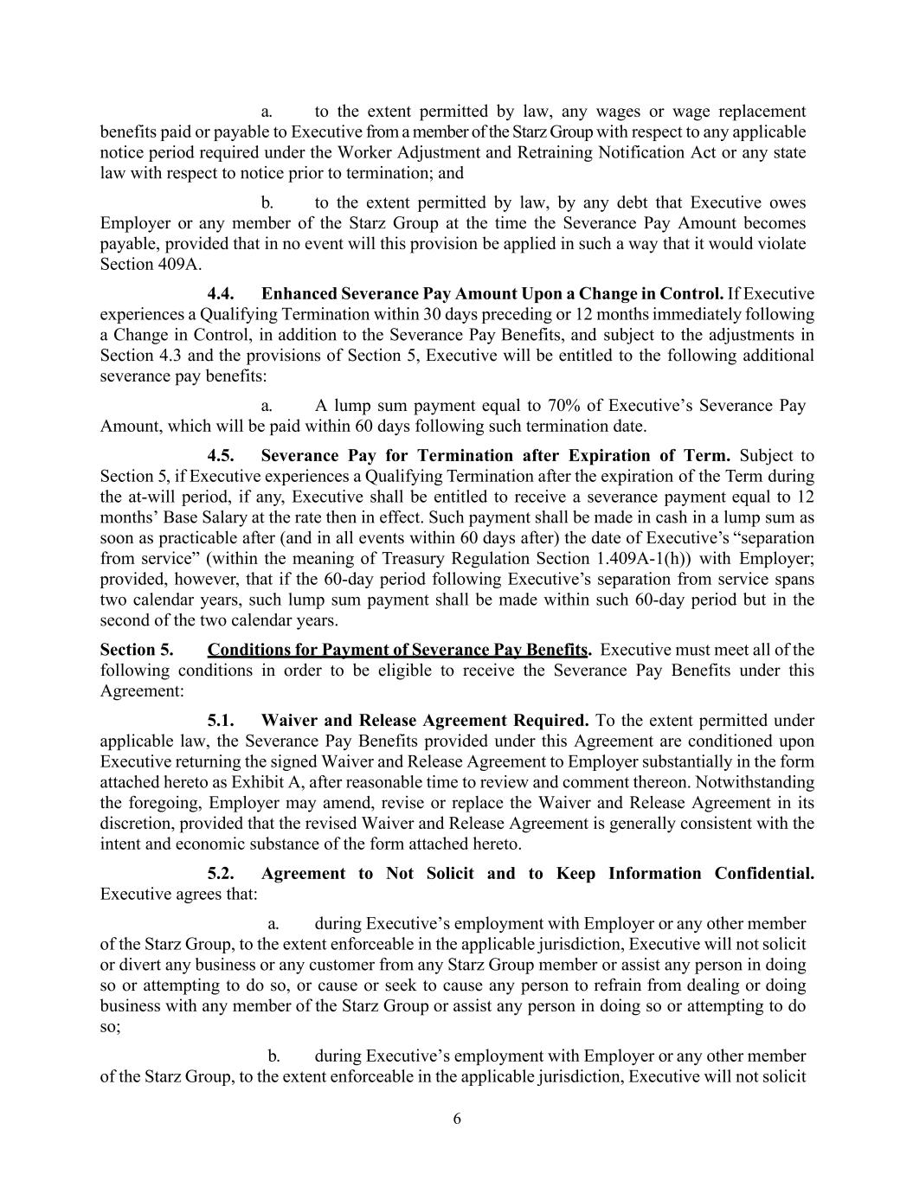
6 a. to the extent permitted by law, any wages or wage replacement benefits paid or payable to Executive from a member of the Starz Group with respect to any applicable notice period required under the Worker Adjustment and Retraining Notification Act or any state law with respect to notice prior to termination; and b. to the extent permitted by law, by any debt that Executive owes Employer or any member of the Starz Group at the time the Severance Pay Amount becomes payable, provided that in no event will this provision be applied in such a way that it would violate Section 409A. 4.4. Enhanced Severance Pay Amount Upon a Change in Control. If Executive experiences a Qualifying Termination within 30 days preceding or 12 months immediately following a Change in Control, in addition to the Severance Pay Benefits, and subject to the adjustments in Section 4.3 and the provisions of Section 5, Executive will be entitled to the following additional severance pay benefits: a. A lump sum payment equal to 70% of Executive’s Severance Pay Amount, which will be paid within 60 days following such termination date. 4.5. Severance Pay for Termination after Expiration of Term. Subject to Section 5, if Executive experiences a Qualifying Termination after the expiration of the Term during the at-will period, if any, Executive shall be entitled to receive a severance payment equal to 12 months’ Base Salary at the rate then in effect. Such payment shall be made in cash in a lump sum as soon as practicable after (and in all events within 60 days after) the date of Executive’s “separation from service” (within the meaning of Treasury Regulation Section 1.409A-1(h)) with Employer; provided, however, that if the 60-day period following Executive’s separation from service spans two calendar years, such lump sum payment shall be made within such 60-day period but in the second of the two calendar years. Section 5. Conditions for Payment of Severance Pay Benefits. Executive must meet all of the following conditions in order to be eligible to receive the Severance Pay Benefits under this Agreement: 5.1. Waiver and Release Agreement Required. To the extent permitted under applicable law, the Severance Pay Benefits provided under this Agreement are conditioned upon Executive returning the signed Waiver and Release Agreement to Employer substantially in the form attached hereto as Exhibit A, after reasonable time to review and comment thereon. Notwithstanding the foregoing, Employer may amend, revise or replace the Waiver and Release Agreement in its discretion, provided that the revised Waiver and Release Agreement is generally consistent with the intent and economic substance of the form attached hereto. 5.2. Agreement to Not Solicit and to Keep Information Confidential. Executive agrees that: a. during Executive’s employment with Employer or any other member of the Starz Group, to the extent enforceable in the applicable jurisdiction, Executive will not solicit or divert any business or any customer from any Starz Group member or assist any person in doing so or attempting to do so, or cause or seek to cause any person to refrain from dealing or doing business with any member of the Starz Group or assist any person in doing so or attempting to do so; b. during Executive’s employment with Employer or any other member of the Starz Group, to the extent enforceable in the applicable jurisdiction, Executive will not solicit

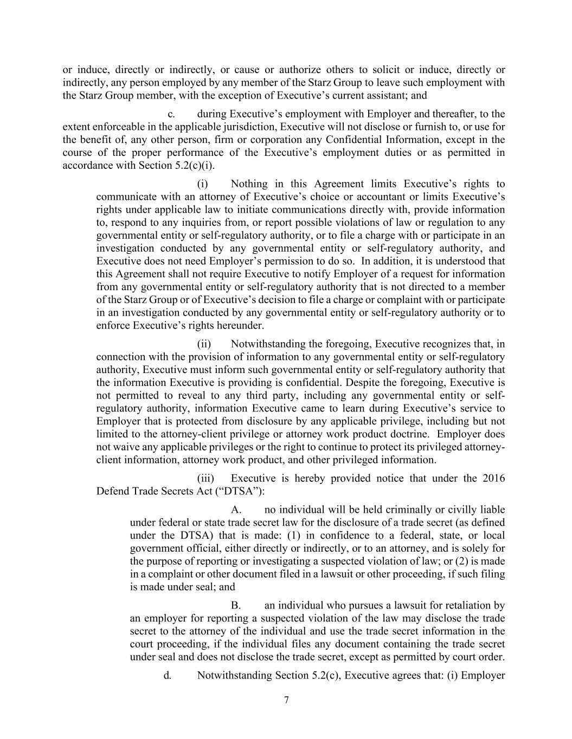
7 or induce, directly or indirectly, or cause or authorize others to solicit or induce, directly or indirectly, any person employed by any member of the Starz Group to leave such employment with the Starz Group member, with the exception of Executive’s current assistant; and c. during Executive’s employment with Employer and thereafter, to the extent enforceable in the applicable jurisdiction, Executive will not disclose or furnish to, or use for the benefit of, any other person, firm or corporation any Confidential Information, except in the course of the proper performance of the Executive’s employment duties or as permitted in accordance with Section 5.2(c)(i). (i) Nothing in this Agreement limits Executive’s rights to communicate with an attorney of Executive’s choice or accountant or limits Executive’s rights under applicable law to initiate communications directly with, provide information to, respond to any inquiries from, or report possible violations of law or regulation to any governmental entity or self-regulatory authority, or to file a charge with or participate in an investigation conducted by any governmental entity or self-regulatory authority, and Executive does not need Employer’s permission to do so. In addition, it is understood that this Agreement shall not require Executive to notify Employer of a request for information from any governmental entity or self-regulatory authority that is not directed to a member of the Starz Group or of Executive’s decision to file a charge or complaint with or participate in an investigation conducted by any governmental entity or self-regulatory authority or to enforce Executive’s rights hereunder. (ii) Notwithstanding the foregoing, Executive recognizes that, in connection with the provision of information to any governmental entity or self-regulatory authority, Executive must inform such governmental entity or self-regulatory authority that the information Executive is providing is confidential. Despite the foregoing, Executive is not permitted to reveal to any third party, including any governmental entity or self- regulatory authority, information Executive came to learn during Executive’s service to Employer that is protected from disclosure by any applicable privilege, including but not limited to the attorney-client privilege or attorney work product doctrine. Employer does not waive any applicable privileges or the right to continue to protect its privileged attorney- client information, attorney work product, and other privileged information. (iii) Executive is hereby provided notice that under the 2016 Defend Trade Secrets Act (“DTSA”): A. no individual will be held criminally or civilly liable under federal or state trade secret law for the disclosure of a trade secret (as defined under the DTSA) that is made: (1) in confidence to a federal, state, or local government official, either directly or indirectly, or to an attorney, and is solely for the purpose of reporting or investigating a suspected violation of law; or (2) is made in a complaint or other document filed in a lawsuit or other proceeding, if such filing is made under seal; and B. an individual who pursues a lawsuit for retaliation by an employer for reporting a suspected violation of the law may disclose the trade secret to the attorney of the individual and use the trade secret information in the court proceeding, if the individual files any document containing the trade secret under seal and does not disclose the trade secret, except as permitted by court order. d. Notwithstanding Section 5.2(c), Executive agrees that: (i) Employer

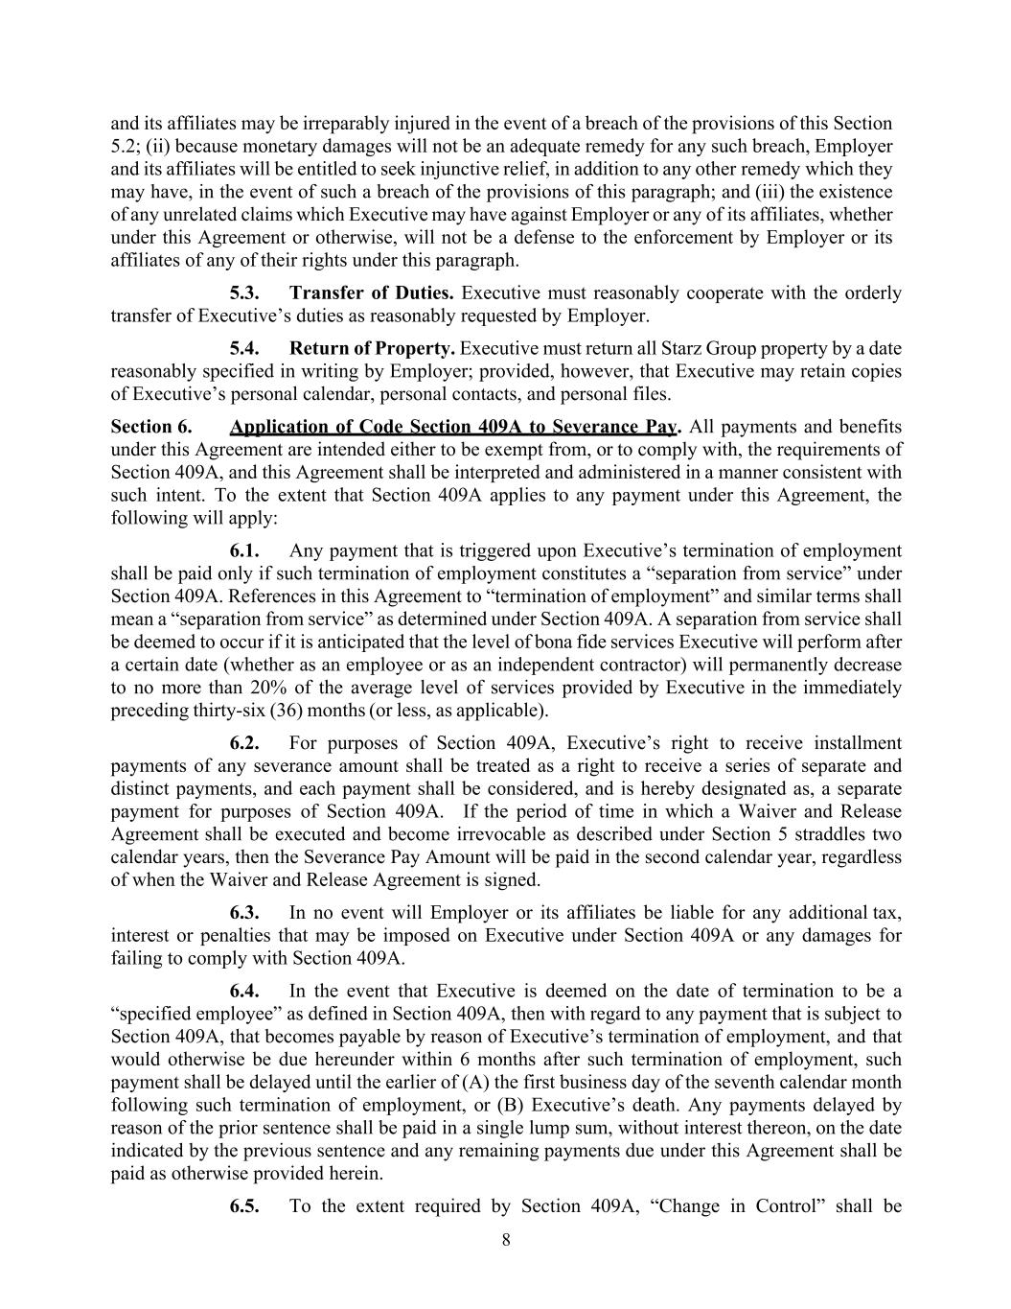
8 and its affiliates may be irreparably injured in the event of a breach of the provisions of this Section 5.2; (ii) because monetary damages will not be an adequate remedy for any such breach, Employer and its affiliates will be entitled to seek injunctive relief, in addition to any other remedy which they may have, in the event of such a breach of the provisions of this paragraph; and (iii) the existence of any unrelated claims which Executive may have against Employer or any of its affiliates, whether under this Agreement or otherwise, will not be a defense to the enforcement by Employer or its affiliates of any of their rights under this paragraph. 5.3. Transfer of Duties. Executive must reasonably cooperate with the orderly transfer of Executive’s duties as reasonably requested by Employer. 5.4. Return of Property. Executive must return all Starz Group property by a date reasonably specified in writing by Employer; provided, however, that Executive may retain copies of Executive’s personal calendar, personal contacts, and personal files. Section 6. Application of Code Section 409A to Severance Pay. All payments and benefits under this Agreement are intended either to be exempt from, or to comply with, the requirements of Section 409A, and this Agreement shall be interpreted and administered in a manner consistent with such intent. To the extent that Section 409A applies to any payment under this Agreement, the following will apply: 6.1. Any payment that is triggered upon Executive’s termination of employment shall be paid only if such termination of employment constitutes a “separation from service” under Section 409A. References in this Agreement to “termination of employment” and similar terms shall mean a “separation from service” as determined under Section 409A. A separation from service shall be deemed to occur if it is anticipated that the level of bona fide services Executive will perform after a certain date (whether as an employee or as an independent contractor) will permanently decrease to no more than 20% of the average level of services provided by Executive in the immediately preceding thirty-six (36) months (or less, as applicable). 6.2. For purposes of Section 409A, Executive’s right to receive installment payments of any severance amount shall be treated as a right to receive a series of separate and distinct payments, and each payment shall be considered, and is hereby designated as, a separate payment for purposes of Section 409A. If the period of time in which a Waiver and Release Agreement shall be executed and become irrevocable as described under Section 5 straddles two calendar years, then the Severance Pay Amount will be paid in the second calendar year, regardless of when the Waiver and Release Agreement is signed. 6.3. In no event will Employer or its affiliates be liable for any additional tax, interest or penalties that may be imposed on Executive under Section 409A or any damages for failing to comply with Section 409A. 6.4. In the event that Executive is deemed on the date of termination to be a “specified employee” as defined in Section 409A, then with regard to any payment that is subject to Section 409A, that becomes payable by reason of Executive’s termination of employment, and that would otherwise be due hereunder within 6 months after such termination of employment, such payment shall be delayed until the earlier of (A) the first business day of the seventh calendar month following such termination of employment, or (B) Executive’s death. Any payments delayed by reason of the prior sentence shall be paid in a single lump sum, without interest thereon, on the date indicated by the previous sentence and any remaining payments due under this Agreement shall be paid as otherwise provided herein. 6.5. To the extent required by Section 409A, “Change in Control” shall be

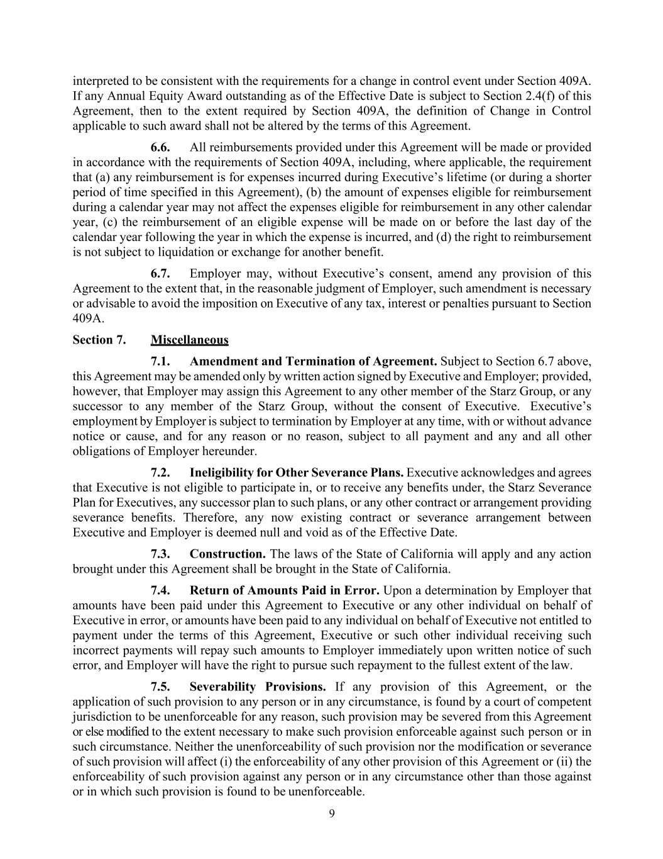
9 interpreted to be consistent with the requirements for a change in control event under Section 409A. If any Annual Equity Award outstanding as of the Effective Date is subject to Section 2.4(f) of this Agreement, then to the extent required by Section 409A, the definition of Change in Control applicable to such award shall not be altered by the terms of this Agreement. 6.6. All reimbursements provided under this Agreement will be made or provided in accordance with the requirements of Section 409A, including, where applicable, the requirement that (a) any reimbursement is for expenses incurred during Executive’s lifetime (or during a shorter period of time specified in this Agreement), (b) the amount of expenses eligible for reimbursement during a calendar year may not affect the expenses eligible for reimbursement in any other calendar year, (c) the reimbursement of an eligible expense will be made on or before the last day of the calendar year following the year in which the expense is incurred, and (d) the right to reimbursement is not subject to liquidation or exchange for another benefit. 6.7. Employer may, without Executive’s consent, amend any provision of this Agreement to the extent that, in the reasonable judgment of Employer, such amendment is necessary or advisable to avoid the imposition on Executive of any tax, interest or penalties pursuant to Section 409A. Section 7. Miscellaneous 7.1. Amendment and Termination of Agreement. Subject to Section 6.7 above, this Agreement may be amended only by written action signed by Executive and Employer; provided, however, that Employer may assign this Agreement to any other member of the Starz Group, or any successor to any member of the Starz Group, without the consent of Executive. Executive’s employment by Employer is subject to termination by Employer at any time, with or without advance notice or cause, and for any reason or no reason, subject to all payment and any and all other obligations of Employer hereunder. 7.2. Ineligibility for Other Severance Plans. Executive acknowledges and agrees that Executive is not eligible to participate in, or to receive any benefits under, the Starz Severance Plan for Executives, any successor plan to such plans, or any other contract or arrangement providing severance benefits. Therefore, any now existing contract or severance arrangement between Executive and Employer is deemed null and void as of the Effective Date. 7.3. Construction. The laws of the State of California will apply and any action brought under this Agreement shall be brought in the State of California. 7.4. Return of Amounts Paid in Error. Upon a determination by Employer that amounts have been paid under this Agreement to Executive or any other individual on behalf of Executive in error, or amounts have been paid to any individual on behalf of Executive not entitled to payment under the terms of this Agreement, Executive or such other individual receiving such incorrect payments will repay such amounts to Employer immediately upon written notice of such error, and Employer will have the right to pursue such repayment to the fullest extent of the law. 7.5. Severability Provisions. If any provision of this Agreement, or the application of such provision to any person or in any circumstance, is found by a court of competent jurisdiction to be unenforceable for any reason, such provision may be severed from this Agreement or else modified to the extent necessary to make such provision enforceable against such person or in such circumstance. Neither the unenforceability of such provision nor the modification or severance of such provision will affect (i) the enforceability of any other provision of this Agreement or (ii) the enforceability of such provision against any person or in any circumstance other than those against or in which such provision is found to be unenforceable.

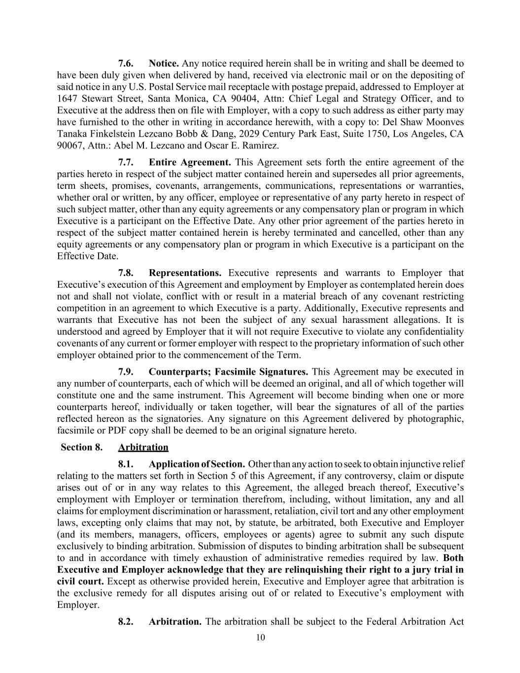
10 7.6. Notice. Any notice required herein shall be in writing and shall be deemed to have been duly given when delivered by hand, received via electronic mail or on the depositing of said notice in any U.S. Postal Service mail receptacle with postage prepaid, addressed to Employer at 1647 Stewart Street, Santa Monica, CA 90404, Attn: Chief Legal and Strategy Officer, and to Executive at the address then on file with Employer, with a copy to such address as either party may have furnished to the other in writing in accordance herewith, with a copy to: Del Shaw Moonves Tanaka Finkelstein Lezcano Bobb & Dang, 2029 Century Park East, Suite 1750, Los Angeles, CA 90067, Attn.: Abel M. Lezcano and Oscar E. Ramirez. 7.7. Entire Agreement. This Agreement sets forth the entire agreement of the parties hereto in respect of the subject matter contained herein and supersedes all prior agreements, term sheets, promises, covenants, arrangements, communications, representations or warranties, whether oral or written, by any officer, employee or representative of any party hereto in respect of such subject matter, other than any equity agreements or any compensatory plan or program in which Executive is a participant on the Effective Date. Any other prior agreement of the parties hereto in respect of the subject matter contained herein is hereby terminated and cancelled, other than any equity agreements or any compensatory plan or program in which Executive is a participant on the Effective Date. 7.8. Representations. Executive represents and warrants to Employer that Executive’s execution of this Agreement and employment by Employer as contemplated herein does not and shall not violate, conflict with or result in a material breach of any covenant restricting competition in an agreement to which Executive is a party. Additionally, Executive represents and warrants that Executive has not been the subject of any sexual harassment allegations. It is understood and agreed by Employer that it will not require Executive to violate any confidentiality covenants of any current or former employer with respect to the proprietary information of such other employer obtained prior to the commencement of the Term. 7.9. Counterparts; Facsimile Signatures. This Agreement may be executed in any number of counterparts, each of which will be deemed an original, and all of which together will constitute one and the same instrument. This Agreement will become binding when one or more counterparts hereof, individually or taken together, will bear the signatures of all of the parties reflected hereon as the signatories. Any signature on this Agreement delivered by photographic, facsimile or PDF copy shall be deemed to be an original signature hereto. Section 8. Arbitration 8.1. Application of Section. Other than any action to seek to obtain injunctive relief relating to the matters set forth in Section 5 of this Agreement, if any controversy, claim or dispute arises out of or in any way relates to this Agreement, the alleged breach thereof, Executive’s employment with Employer or termination therefrom, including, without limitation, any and all claims for employment discrimination or harassment, retaliation, civil tort and any other employment laws, excepting only claims that may not, by statute, be arbitrated, both Executive and Employer (and its members, managers, officers, employees or agents) agree to submit any such dispute exclusively to binding arbitration. Submission of disputes to binding arbitration shall be subsequent to and in accordance with timely exhaustion of administrative remedies required by law. Both Executive and Employer acknowledge that they are relinquishing their right to a jury trial in civil court. Except as otherwise provided herein, Executive and Employer agree that arbitration is the exclusive remedy for all disputes arising out of or related to Executive’s employment with Employer. 8.2. Arbitration. The arbitration shall be subject to the Federal Arbitration Act

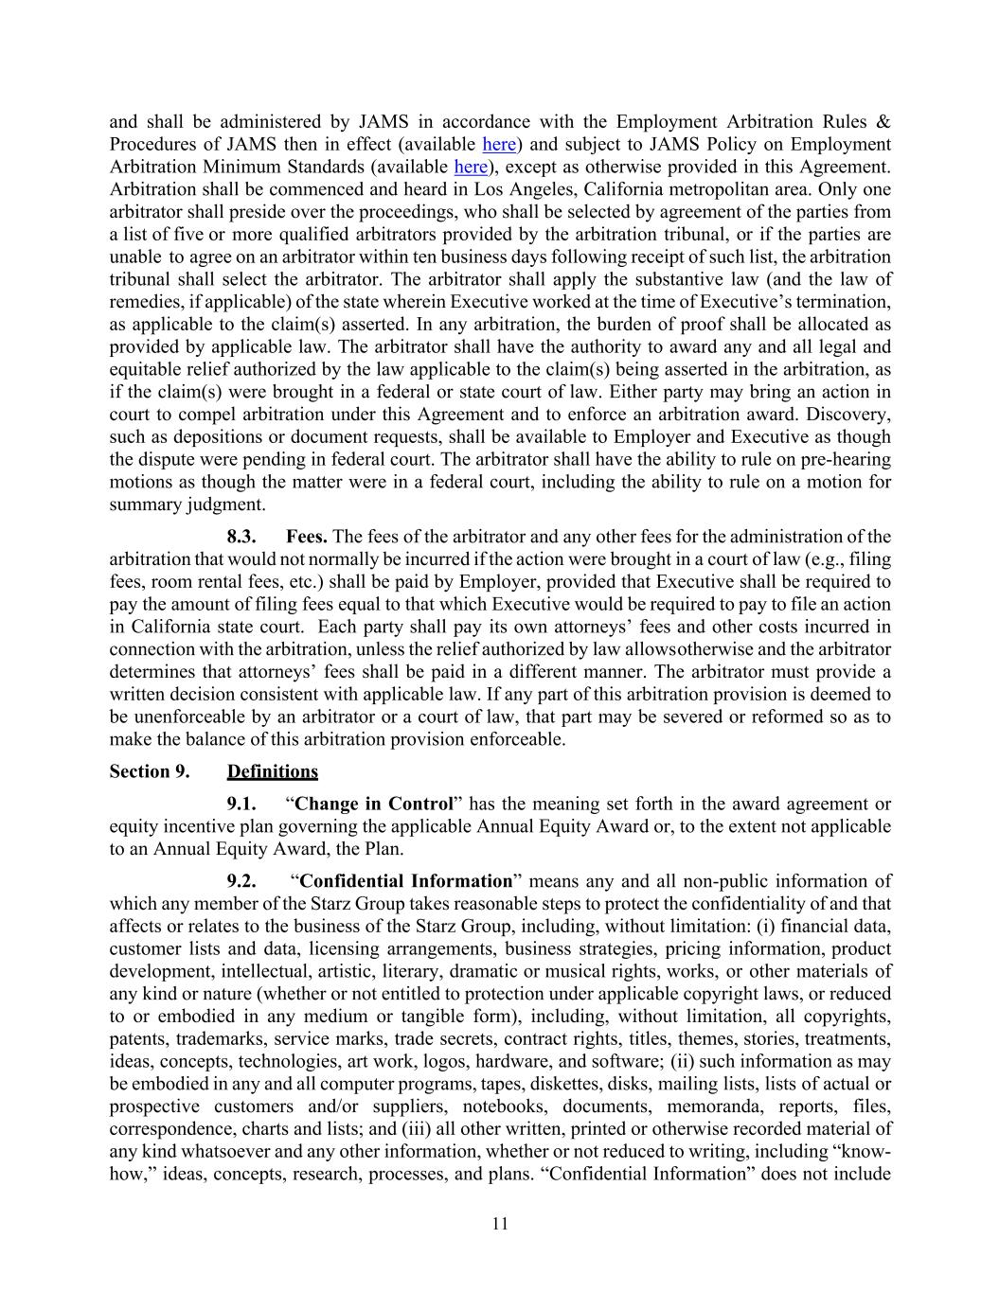
11 and shall be administered by JAMS in accordance with the Employment Arbitration Rules & Procedures of JAMS then in effect (available here) and subject to JAMS Policy on Employment Arbitration Minimum Standards (available here), except as otherwise provided in this Agreement. Arbitration shall be commenced and heard in Los Angeles, California metropolitan area. Only one arbitrator shall preside over the proceedings, who shall be selected by agreement of the parties from a list of five or more qualified arbitrators provided by the arbitration tribunal, or if the parties are unable to agree on an arbitrator within ten business days following receipt of such list, the arbitration tribunal shall select the arbitrator. The arbitrator shall apply the substantive law (and the law of remedies, if applicable) of the state wherein Executive worked at the time of Executive’s termination, as applicable to the claim(s) asserted. In any arbitration, the burden of proof shall be allocated as provided by applicable law. The arbitrator shall have the authority to award any and all legal and equitable relief authorized by the law applicable to the claim(s) being asserted in the arbitration, as if the claim(s) were brought in a federal or state court of law. Either party may bring an action in court to compel arbitration under this Agreement and to enforce an arbitration award. Discovery, such as depositions or document requests, shall be available to Employer and Executive as though the dispute were pending in federal court. The arbitrator shall have the ability to rule on pre-hearing motions as though the matter were in a federal court, including the ability to rule on a motion for summary judgment. 8.3. Fees. The fees of the arbitrator and any other fees for the administration of the arbitration that would not normally be incurred if the action were brought in a court of law (e.g., filing fees, room rental fees, etc.) shall be paid by Employer, provided that Executive shall be required to pay the amount of filing fees equal to that which Executive would be required to pay to file an action in California state court. Each party shall pay its own attorneys’ fees and other costs incurred in connection with the arbitration, unless the relief authorized by law allows otherwise and the arbitrator determines that attorneys’ fees shall be paid in a different manner. The arbitrator must provide a written decision consistent with applicable law. If any part of this arbitration provision is deemed to be unenforceable by an arbitrator or a court of law, that part may be severed or reformed so as to make the balance of this arbitration provision enforceable. Section 9. Definitions 9.1. “Change in Control” has the meaning set forth in the award agreement or equity incentive plan governing the applicable Annual Equity Award or, to the extent not applicable to an Annual Equity Award, the Plan. 9.2. “Confidential Information” means any and all non-public information of which any member of the Starz Group takes reasonable steps to protect the confidentiality of and that affects or relates to the business of the Starz Group, including, without limitation: (i) financial data, customer lists and data, licensing arrangements, business strategies, pricing information, product development, intellectual, artistic, literary, dramatic or musical rights, works, or other materials of any kind or nature (whether or not entitled to protection under applicable copyright laws, or reduced to or embodied in any medium or tangible form), including, without limitation, all copyrights, patents, trademarks, service marks, trade secrets, contract rights, titles, themes, stories, treatments, ideas, concepts, technologies, art work, logos, hardware, and software; (ii) such information as may be embodied in any and all computer programs, tapes, diskettes, disks, mailing lists, lists of actual or prospective customers and/or suppliers, notebooks, documents, memoranda, reports, files, correspondence, charts and lists; and (iii) all other written, printed or otherwise recorded material of any kind whatsoever and any other information, whether or not reduced to writing, including “know- how,” ideas, concepts, research, processes, and plans. “Confidential Information” does not include

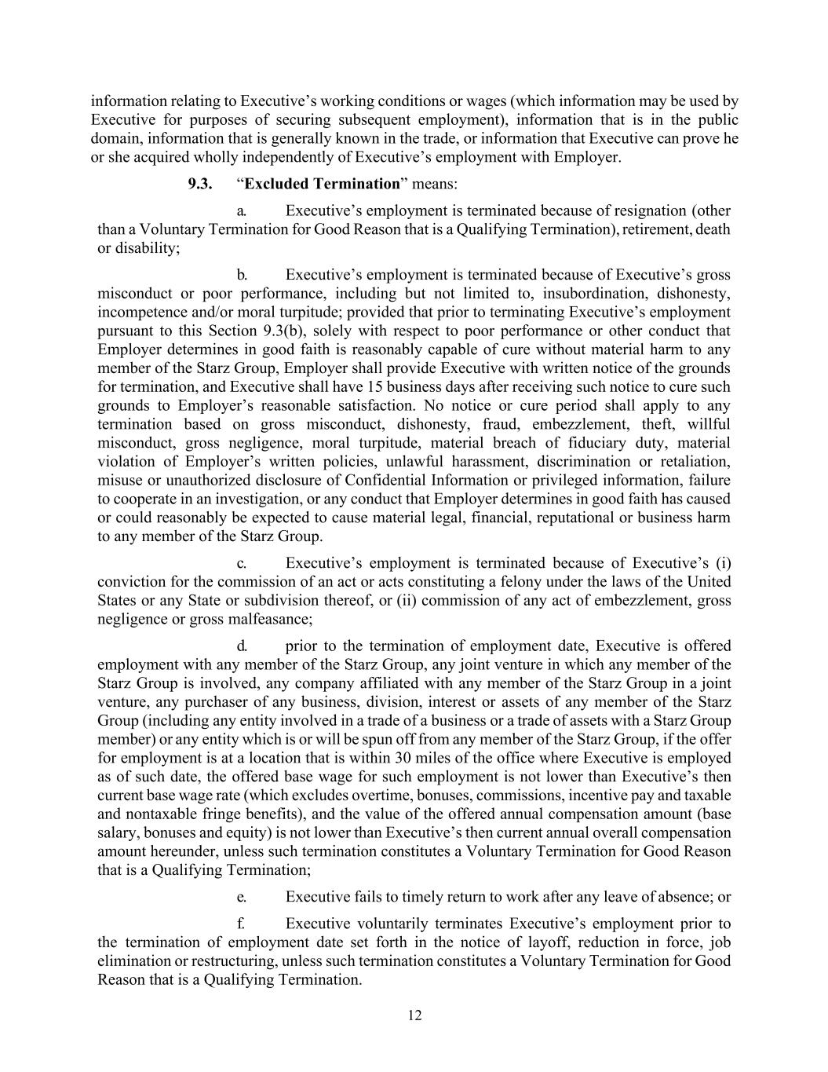
12 information relating to Executive’s working conditions or wages (which information may be used by Executive for purposes of securing subsequent employment), information that is in the public domain, information that is generally known in the trade, or information that Executive can prove he or she acquired wholly independently of Executive’s employment with Employer. 9.3. “Excluded Termination” means: a. Executive’s employment is terminated because of resignation (other than a Voluntary Termination for Good Reason that is a Qualifying Termination), retirement, death or disability; b. Executive’s employment is terminated because of Executive’s gross misconduct or poor performance, including but not limited to, insubordination, dishonesty, incompetence and/or moral turpitude; provided that prior to terminating Executive’s employment pursuant to this Section 9.3(b), solely with respect to poor performance or other conduct that Employer determines in good faith is reasonably capable of cure without material harm to any member of the Starz Group, Employer shall provide Executive with written notice of the grounds for termination, and Executive shall have 15 business days after receiving such notice to cure such grounds to Employer’s reasonable satisfaction. No notice or cure period shall apply to any termination based on gross misconduct, dishonesty, fraud, embezzlement, theft, willful misconduct, gross negligence, moral turpitude, material breach of fiduciary duty, material violation of Employer’s written policies, unlawful harassment, discrimination or retaliation, misuse or unauthorized disclosure of Confidential Information or privileged information, failure to cooperate in an investigation, or any conduct that Employer determines in good faith has caused or could reasonably be expected to cause material legal, financial, reputational or business harm to any member of the Starz Group. c. Executive’s employment is terminated because of Executive’s (i) conviction for the commission of an act or acts constituting a felony under the laws of the United States or any State or subdivision thereof, or (ii) commission of any act of embezzlement, gross negligence or gross malfeasance; d. prior to the termination of employment date, Executive is offered employment with any member of the Starz Group, any joint venture in which any member of the Starz Group is involved, any company affiliated with any member of the Starz Group in a joint venture, any purchaser of any business, division, interest or assets of any member of the Starz Group (including any entity involved in a trade of a business or a trade of assets with a Starz Group member) or any entity which is or will be spun off from any member of the Starz Group, if the offer for employment is at a location that is within 30 miles of the office where Executive is employed as of such date, the offered base wage for such employment is not lower than Executive’s then current base wage rate (which excludes overtime, bonuses, commissions, incentive pay and taxable and nontaxable fringe benefits), and the value of the offered annual compensation amount (base salary, bonuses and equity) is not lower than Executive’s then current annual overall compensation amount hereunder, unless such termination constitutes a Voluntary Termination for Good Reason that is a Qualifying Termination; e. Executive fails to timely return to work after any leave of absence; or f. Executive voluntarily terminates Executive’s employment prior to the termination of employment date set forth in the notice of layoff, reduction in force, job elimination or restructuring, unless such termination constitutes a Voluntary Termination for Good Reason that is a Qualifying Termination.

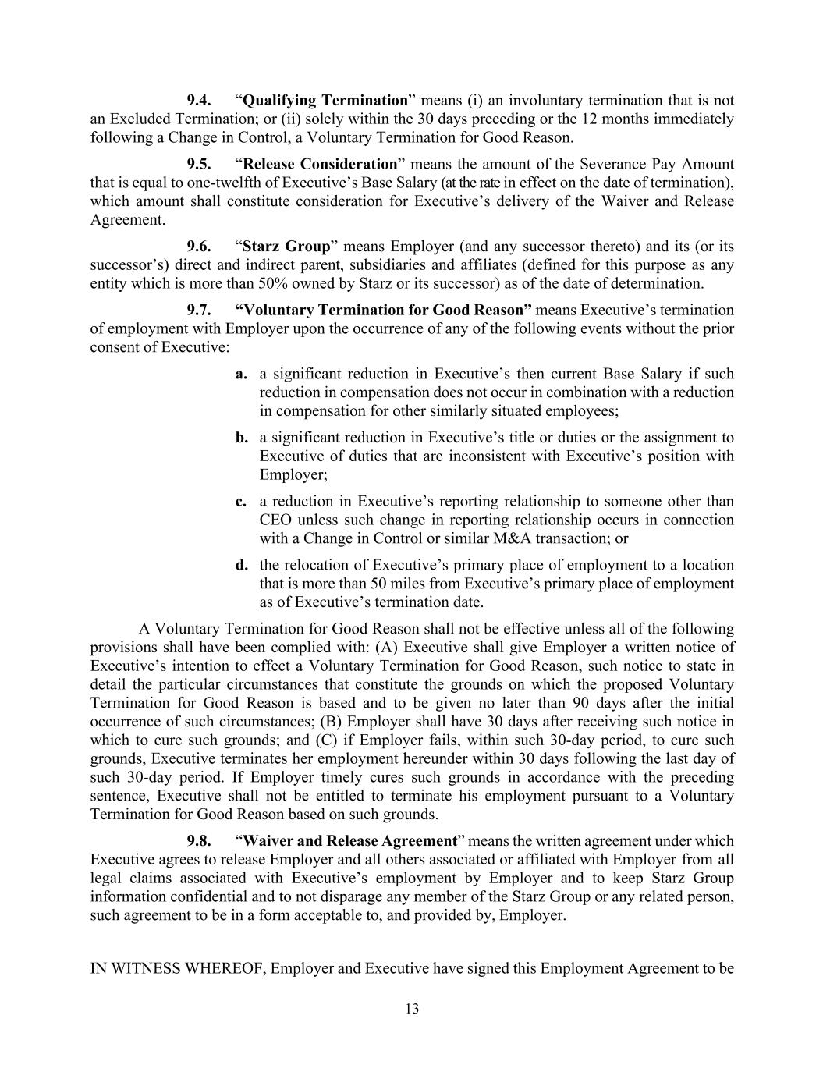
13 9.4. “Qualifying Termination” means (i) an involuntary termination that is not an Excluded Termination; or (ii) solely within the 30 days preceding or the 12 months immediately following a Change in Control, a Voluntary Termination for Good Reason. 9.5. “Release Consideration” means the amount of the Severance Pay Amount that is equal to one-twelfth of Executive’s Base Salary (at the rate in effect on the date of termination), which amount shall constitute consideration for Executive’s delivery of the Waiver and Release Agreement. 9.6. “Starz Group” means Employer (and any successor thereto) and its (or its successor’s) direct and indirect parent, subsidiaries and affiliates (defined for this purpose as any entity which is more than 50% owned by Starz or its successor) as of the date of determination. 9.7. “Voluntary Termination for Good Reason” means Executive’s termination of employment with Employer upon the occurrence of any of the following events without the prior consent of Executive: a. a significant reduction in Executive’s then current Base Salary if such reduction in compensation does not occur in combination with a reduction in compensation for other similarly situated employees; b. a significant reduction in Executive’s title or duties or the assignment to Executive of duties that are inconsistent with Executive’s position with Employer; c. a reduction in Executive’s reporting relationship to someone other than CEO unless such change in reporting relationship occurs in connection with a Change in Control or similar M&A transaction; or d. the relocation of Executive’s primary place of employment to a location that is more than 50 miles from Executive’s primary place of employment as of Executive’s termination date. A Voluntary Termination for Good Reason shall not be effective unless all of the following provisions shall have been complied with: (A) Executive shall give Employer a written notice of Executive’s intention to effect a Voluntary Termination for Good Reason, such notice to state in detail the particular circumstances that constitute the grounds on which the proposed Voluntary Termination for Good Reason is based and to be given no later than 90 days after the initial occurrence of such circumstances; (B) Employer shall have 30 days after receiving such notice in which to cure such grounds; and (C) if Employer fails, within such 30-day period, to cure such grounds, Executive terminates her employment hereunder within 30 days following the last day of such 30-day period. If Employer timely cures such grounds in accordance with the preceding sentence, Executive shall not be entitled to terminate his employment pursuant to a Voluntary Termination for Good Reason based on such grounds. 9.8. “Waiver and Release Agreement” means the written agreement under which Executive agrees to release Employer and all others associated or affiliated with Employer from all legal claims associated with Executive’s employment by Employer and to keep Starz Group information confidential and to not disparage any member of the Starz Group or any related person, such agreement to be in a form acceptable to, and provided by, Employer. IN WITNESS WHEREOF, Employer and Executive have signed this Employment Agreement to be

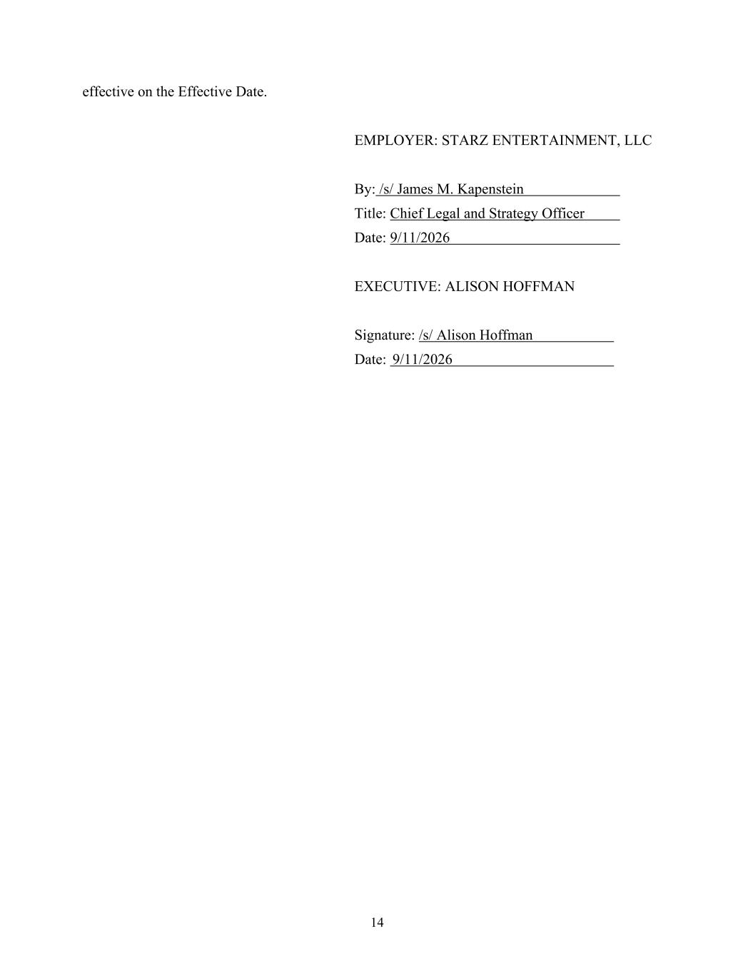
14 effective on the Effective Date. EMPLOYER: STARZ ENTERTAINMENT, LLC By: /s/ James M. Kapenstein Title: Chief Legal and Strategy Officer Date: 9/11/2026 EXECUTIVE: ALISON HOFFMAN Signature: /s/ Alison Hoffman Date: 9/11/2026


15 EXHIBIT A – FORM OF RELEASE AGREEMENT [INTENTIONALLY OMITTED]

