UNITED STATES
SECURITIES AND EXCHANGE COMMISSION
WASHINGTON, D.C. 20549
FORM 10-Q
x |  |  | QUARTERLY REPORT PURSUANT TO SECTION 13 OR 15(d) OF THE SECURITIES EXCHANGE ACT OF 1934
For the quarterly period ended June 30, 2026
OR
o |  |  | TRANSITION REPORT PURSUANT TO SECTION 13 OR 15(d) OF THE SECURITIES EXCHANGE ACT OF 1934
For the transition period from ___________ to ___________
Commission File No. 1-14880
Starz Entertainment Corp.
(Exact name of registrant as specified in its charter)
British Columbia, Canada |  |  |  |  |  |  |  |  | N/A
(State or other jurisdiction of incorporation or organization) |  |  |  |  |  |  |  |  | (I.R.S. Employer Identification No.)
250 Howe Street, 20th Floor  Vancouver, British Columbia V6C 3R8 |  |  |  |  |  |  |  |  | 1647 Stewart St.  Santa Monica, California 90404
(604) 648-6559 |  |  |  |  |  |  |  |  | (877) 848-3866
(Address of Principal Executive Offices)
Registrant's telephone number, including area code: 1 (604) 648-6559
Securities registered pursuant to Section 12(b) of the Act:
Title of each class |  |  |  |  |  | Trading Symbol(s) |  |  |  |  |  | Name of each exchange on which registered
Common Shares, no par value per share |  |  |  |  |  | STRZ |  |  |  |  |  | The Nasdaq Stock Market LLC  (Nasdaq Global Select Market)
Indicate by check mark whether the registrant (1) has filed all reports required to be filed by Section 13 or 15(d) of the Securities Exchange Act of 1934 during the preceding 12 months (or for such shorter period that the registrant was required to file such reports), and (2) has been subject to such filing requirements for the past 90 days. Yes x No o
Indicate by check mark whether the registrant has submitted electronically every Interactive Data File required to be submitted pursuant to Rule 405 of Regulation S-T (§ 232.405 of this chapter) during the preceding 12 months (or for such shorter period that the registrant was required to submit such files). Yes x No o
Indicate by check mark whether the registrant is a large accelerated filer, an accelerated filer, a non-accelerated filer, a smaller reporting company, or an emerging growth company. See the definitions of “large accelerated filer,” “accelerated filer,” “smaller reporting company, ”and "emerging growth company" in Rule 12b-2 of the Exchange Act.
Large accelerated filer |  |  | o |  |  |  |  |  | Accelerated filer |  |  | o
Non-accelerated filer |  |  | x |  |  |  |  |  | Smaller reporting company |  |  | o
 |  |  |  |  |  |  |  |  | Emerging growth company |  |  | o
If an emerging growth company, indicate by check mark if the registrant has elected not to use the extended transition period for complying with any new or revised financial accounting standards provided pursuant to Section 13(a) of the Exchange Act. o
Indicate by check mark whether the registrant is a shell company (as defined in Rule 12b-2 of the Act). Yes o No x
As of July 15, 2026, 17,124,171 of the registrant’s common shares were outstanding.

Table of Contents
STARZ ENTERTAINMENT CORP.
TABLE OF CONTENTS
 |  |  |  |  |  |  |  |  | Page Number
Part I. Financial Information
 |  |  | Item 1. |  |  | Financial Statements (Unaudited) |  |  | 4
 |  |  |  |  |  | Unaudited Condensed Consolidated Balance Sheets |  |  | 4
 |  |  |  |  |  | Unaudited Condensed Consolidated Statements of Operations |  |  | 5
 |  |  |  |  |  | Unaudited Condensed Consolidated Statements of Comprehensive Loss |  |  | 6
 |  |  |  |  |  | Unaudited Condensed Consolidated Statements of Equity |  |  | 7
 |  |  |  |  |  | Unaudited Condensed Consolidated Statements of Cash Flows |  |  | 8
 |  |  |  |  |  | Notes to Unaudited Condensed Consolidated Financial Statements |  |  | 9
 |  |  | Item 2. |  |  | Management's Discussion and Analysis of Financial Condition and Results of Operations |  |  | 26
 |  |  | Item 3. |  |  | Quantitative and Qualitative Disclosures About Market Risk |  |  | 44
 |  |  | Item 4. |  |  | Controls and Procedures |  |  | 45
Part II. Other Information |  |  |  |  |  |  |  |  | 45
 |  |  | Item 1. |  |  | Legal Proceedings |  |  | 45
 |  |  | Item 1A. |  |  | Risk Factors |  |  | 45
 |  |  | Item 2. |  |  | Unregistered Sales of Equity Securities and Use of Proceeds |  |  | 45
 |  |  | Item 3. |  |  | Defaults Upon Senior Securities |  |  | 45
 |  |  | Item 4. |  |  | Mine Safety Disclosures |  |  | 45
 |  |  | Item 5. |  |  | Other Information |  |  | 45
 |  |  | Item 6. |  |  | Exhibits |  |  | 46
Signatures |  |  |  |  |  |  |  |  | 48

2
Table of Contents
STARZ ENTERTAINMENT CORP.
FORWARD-LOOKING STATEMENTS
This Quarterly Report on Form 10-Q includes statements that are, or may be deemed to be, “forward-looking statements” within the meaning of Section 27A of the Securities Act of 1933, as amended (the “Securities Act”), and Section 21E of the Securities Exchange Act of 1934, as amended (the “Exchange Act”). These forward-looking statements can be identified by the use of forward-looking terminology, including the terms “believes,” “estimates,” “potential,” “anticipates,” “expects,” “intends,” “plans,” “projects,” “forecasts,” “may,” “will,” “could,” “would” or “should” or, in each case, their negative or other variations or comparable terminology. These forward-looking statements include all matters that are not historical facts. They appear in a number of places throughout this report and include statements regarding our intentions, beliefs or current expectations concerning, among other things, our results of operations, financial condition, liquidity, prospects, growth, strategies and the industry in which we operate.
By their nature, forward-looking statements involve risks and uncertainties because they relate to events and depend on circumstances that may or may not occur in the future. We believe that these risks and uncertainties include, but are not limited to, those discussed under Part I, Item 1A. Risk Factors found in our Annual Report on Form 10-KT filed with the Securities and Exchange Commission (the “SEC”) on February 26, 2026 (the "Form 10-KT") as updated by any update to the risk factors found under Part II, Item 1A. "Risk Factors" herein. These risk factors should not be construed as exhaustive and should be read with our Form 10-KT and the other cautionary statements and information in this report.
We caution you that forward-looking statements made in this report or anywhere else are not guarantees of future performance and that our actual results of operations, financial condition and liquidity, and the development of the industry in which we operate may differ materially and adversely from those made in or suggested by the forward-looking statements contained in this report as a result of various important factors, including, but not limited to: the benefits of the Separation (as defined below); unexpected costs related to the Separation; the substantial investment of capital required to produce, market, and distribute programming; budget overruns; limitations imposed by our credit facilities and notes; unpredictability of the commercial success of our programming; risks related to acquisition and integration of future acquired businesses; the effects of dispositions of businesses or assets, including individual series or film libraries; the cost of defending our intellectual property; technological changes and other trends affecting the entertainment industry; potential adverse reactions or changes to business or employee relationships; the impact of global pandemics on our business; weakness in the global economy and financial markets, including a recession and past and future bank failures; wars, terrorism and multiple international conflicts that could cause significant economic disruption and political and social instability; labor disruptions and strikes; and the other risks and uncertainties discussed under Part I, Item 1A. Risk Factors found in our Form 10-KT, which risk factors are incorporated herein by reference, as updated by any risk factors found under Part II, Item 1A. "Risk Factors" herein.
Any forward-looking statements which we make in this report speak only as of the date of such statement, and we undertake no obligation to update such statements. Comparisons of results for current and any prior periods are not intended to express any future trends or indications of future performance, unless expressed as such, and should only be viewed as historical data.
OTHER INFORMATION
This report contains references to our trademarks and to trademarks belonging to other entities. Solely for convenience, trademarks and trade names referred to in this report, including logos, artwork and other visual displays, may appear without the ® or TM symbols, but such references are not intended to indicate, in any way, that we will not assert, to the fullest extent under applicable law, our rights or the rights of the applicable licensor to these trademarks and trade names. We do not intend our use or display of other companies’ trade names or trademarks to imply a relationship with, or endorsement or sponsorship of us by, any other company.
Unless otherwise indicated or the context requires, all references to the “Company,” “Starz,” “we,” “us,” and “our” refer to Starz Entertainment Corp., a corporation organized under the laws of the province of British Columbia, Canada, and its direct and indirect subsidiaries.

3
Table of Contents
STARZ ENTERTAINMENT CORP.
PART I. FINANCIAL INFORMATION

ITEM 1. FINANCIAL STATEMENTS

UNAUDITED CONDENSED CONSOLIDATED BALANCE SHEETS
 |  |  | June 30,  2026 |  |  |  |  |  | December 31,  2025
 |  |  | (Amounts in millions)
ASSETS
Cash and cash equivalents |  |  | $ | 59.6 |  |  |  |  | $ | 35.7
Accounts receivable, net, including other receivables of $17.5 million and $9.9 million as of June 30, 2026 and December 31, 2025, respectively. |  |  | 80.4 |  |  |  |  |  | 84.4
Prepaid expenses and other |  |  | 10.6 |  |  |  |  |  | 12.1
Total current assets |  |  | 150.6 |  |  |  |  |  | 132.2
Programming content, net |  |  | 866.0 |  |  |  |  |  | 993.8
Property and equipment, net |  |  | 47.8 |  |  |  |  |  | 49.1
Intangible assets, net |  |  | 566.1 |  |  |  |  |  | 690.9
Other assets |  |  | 41.3 |  |  |  |  |  | 47.2
Total assets |  |  | $ | 1,671.8 |  |  |  |  | $ | 1,913.2
LIABILITIES
Current portion of debt |  |  | $ | 15.0 |  |  |  |  | $ | 7.5
Accounts payable |  |  | 60.8 |  |  |  |  |  | 60.0
Programming related payables |  |  | 212.9 |  |  |  |  |  | 255.2
Other accrued liabilities |  |  | 120.9 |  |  |  |  |  | 49.1
Residuals |  |  | 22.2 |  |  |  |  |  | 27.1
Programming related obligations |  |  | 110.8 |  |  |  |  |  | 87.7
Deferred revenue |  |  | 53.4 |  |  |  |  |  | 52.8
Total current liabilities |  |  | 596.0 |  |  |  |  |  | 539.4
Debt |  |  | 600.1 |  |  |  |  |  | 605.8
Programming related obligations |  |  | 6.8 |  |  |  |  |  | 41.4
Other liabilities |  |  | 170.0 |  |  |  |  |  | 72.7
Deferred tax liabilities |  |  | 3.0 |  |  |  |  |  | 7.9
Total liabilities |  |  | 1,375.9 |  |  |  |  |  | 1,267.2
Contingencies (Note 15)
EQUITY
Common shares, no par value, unlimited authorized, 16.8 million and 16.7 million shares issued and outstanding as of June 30, 2026 and December 31, 2025, respectively. |  |  | 737.3 |  |  |  |  |  | 735.1
Accumulated other comprehensive income |  |  | 21.4 |  |  |  |  |  | 19.4
Accumulated deficit |  |  | (462.8) |  |  |  |  |  | (108.5)
Total equity |  |  | 295.9 |  |  |  |  |  | 646.0
Total liabilities and equity |  |  | $ | 1,671.8 |  |  |  |  | $ | 1,913.2
See accompanying notes.

4
Table of Contents
STARZ ENTERTAINMENT CORP.
UNAUDITED CONDENSED CONSOLIDATED STATEMENTS OF OPERATIONS
 |  |  | Three Months Ended |  |  |  |  |  |  |  |  |  |  |  | Six Months Ended
 |  |  | June 30, |  |  |  |  |  |  |  |  |  |  |  | June 30,
 |  |  | 2026 |  |  |  |  |  | 2025 |  |  |  |  |  | 2026 |  |  |  |  |  | 2025
 |  |  | (Amounts in millions, except per share amounts)
Revenue
OTT revenue |  |  | $ | 221.3 |  |  |  |  | $ | 221.1 |  |  |  |  | $ | 432.4 |  |  |  |  | $ | 446.6
Linear and other revenue |  |  | 86.6 |  |  |  |  |  | 98.6 |  |  |  |  |  | 182.4 |  |  |  |  |  | 203.7
Total revenue |  |  | 307.9 |  |  |  |  |  | 319.7 |  |  |  |  |  | 614.8 |  |  |  |  |  | 650.3
Operating expenses:
Programming amortization |  |  | 114.1 |  |  |  |  |  | 162.5 |  |  |  |  |  | 252.4 |  |  |  |  |  | 280.9
Other operating |  |  | 40.5 |  |  |  |  |  | 36.5 |  |  |  |  |  | 74.8 |  |  |  |  |  | 75.2
Advertising and marketing |  |  | 70.3 |  |  |  |  |  | 63.4 |  |  |  |  |  | 120.7 |  |  |  |  |  | 122.3
General and administrative |  |  | 40.0 |  |  |  |  |  | 29.1 |  |  |  |  |  | 69.1 |  |  |  |  |  | 54.5
Depreciation and amortization |  |  | 67.3 |  |  |  |  |  | 48.7 |  |  |  |  |  | 135.8 |  |  |  |  |  | 96.8
Restructuring and other |  |  | 151.2 |  |  |  |  |  | 6.4 |  |  |  |  |  | 290.3 |  |  |  |  |  | 189.8
Total expenses |  |  | 483.4 |  |  |  |  |  | 346.6 |  |  |  |  |  | 943.1 |  |  |  |  |  | 819.5
Operating loss |  |  | (175.5) |  |  |  |  |  | (26.9) |  |  |  |  |  | (328.3) |  |  |  |  |  | (169.2)
Interest expense |  |  | (13.6) |  |  |  |  |  | (13.2) |  |  |  |  |  | (27.5) |  |  |  |  |  | (24.1)
Interest and other income |  |  | 0.5 |  |  |  |  |  | — |  |  |  |  |  | 0.9 |  |  |  |  |  | 1.7
Other expense |  |  | (2.0) |  |  |  |  |  | (2.5) |  |  |  |  |  | (3.8) |  |  |  |  |  | (4.3)
Loss on extinguishment of debt |  |  | — |  |  |  |  |  | — |  |  |  |  |  | — |  |  |  |  |  | (0.7)
Loss from continuing operations |  |  | (190.6) |  |  |  |  |  | (42.6) |  |  |  |  |  | (358.7) |  |  |  |  |  | (196.6)
Income tax benefit |  |  | 1.2 |  |  |  |  |  | 0.1 |  |  |  |  |  | 4.4 |  |  |  |  |  | 0.1
Net loss from continuing operations |  |  | (189.4) |  |  |  |  |  | (42.5) |  |  |  |  |  | (354.3) |  |  |  |  |  | (196.5)
Net income from discontinued operations, net of income taxes |  |  | — |  |  |  |  |  | — |  |  |  |  |  | — |  |  |  |  |  | 1.0
Net loss |  |  | $ | (189.4) |  |  |  |  | $ | (42.5) |  |  |  |  | $ | (354.3) |  |  |  |  | $ | (195.5)
Per share information attributable to Starz Entertainment Corp. shareholders:
Basic and diluted net loss per common share - continuing operations |  |  | $ | (11.27) |  |  |  |  | $ | (2.54) |  |  |  |  | $ | (21.12) |  |  |  |  | $ | (11.75)
Basic and diluted net income per common share - discontinued operations |  |  | — |  |  |  |  |  | — |  |  |  |  |  | — |  |  |  |  |  | 0.06
Basic and diluted net loss per common share |  |  | $ | (11.27) |  |  |  |  | $ | (2.54) |  |  |  |  | $ | (21.12) |  |  |  |  | $ | (11.69)
Weighted average number of common shares outstanding:
Basic |  |  | 16.8 |  |  |  |  |  | 16.7 |  |  |  |  |  | 16.8 |  |  |  |  |  | 16.7
Diluted |  |  | 16.8 |  |  |  |  |  | 16.7 |  |  |  |  |  | 16.8 |  |  |  |  |  | 16.7
See accompanying notes.

5
Table of Contents
STARZ ENTERTAINMENT CORP.
UNAUDITED CONDENSED CONSOLIDATED STATEMENTS OF COMPREHENSIVE LOSS
 |  |  | Three Months Ended |  |  |  |  |  |  |  |  |  |  |  | Six Months Ended
 |  |  | June 30, |  |  |  |  |  |  |  |  |  |  |  | June 30,
 |  |  | 2026 |  |  |  |  |  | 2025 |  |  |  |  |  | 2026 |  |  |  |  |  | 2025
 |  |  | (Amounts in millions)
Net loss from continuing operations |  |  | $ | (189.4) |  |  |  |  | $ | (42.5) |  |  |  |  | $ | (354.3) |  |  |  |  | $ | (196.5)
Net unrealized gain on cash flow hedges, net of tax |  |  | 0.9 |  |  |  |  |  | — |  |  |  |  |  | 2.0 |  |  |  |  |  | —
Comprehensive loss from continuing operations, net of tax |  |  | (188.5) |  |  |  |  |  | (42.5) |  |  |  |  |  | (352.3) |  |  |  |  |  | (196.5)
Net income from discontinued operations |  |  | — |  |  |  |  |  | — |  |  |  |  |  | — |  |  |  |  |  | 1.0
Comprehensive loss |  |  | $ | (188.5) |  |  |  |  | $ | (42.5) |  |  |  |  | $ | (352.3) |  |  |  |  | $ | (195.5)
See accompanying notes.

6
Table of Contents
STARZ ENTERTAINMENT CORP.
UNAUDITED CONDENSED CONSOLIDATED STATEMENTS OF EQUITY
 |  |  | Starz Common Shares |  |  |  |  |  |  |  |  |  |  |  | Accumulated Deficit |  |  |  |  |  | Parent(1) Net Investment |  |  |  |  |  | Accumulated  Other  Comprehensive  Income |  |  |  |  |  | Total Equity
 |  |  | Number |  |  |  |  |  | Amount
 |  |  | (Amounts in millions)
Balance as of December 31, 2024 |  |  | — |  |  |  |  |  | $ | — |  |  |  |  | $ | — |  |  |  |  | $ | 892.1 |  |  |  |  | $ | 19.2 |  |  |  |  | $ | 911.3
Net loss |  |  | — |  |  |  |  |  | — |  |  |  |  |  | — |  |  |  |  |  | (153.0) |  |  |  |  |  | — |  |  |  |  |  | (153.0)
Net transfers from Parent |  |  | — |  |  |  |  |  | — |  |  |  |  |  | — |  |  |  |  |  | 8.1 |  |  |  |  |  | — |  |  |  |  |  | 8.1
Balance as of March 31, 2025 |  |  | — |  |  |  |  |  | $ | — |  |  |  |  | $ | — |  |  |  |  | $ | 747.2 |  |  |  |  | $ | 19.2 |  |  |  |  | $ | 766.4
Distribution from Old Lionsgate upon Separation |  |  | — |  |  |  |  |  | — |  |  |  |  |  | — |  |  |  |  |  | 0.1 |  |  |  |  |  |  |  |  |  |  |  | 0.1
Net loss prior to Separation |  |  | — |  |  |  |  |  | — |  |  |  |  |  | — |  |  |  |  |  | (7.3) |  |  |  |  |  | — |  |  |  |  |  | (7.3)
Issuance of Starz common shares to holders of Old Lionsgate Class A Voting and Class B Non-Voting Common Shares and Separation from Old Lionsgate |  |  | 16.7 |  |  |  |  |  | 740.0 |  |  |  |  |  | — |  |  |  |  |  | (740.0) |  |  |  |  |  | — |  |  |  |  |  | —
Net loss after Separation |  |  | — |  |  |  |  |  | — |  |  |  |  |  | (35.2) |  |  |  |  |  | — |  |  |  |  |  | — |  |  |  |  |  | (35.2)
Share-based compensation after Separation |  |  | — |  |  |  |  |  | 5.9 |  |  |  |  |  | — |  |  |  |  |  | — |  |  |  |  |  | — |  |  |  |  |  | 5.9
Share-based liability for modified July Vesting awards |  |  | — |  |  |  |  |  | (17.6) |  |  |  |  |  | — |  |  |  |  |  | — |  |  |  |  |  | — |  |  |  |  |  | (17.6)
Balance at June 30, 2025 |  |  | 16.7 |  |  |  |  |  | $ | 728.3 |  |  |  |  | $ | (35.2) |  |  |  |  | $ | — |  |  |  |  | $ | 19.2 |  |  |  |  | $ | 712.3
Balance as of December 31, 2025 |  |  | 16.7 |  |  |  |  |  | $ | 735.1 |  |  |  |  | $ | (108.5) |  |  |  |  | $ | — |  |  |  |  | $ | 19.4 |  |  |  |  | $ | 646.0
Net loss |  |  | — |  |  |  |  |  | — |  |  |  |  |  | (164.9) |  |  |  |  |  | — |  |  |  |  |  | — |  |  |  |  |  | (164.9)
Share-based compensation |  |  | 0.1 |  |  |  |  |  | 3.2 |  |  |  |  |  | — |  |  |  |  |  | — |  |  |  |  |  | — |  |  |  |  |  | 3.2
Reclassification of unvested pre-spin award expense from equity to liability |  |  | — |  |  |  |  |  | (6.7) |  |  |  |  |  | — |  |  |  |  |  | — |  |  |  |  |  | — |  |  |  |  |  | (6.7)
Other comprehensive gain |  |  | — |  |  |  |  |  | — |  |  |  |  |  | — |  |  |  |  |  | — |  |  |  |  |  | 1.1 |  |  |  |  |  | 1.1
Balance as of March 31, 2026 |  |  | 16.8 |  |  |  |  |  | $ | 731.6 |  |  |  |  | $ | (273.4) |  |  |  |  | $ | — |  |  |  |  | $ | 20.5 |  |  |  |  | $ | 478.7
Net loss |  |  |  |  |  |  |  |  |  |  |  |  |  |  | (189.4) |  |  |  |  |  |  |  |  |  |  |  |  |  |  |  |  |  | (189.4)
Share-based compensation |  |  | — |  |  |  |  |  | 5.3 |  |  |  |  |  |  |  |  |  |  |  |  |  |  |  |  |  |  |  |  |  |  |  | 5.3
Exercise of stock options |  |  | — |  |  |  |  |  | 0.4 |  |  |  |  |  |  |  |  |  |  |  |  |  |  |  |  |  |  |  |  |  |  |  | 0.4
Other comprehensive gain |  |  |  |  |  |  |  |  |  |  |  |  |  |  |  |  |  |  |  |  |  |  |  |  |  |  | 0.9 |  |  |  |  |  | 0.9
Balance as of June 30, 2026 |  |  | 16.8 |  |  |  |  |  | $ | 737.3 |  |  |  |  | $ | (462.8) |  |  |  |  | $ | — |  |  |  |  | $ | 21.4 |  |  |  |  | $ | 295.9
__________________________________
(1) Unless otherwise indicated or as the context requires, references to the “Parent” refer to Lions Gate Entertainment Corp., prior to the Separation.
See accompanying notes.

7
Table of Contents
STARZ ENTERTAINMENT CORP.
UNAUDITED CONDENSED CONSOLIDATED STATEMENTS OF CASH FLOWS
 |  |  | Six Months Ended
 |  |  | June 30,
 |  |  | 2026 |  |  |  |  |  | 2025
 |  |  | (Amounts in millions)
Operating Activities:
Net loss |  |  | $ | (354.3) |  |  |  |  | $ | (195.5)
Less: net income from discontinued operations, net of tax |  |  | — |  |  |  |  |  | 1.0
Net loss from continuing operations, net of tax |  |  | (354.3) |  |  |  |  |  | (196.5)
Adjustments to reconcile net loss to net cash provided by operating activities:
Depreciation and amortization |  |  | 135.8 |  |  |  |  |  | 96.8
Programming amortization |  |  | 252.4 |  |  |  |  |  | 280.9
Net content impairment |  |  | 129.2 |  |  |  |  |  | 167.3
Amortization of debt financing costs and other non-cash interest |  |  | 2.3 |  |  |  |  |  | 2.0
Share-based compensation |  |  | 20.2 |  |  |  |  |  | 11.7
Other amortization |  |  | 4.2 |  |  |  |  |  | 3.5
Loss on extinguishment of debt |  |  | — |  |  |  |  |  | 0.7
Deferred income taxes |  |  | — |  |  |  |  |  | 0.2
Changes in operating assets and liabilities:
Accounts receivable, net |  |  | 2.6 |  |  |  |  |  | 60.1
Cash paid for programming content(1) |  |  | (294.9) |  |  |  |  |  | (394.3)
Other assets |  |  | 2.8 |  |  |  |  |  | (5.5)
Accounts payable and accrued liabilities |  |  | 145.4 |  |  |  |  |  | 4.2
Residuals |  |  | (1.3) |  |  |  |  |  | (0.1)
Deferred revenue |  |  | 0.6 |  |  |  |  |  | 6.4
Due to LG Studios Business |  |  | — |  |  |  |  |  | (35.5)
Net cash flows provided by operating activities |  |  | 45.0 |  |  |  |  |  | 1.9
Investing activities:
Capital expenditures |  |  | (9.7) |  |  |  |  |  | (10.8)
Deferred purchase price of receivables sold |  |  | 1.2 |  |  |  |  |  | 0.5
New Lionsgate revolving credit facility – increases |  |  | — |  |  |  |  |  | 455.5
New Lionsgate revolving credit facility – decreases |  |  | — |  |  |  |  |  | (321.5)
Net cash flows (used in) provided by investing activities |  |  | (8.5) |  |  |  |  |  | 123.7
Financing activities:
Programming related obligations – borrowings |  |  | 238.2 |  |  |  |  |  | 290.6
Programming related obligations – repayments |  |  | (251.0) |  |  |  |  |  | (278.7)
Exercise of stock options |  |  | 0.2 |  |  |  |  |  | —
Distribution of Exchange Notes to New Lionsgate upon Separation |  |  | — |  |  |  |  |  | (389.9)
Debt – borrowings, net of debt issuance and redemption costs |  |  | — |  |  |  |  |  | 388.3
Debt repayments |  |  | — |  |  |  |  |  | (96.5)
Parent net investment |  |  | — |  |  |  |  |  | (2.0)
Net cash flows used in financing activities |  |  | (12.6) |  |  |  |  |  | (88.2)
Net change in cash and cash equivalents |  |  | 23.9 |  |  |  |  |  | 37.4
Cash and cash equivalents – beginning of period |  |  | 35.7 |  |  |  |  |  | 14.2
Cash and cash equivalents – end of period |  |  | $ | 59.6 |  |  |  |  | $ | 51.6
__________________________________
(1)Cash paid for programming content for the six months ended June 30, 2026 includes $157.1 million for the licensing of program rights from the LG Studios Business (as defined below).
See accompanying notes.

8
Table of Contents
STARZ ENTERTAINMENT CORP.
NOTES TO UNAUDITED CONDENSED CONSOLIDATED FINANCIAL STATEMENTS

1. Description of Business, Basis of Presentation and Significant Accounting Policies
Description of Business
Starz Entertainment Corp. (the "Company", "Starz", "we", "us", or "our") operates primarily in the U.S. and distributes the STARZ branded premium subscription video services on a direct-to-consumer over-the-top (“OTT”) basis through the Starz App and through wholesale OTT and multichannel video programming distributors (“MVPDs”), including cable operators, satellite television providers and telecommunications companies (in the aggregate the “Starz Platform”, and if referring to the Company prior to October 2025, inclusive of Starz's Canadian operations at that time). In October 2025, Starz changed its operations in Canada resulting in its partner assuming all operational oversight of the service and Starz moving to a content licensing arrangement.
Separation
On May 6, 2025, Lions Gate Entertainment Corp. (“Old Lionsgate” or “Parent”) completed the separation of its studio operations (the “LG Studios Business”) from its media networks operations (the “Starz Business”) pursuant to an arrangement agreement, resulting in two independent publicly traded companies: Lionsgate Studios Corp. (“New Lionsgate”), which now holds the LG Studios Business, and Starz Entertainment Corp., which now holds the Starz Business (the "Separation"). As part of the distribution, Old Lionsgate shareholders received shares in both companies, and Starz Entertainment Corp. subsequently executed a 15-for-1 reverse stock split, such that every fifteen (15) Starz common shares were consolidated into one (1) Starz common share. For accounting purposes under U.S. GAAP, New Lionsgate is considered the accounting spinnor or divesting entity and Starz is considered the accounting spinnee or divested entity, and the historical results of the Starz Business prior to the transaction have been prepared on a carve-out basis.
Refer to our Transition Report on Form 10-KT for the nine months ended December 31, 2025 for a full description of the Separation.
International Restructuring
During 2023, Old Lionsgate began a plan to restructure and shut down its international LIONSGATE+ business, which was finalized with the shutdown of the United Kingdom territory in May 2024. Refer to our Transition Report on Form 10-KT for the nine months ended December 31, 2025, Note 19, Discontinued Operations, for a full description of the International Restructuring. The international restructuring is included in discontinued operations in the accompanying financial statements.
Starz Networks Strategic Content Review
During the three and six months ended June 30, 2026, Starz undertook actions to rationalize its content portfolio as part of its ongoing efforts to right-size its content cost structure in response to the evolving macroeconomic and industry environment, including continued declines in traditional linear services and operating as a standalone company following the Separation. These actions included evaluating programming on the Starz Platform, cancelling certain previously ordered programming, and removing and abandoning content determined to have limited strategic value.
In April 2026, Starz entered into an agreement to terminate certain live-action films under a post pay-one output licensing agreement. As a result, Starz recognized programming contract termination fees, which were recorded within Restructuring and other costs during the three and six months ended June 30, 2026.
Basis of Presentation
The accompanying unaudited condensed consolidated financial statements have been prepared in accordance with U.S. GAAP for interim reporting and the instructions to the quarterly report on Form 10-Q under the Securities Exchange Act of 1934, as amended, and Article 10 of Regulation S-X on the same basis as the Company’s annual financial statements. Prior to the Separation, the Starz Business operated as a segment of Old Lionsgate, and the historical financial information for those periods was prepared on a carve-out basis derived from Old Lionsgate’s consolidated records. Following the Separation, the Company’s financial statements are presented on a consolidated basis and include Starz Entertainment Corp. and its majority-owned subsidiaries.
9
Table of Contents
STARZ ENTERTAINMENT CORP.
NOTES TO UNAUDITED CONDENSED CONSOLIDATED FINANCIAL STATEMENTS — (Continued)
In the opinion of the Company’s management, all adjustments (consisting only of normal recurring adjustments) considered necessary for a fair presentation have been reflected in these unaudited condensed consolidated financial statements. Management believes the assumptions underlying our financial statements, including the assumptions regarding the allocation of general and administrative expenses from Old Lionsgate, are reasonable. However, such allocations from Old Lionsgate may not include all the actual expenses that would have been incurred by Starz had we been a standalone company during the periods presented. It is not practicable to estimate actual costs that would have been incurred had we been a standalone company and operated as an unaffiliated entity during the pre-separation periods presented. Actual costs that might have been incurred had we been a standalone company during those pre-separation periods would depend on a number of factors, including the organizational structure, what corporate functions we might have performed directly or outsourced and strategic decisions we might have made in areas such as executive management, legal and other professional services, and certain corporate overhead functions.
These unaudited condensed consolidated financial statements do not include all disclosures required for annual financial statements and should be read together with the Company’s audited financial statements included in our Form 10-KT for the nine months ended December 31, 2025, which contains a full description of the Separation, historical allocations, intercompany arrangements, and related accounting policies.
Certain amounts presented in prior periods have been reclassified to conform to the current period presentation.
Change in Fiscal Year End
On May 8, 2025, the Company's Board of Directors approved a change in Starz’s fiscal year end from March 31 to December 31. As a result of the change, the Company filed a Transition Report on Form 10-KT for the nine-month transition period from April 1, 2025 to December 31, 2025.
Generally Accepted Accounting Principles
These financial statements have been prepared in accordance with U.S. GAAP.
Use of Estimates
The preparation of financial statements in conformity with U.S. GAAP requires management to make estimates and assumptions, that affect the reported amounts of assets and liabilities and disclosure of contingent assets and liabilities at the date of the financial statements, and the reported amounts of revenue and expenses during the reporting period. The most significant estimates made by management in the preparation of the accompanying financial statements relate to the intangible asset associated with the customer relationships with U.S. MVPDs ("Starz Traditional Affiliates"), which is amortized in the proportion that current period revenue bears to management’s estimate of future revenue over the remaining estimated useful life of the asset; estimates of future viewership used for the amortization of programming content; income taxes including the assessment of valuation allowances for deferred tax assets; and impairment assessments for licensed program rights and intangible assets. Actual results could differ from such estimates.
Segments
Following the Separation, Starz manages and reports its operating results through one reportable segment, Starz Networks, which includes our consolidated operations. During the six months ended June 30, 2026, International included our operations in India and Southeast Asia. Effective April 1, 2025, we transferred our operations in India and Southeast Asia to New Lionsgate. Given that Starz and New Lionsgate were under common control at the time of the transfer, no gain or loss was recorded related to the transfer.
Significant Accounting Policies
There have been no material changes to our significant accounting policies as described in our Transition Report on Form 10-KT for the nine months ended December 31, 2025.

10
Table of Contents
STARZ ENTERTAINMENT CORP.
NOTES TO UNAUDITED CONDENSED CONSOLIDATED FINANCIAL STATEMENTS — (Continued)
Recent Accounting Pronouncements
Internal-Use Software: In September 2025, the FASB issued Accounting Standards Update (ASU) 2025-06, which modernizes the accounting guidance for internal-use software under ASC 350-40. The update eliminates the previous “project stage” model and introduces a principles-based framework that better aligns with contemporary software development practices. Under the new guidance, entities may begin capitalizing internal-use software costs when two conditions are met: (1) management has authorized and committed to funding the software project, and (2) it is probable that the project will be completed and the software will be used for its intended purpose (the “probable-to-complete” threshold). The ASU also consolidates website development cost guidance into ASC 350-40 and clarifies disclosure requirements for capitalized software costs. This guidance is effective for annual reporting periods beginning after December 15, 2027, with early adoption permitted. The Company is currently evaluating the impact of adopting this guidance on its consolidated financial statements and disclosures.
Income Statement: In November 2024, the FASB issued guidance requiring public business entities to disclose additional information about specific expense categories in the notes to financial statements for interim and annual reporting periods. This guidance is effective for fiscal years beginning after December 15, 2026, and therefore will be effective beginning with the Company’s financial statements issued for the fiscal year ending December 31, 2027 and interim reporting periods beginning in fiscal 2029, with early adoption permitted. The disclosures required under the guidance can be applied either prospectively to financial statements issued for reporting periods after the effective date or retrospectively to any or all periods presented in the financial statements. The Company is currently evaluating the impact of adopting this guidance on its consolidated financial statements and disclosures.

2. Programming Content
The predominant monetization strategy for the Company's programming content (which includes licensed program rights and owned and produced films and television programs) is as a group. Total programming content is as follows:
 |  |  | June 30,  2026 |  |  |  |  |  | December 31,  2025
 |  |  | (Amounts in millions)
Licensed program rights, net of accumulated amortization |  |  | $ | 794.7 |  |  |  |  | $ | 941.2
Owned and produced films and television programs:
Released, net of accumulated amortization |  |  | 4.6 |  |  |  |  |  | 5.1
Complete and not released |  |  | 45.0 |  |  |  |  |  | —
In progress |  |  | 6.9 |  |  |  |  |  | 36.6
In development |  |  | 14.8 |  |  |  |  |  | 10.9
 |  |  | 71.3 |  |  |  |  |  | 52.6
Programming content, net |  |  | $ | 866.0 |  |  |  |  | $ | 993.8
Amortization of programming content is as follows and is included in programming amortization in the accompanying unaudited condensed consolidated statements of operations:
 |  |  | Three Months Ended |  |  |  |  |  |  |  |  |  |  |  | Six Months Ended
 |  |  | June 30, |  |  |  |  |  |  |  |  |  |  |  | June 30,
 |  |  | 2026 |  |  |  |  |  | 2025 |  |  |  |  |  | 2026 |  |  |  |  |  | 2025
 |  |  | (Amounts in millions)
Programming amortization expense:
Licensed program rights |  |  | $ | 112.3 |  |  |  |  | $ | 161.5 |  |  |  |  | $ | 249.4 |  |  |  |  | $ | 280.2
Owned and produced films and television programs |  |  | 1.8 |  |  |  |  |  | 1.0 |  |  |  |  |  | 3.0 |  |  |  |  |  | 0.7
 |  |  | $ | 114.1 |  |  |  |  | $ | 162.5 |  |  |  |  | $ | 252.4 |  |  |  |  | $ | 280.9

11
Table of Contents
STARZ ENTERTAINMENT CORP.
NOTES TO UNAUDITED CONDENSED CONSOLIDATED FINANCIAL STATEMENTS — (Continued)
3. Debt
Debt is summarized as follows:
 |  |  | June 30,  2026 |  |  |  |  |  | December 31,  2025
 |  |  | (Amounts in millions)
Corporate debt:
Term Loan A |  |  | $ | 300.0 |  |  |  |  | $ | 300.0
5.5% Senior Notes |  |  | 325.1 |  |  |  |  |  | 325.1
Unamortized debt issuance costs |  |  | (10.0) |  |  |  |  |  | (11.8)
Total debt, net |  |  | 615.1 |  |  |  |  |  | 613.3
Less current portion of debt(1) |  |  | (15.0) |  |  |  |  |  | (7.5)
Non-current portion of debt |  |  | $ | 600.1 |  |  |  |  | $ | 605.8
_______________
(1)Amount includes the current portion of the $300.0 million senior secured term loan credit facility ("Term Loan A") as of June 30, 2026 and December 31, 2025, respectively.
Starz Credit Agreement
On May 6, 2025, in connection with the consummation of the Separation, Starz entered into a new credit agreement with Starz Capital Holdings LLC, as borrower (the “Borrower”), the guarantors referred to therein, the lenders referred to therein and JPMorgan Chase Bank, N.A., as administrative agent.
The Starz Credit Agreement provides for (i) a $300.0 million senior secured term loan credit facility ("Term Loan A") and (ii) a $150.0 million senior secured revolving credit facility. The Starz Credit Agreement and commitments thereunder will mature on the date that is the earlier of five years after the closing date of the facility and 135 days prior to the 5.5% Senior Notes maturity date. Borrowings bear interest at a rate per annum equal to, at the Borrower’s option, either Term SOFR or a base rate, in each case plus an applicable margin initially of 3% for Term SOFR loans and 2% for base rate loans. From and after September 30, 2025, the applicable margin varies based on the Borrower’s Net Total Leverage Ratio (as defined in the Credit Agreement).
Repayments under the Term Loan A assume a maturity date of December 1, 2028 (135 days prior to the 5.5% Senior Notes maturity date).
Starz pays a commitment fee ranging from 0.25% to 0.375% per annum based on the Borrower’s Net Total Leverage Ratio (as defined in the Credit Agreement), in respect of unutilized commitments thereunder.
Borrowings may be used for working capital needs and other general corporate purposes, including the financing of permitted acquisitions and investments.
Starz’s obligations under the Starz Credit Agreement are guaranteed by Starz and substantially all of its wholly owned restricted subsidiaries and secured by substantially all assets of the Borrower and the guarantors, in each case subject to certain customary exceptions.
The Starz Credit Agreement contains certain customary affirmative and negative covenants that limit the ability of the Borrower and its restricted subsidiaries, among other things and subject to certain significant exceptions, to incur debt or liens, make investments, enter into certain mergers, consolidations, asset sales and acquisitions, pay dividends and make other restricted payments and enter into transactions with affiliates. The Starz Credit Agreement also contains events of default customary for financings of this type, including relating to a change of control.
In addition, the Starz Credit Agreement contains financial covenants requiring the Borrower to maintain (A) a Net Total Leverage Ratio, as of the last day of each fiscal quarter ending on and after (i) June 30, 2025, no greater than 4.50 to 1.00; (ii) March 31, 2026, no greater than 4.25 to 1.00; (iii) March 31, 2027, no greater than 4.00 to 1.00; and (iv) March 31, 2028, no greater than 3.50 to 1.00; (B) a Net First Lien Leverage Ratio (as defined in the Starz Credit Agreement) no greater than 3.00 to 1.00; and (C) an Interest Coverage Ratio (as defined in the Starz Credit Agreement) no less than 2.50 to 1.00. As of June 30, 2026, the Company was in compliance with all applicable covenants.

12
Table of Contents
STARZ ENTERTAINMENT CORP.
NOTES TO UNAUDITED CONDENSED CONSOLIDATED FINANCIAL STATEMENTS — (Continued)
5.5% Senior Notes
Interest: The 5.5% Senior Notes bear interest at 5.5% annually (payable semi-annually in arrears on April 15 and October 15 of each year, commencing on October 15, 2021).
Maturity Date: April 15, 2029.
Optional Redemption: On or after April 15, 2024, the issuer may redeem the 5.5% Senior Notes in whole at any time, or in part from time to time, at certain specified redemption prices, plus accrued and unpaid interest, if any, to, but not including, the redemption date. Such redemption prices are as follows (as a percentage of the principal amount redeemed): (i) on or after April 15, 2024 - 102.750%; (ii) on or after April 15, 2025 - 101.375%; and (iii) on or after April 15, 2026 - 100%.
Security. The 5.5% Senior Notes are unsecured obligations of the Company.
Issuer. Starz Capital Holdings LLC, a wholly owned subsidiary of the Company.
Guarantors. The Company and its other subsidiaries are guarantors under the 5.5% Senior Notes.
Covenants. As of June 30, 2026, the issuer was in compliance with all applicable covenants.

4. Programming Related Obligations
Programming related obligations include programming notes, which represent individual unsecured loans for the licensing of film and television programs. As of June 30, 2026, outstanding programming notes had a balance of $62.1 million and had contractual repayment dates ranging from July 2026 through August 2026, and incurred SOFR-based interest at a weighted average rate of 8.1%. There were $87.7 million of programming notes outstanding as of December 31, 2025.
In addition to programming notes, current and non-current Programming related obligations include secured production loans with outstanding balances of $48.7 million due in January 2027 and $6.8 million due in May 2028, in each case as of June 30, 2026. As of December 31, 2025, the production loans had an outstanding balance of $41.4 million and were included in non-current Programming related obligations as they were not current liabilities at that time. The production loans each incurred SOFR-based interest of 6.0%. Production loans represent financing arrangements for individual original series produced by the Company. These loans are secured by collateral consisting of the underlying intellectual property rights (e.g., the related film or television program).

13
Table of Contents
STARZ ENTERTAINMENT CORP.
NOTES TO UNAUDITED CONDENSED CONSOLIDATED FINANCIAL STATEMENTS — (Continued)
5. Fair Value Measurements
Fair Value
Accounting guidance and standards about fair value define fair value as the price that would be received from selling an asset or paid to transfer a liability in an orderly transaction between market participants at the measurement date.
Fair Value Hierarchy
Fair value hierarchy requires an entity to maximize the use of observable inputs and minimize the use of unobservable inputs when measuring fair value. A financial instrument’s categorization within the fair value hierarchy is based upon the lowest level of input that is significant to the fair value measurement. The accounting guidance and standards establish three levels of inputs that may be used to measure fair value:
•Level 1 — Quoted prices in active markets for identical assets or liabilities.
•Level 2 — Observable inputs other than Level 1 prices such as quoted prices for similar assets or liabilities; quoted prices in markets with insufficient volume or infrequent transactions (less active markets); or model-derived valuations in which all significant inputs are observable or can be derived principally from or corroborated by observable market data for substantially the full term of the assets or liabilities.
•Level 3 — Unobservable inputs to the valuation methodology that are significant to the measurement of fair value of assets or liabilities.
The following table sets forth the carrying values and fair values of the Company’s outstanding debt, programming notes, production loans and derivatives:
 |  |  | June 30, 2026 |  |  |  |  |  |  |  |  |  |  |  | December 31, 2025
 |  |  | (Amounts in millions)
 |  |  | Carrying  Value |  |  |  |  |  | Fair Value(1) |  |  |  |  |  | Carrying Value |  |  |  |  |  | Fair Value(1)
 |  |  |  |  |  |  |  |  | (Level 2) |  |  |  |  |  |  |  |  |  |  |  | (Level 2)
Liabilities:
Term Loan A |  |  | $ | 294.9 |  |  |  |  | $ | 300.0 |  |  |  |  | $ | 293.9 |  |  |  |  | $ | 300.0
5.5% Senior Notes |  |  | 320.2 |  |  |  |  |  | 294.2 |  |  |  |  |  | 319.4 |  |  |  |  |  | 264.1
Programming Notes |  |  | 62.1 |  |  |  |  |  | 62.1 |  |  |  |  |  | 87.7 |  |  |  |  |  | 87.7
Production Loans |  |  | 55.5 |  |  |  |  |  | 55.5 |  |  |  |  |  | 41.4 |  |  |  |  |  | 41.4
Interest rate exchange swaps(2) |  |  | 1.0 |  |  |  |  |  | 1.0 |  |  |  |  |  | (0.9) |  |  |  |  |  | (0.9)
Foreign currency forward exchange contracts(2) |  |  | 0.2 |  |  |  |  |  | 0.2 |  |  |  |  |  | nil |  |  |  |  |  | nil
________________
(1)The Company measures the fair value of its outstanding debt using discounted cash flow techniques that use observable market inputs, such as SOFR-based yield curves, swap rates, and credit ratings (Level 2 measurements).
(2)Represents the fair value measurements of the Company’s derivative instruments, specifically forward exchange contracts and interest rate swaps, as of June 30, 2026. These instruments are classified within the fair value hierarchy in accordance with ASC 820. Refer to Note 12, Derivative Instruments and Hedging Activities, for further detail.
The Company’s financial instruments also include cash and cash equivalents, accounts receivable, accounts payable, programming related payables, other accrued liabilities and other liabilities. The carrying values of these financial instruments approximated the fair values of these financial instruments as of June 30, 2026 and December 31, 2025. The Company recorded material, non-recurring fair value adjustments of $129.8 million and $167.4 million during the six months ended June 30, 2026 and June 30, 2025, respectively, related to content impairments. Refer to Note 8, Restructuring and other, for further detail.

14
Table of Contents
STARZ ENTERTAINMENT CORP.
NOTES TO UNAUDITED CONDENSED CONSOLIDATED FINANCIAL STATEMENTS — (Continued)
6. Capital Stock
Common Shares
The Company has an unlimited number of authorized common shares as of June 30, 2026.
Share-based compensation expense from continuing operations, by expense category, consisted of the following:
 |  |  | Three Months Ended |  |  |  |  |  |  |  |  |  |  |  | Six Months Ended
 |  |  | June 30, |  |  |  |  |  |  |  |  |  |  |  | June 30,
 |  |  | 2026 |  |  |  |  |  | 2025 |  |  |  |  |  | 2026 |  |  |  |  |  | 2025
 |  |  | (Amounts in millions)
Share-based compensation expense:
Other operating expense |  |  | $ | 3.4 |  |  |  |  | $ | 0.9 |  |  |  |  | $ | 3.9 |  |  |  |  | $ | 1.7
General and administrative |  |  | 13.5 |  |  |  |  |  | 4.3 |  |  |  |  |  | 16.2 |  |  |  |  |  | 7.6
Restructuring and other |  |  | 0.1 |  |  |  |  |  | 2.2 |  |  |  |  |  | 0.1 |  |  |  |  |  | 2.4
 |  |  | $ | 17.0 |  |  |  |  | $ | 7.4 |  |  |  |  | $ | 20.2 |  |  |  |  | $ | 11.7
Rights Agreement
On March 10, 2026, the Board adopted a Shareholder Protection Rights Agreement and declared a dividend of one right per common share, issued to shareholders of record on March 20, 2026. The rights become exercisable upon the acquisition of 17.5% or more of the Company’s common shares, and generally entitle holders to purchase one common share at an exercise price of $93.00, subject to adjustment. Refer to the Company’s March 10, 2026 Form 8-K for additional information.

15
Table of Contents
STARZ ENTERTAINMENT CORP.
NOTES TO UNAUDITED CONDENSED CONSOLIDATED FINANCIAL STATEMENTS — (Continued)
7. Revenue
Revenue by segment is as follows:
 |  |  | Three Months Ended |  |  |  |  |  |  |  |  |  |  |  | Six Months Ended
 |  |  | June 30, |  |  |  |  |  |  |  |  |  |  |  | June 30,
 |  |  | 2026 |  |  |  |  |  | 2025 |  |  |  |  |  | 2026 |  |  |  |  |  | 2025
 |  |  | (Amounts in millions)
Revenue
Starz Networks |  |  | $ | 307.9 |  |  |  |  | $ | 319.7 |  |  |  |  | $ | 614.8 |  |  |  |  | $ | 645.9
International(1) |  |  | — |  |  |  |  |  | — |  |  |  |  |  | — |  |  |  |  |  | 4.4
 |  |  | $ | 307.9 |  |  |  |  | $ | 319.7 |  |  |  |  | $ | 614.8 |  |  |  |  | $ | 650.3
_____________________
(1) Includes the operations in India and Southeast Asia for the three and six months ended June 30, 2025.
Remaining Revenue Performance Obligations
Remaining revenue performance obligations represent deferred revenue included on the balance sheet. Revenue totaling $53.4 million is expected to be recognized in the next twelve months, in relation to performance obligations that are unsatisfied as of June 30, 2026.
Accounts Receivable and Deferred Revenue
The timing of revenue recognition, billings and cash collections affects the recognition of accounts receivable and deferred revenue. See the accompanying unaudited condensed consolidated balance sheets for accounts receivable and deferred revenue balances at June 30, 2026 and December 31, 2025.
Accounts Receivable. Accounts receivable is presented net of a provision for credit losses. The Company estimates provisions for accounts receivable based on historical experience for the respective risk categories and current and future expected economic conditions. To assess collectability, the Company analyzes market trends, economic conditions, the aging of receivables and customer specific risks, and records a provision for estimated credit losses expected over the lifetime of the receivables in direct operating expense.
The Company monitors its credit exposure through active review of customers' financial condition, aging of receivable balances, historical collection trends, and expectations about relevant future events that may significantly affect collectability. The Company generally does not require collateral for its trade accounts receivable.
Credit Risk. Concentration of credit risk with the Company’s customers is limited due to the Company’s customer base and the diversity of its sales throughout the U.S. and Canada. The Company performs ongoing credit evaluations and maintains a provision for potential credit losses.
Deferred Revenue. Deferred revenue relates primarily to subscribers to the Starz App, who are billed in advance of the start of their monthly or multi-month membership. Revenue is recognized ratably over each applicable membership period when the Company satisfies the corresponding performance obligation. Deferred revenue consists primarily of customer cash advances or deposits received prior to when the Company satisfies the corresponding performance obligation. Revenue of $11.8 million and $43.4 million was recognized during the three and six months ended June 30, 2026, respectively, related to the balance of deferred revenue at December 31, 2025.

16
Table of Contents
STARZ ENTERTAINMENT CORP.
NOTES TO UNAUDITED CONDENSED CONSOLIDATED FINANCIAL STATEMENTS — (Continued)
8. Restructuring and Other
Restructuring and other includes restructuring costs, and certain transaction-related and other expenses. During the three and six months ended June 30, 2026 and June 30, 2025, the Company also incurred certain other unusual charges and benefits. The following table sets forth restructuring and other and these other unusual charges:
 |  |  | Three Months Ended |  |  |  |  |  |  |  |  |  |  |  | Six Months Ended
 |  |  | June 30, |  |  |  |  |  |  |  |  |  |  |  | June 30,
 |  |  | 2026 |  |  |  |  |  | 2025 |  |  |  |  |  | 2026 |  |  |  |  |  | 2025
 |  |  | (Amounts in millions)
Contract termination fees(1) |  |  | $ | 147.2 |  |  |  |  | $ | — |  |  |  |  | $ | 147.2 |  |  |  |  | $ | —
Content impairments (recoveries)(2) |  |  | 1.7 |  |  |  |  |  | (0.3) |  |  |  |  |  | 129.8 |  |  |  |  |  | 167.4
Transaction and other costs(3) |  |  | 1.7 |  |  |  |  |  | 4.5 |  |  |  |  |  | 6.8 |  |  |  |  |  | 18.5
Severance(4) |  |  | 0.5 |  |  |  |  |  | — |  |  |  |  |  | 6.4 |  |  |  |  |  | 1.5
Share-based compensation |  |  | 0.1 |  |  |  |  |  | 2.2 |  |  |  |  |  | 0.1 |  |  |  |  |  | 2.4
 |  |  | $ | 151.2 |  |  |  |  | $ | 6.4 |  |  |  |  | $ | 290.3 |  |  |  |  | $ | 189.8
_____________________
(1) In April 2026, Starz entered into an agreement to terminate certain live-action films under a post pay-one output licensing agreement. As a result, Starz recognized programming contract termination fees, which were recorded within Restructuring and other costs during the three and six months ended June 30, 2026. The termination cost is based on an agreed fee schedule which includes a measure of theatrical box office performance. Some of the underlying films have not yet been released theatrically, therefore the liability is an estimate, and the final termination cost may differ.
The reconciliation of the beginning and ending contract termination liability balance showing activity during the year is as follows:
Contract termination liability balance as of January 1, 2026 |  |  | $ | —
Accrued contract termination liability(a) |  |  | 143.9
Contract termination liability accretion |  |  | 3.3
Contract termination liability balance as of June 30, 2026 |  |  | $ | 147.2
(a) The Company measures the present value of its contract liability termination fee using discounted cash flow techniques. This fair value measurement is classified within Level 2 of the fair value hierarchy as it utilizes observable market inputs, including market-based corporate yield curves, estimated timing of expected cash flows, and credit risk assumptions derived from comparable rated debt instruments.
(2) During the three and six months ended June 30, 2026 and June 30, 2025, Starz undertook actions to rationalize its content portfolio as part of its ongoing efforts to right-size its content cost structure in response to the evolving macroeconomic and industry environment, including continued declines in traditional linear services and operating as a standalone company following the Separation. These actions included evaluating programming on the Starz Platform, cancelling certain previously ordered programming, and removing and abandoning content determined to have limited strategic value.
(3) Transaction and other costs during the three and six months ended June 30, 2026 and June 30, 2025 reflect costs associated with certain potential strategic transactions, costs associated with certain legal matters, and transaction, integration, and legal costs associated with the Separation.
(4) Severance costs for the three and six months ended June 30, 2026 and June 30, 2025, represent a reduction in our work force due to cost-saving initiatives and the continued decline in traditional linear services.

17
Table of Contents
STARZ ENTERTAINMENT CORP.
NOTES TO UNAUDITED CONDENSED CONSOLIDATED FINANCIAL STATEMENTS — (Continued)
9. Income Taxes
The income tax provision for the six months ended June 30, 2026 was calculated by estimating the Company’s annual effective tax rate (estimated annual tax provision divided by estimated annual income before income taxes), and then applying the effective tax rate to income (loss) before income taxes for the period, plus or minus the tax effects of items that relate discretely to the period, if any. The Starz Business’s U.S. operations and certain of its non-U.S. operations were historically included in the income tax returns of Old Lionsgate or its subsidiaries. For the three months ended June 30, 2025, income taxes were calculated as if the Starz Business filed income tax returns on a standalone basis, including assumptions regarding the allocation of consolidated tax attributes.
The Company’s income tax provision differs from the federal statutory income tax rate applied to income (loss) before taxes due to the level and geographic mix of earnings, changes in tax laws and regulations, changes in uncertain tax positions, as well as changes in valuation allowances on deferred tax assets. The Company’s income tax provision for the six months ended June 30, 2026 and June 30, 2025 were impacted by changes in the valuation allowances against certain U.S. and foreign deferred tax assets, net of applicable deferred tax liabilities.
There were no material discrete income tax items or significant changes in uncertain tax positions during the six months ended June 30, 2026.

18
Table of Contents
STARZ ENTERTAINMENT CORP.
NOTES TO UNAUDITED CONDENSED CONSOLIDATED FINANCIAL STATEMENTS — (Continued)
10. Net Loss Per Share
Basic and diluted net loss per share is calculated based on the weighted average common shares outstanding for the period. For the three and six months ended June 30, 2026 and June 30, 2025, the Company reported a net loss, and therefore all potentially dilutive common shares were excluded from the calculation of diluted net loss per common share because their inclusion would have been anti-dilutive. As a result, diluted net loss per common share is the same as basic net loss per common share.
For the three and six months ended June 30, 2026 and June 30, 2025, the following common shares issuable were excluded from net loss per common share because their inclusion would have had an anti-dilutive effect:
 |  |  | Three Months Ended |  |  |  |  |  |  |  |  |  |  |  | Six Months Ended
 |  |  | June 30, |  |  |  |  |  |  |  |  |  |  |  | June 30,
 |  |  | 2026 |  |  |  |  |  | 2025 |  |  |  |  |  | 2026 |  |  |  |  |  | 2025
 |  |  | (Amounts in millions)
Stock options and share appreciation rights (SARs) |  |  | 1.1 |  |  |  |  |  | 0.8 |  |  |  |  |  | 1.1 |  |  |  |  |  | 0.8
Restricted share units |  |  | 2.4 |  |  |  |  |  | 2.5 |  |  |  |  |  | 2.4 |  |  |  |  |  | 2.5
Total anti-dilutive shares issuable excluded from diluted net loss per common share |  |  | 3.5 |  |  |  |  |  | 3.3 |  |  |  |  |  | 3.5 |  |  |  |  |  | 3.3

19
Table of Contents
STARZ ENTERTAINMENT CORP.
NOTES TO UNAUDITED CONDENSED CONSOLIDATED FINANCIAL STATEMENTS — (Continued)
11. Segment Information
The Company’s reportable segments have been determined based on the distinct nature of their operations, the Company's internal management structure, and the financial information that is evaluated regularly by the Company's chief operating decision maker ("CODM") in deciding how to allocate resources to an individual segment and in assessing performance. Our Chief Executive Officer ("CEO") is the CODM.
As described in Note 1, Description of Business, Basis of Presentation and Significant Accounting Policies, as of June 30, 2026, the Company has one reportable segment: Starz Networks, which includes our operations in the U.S. and Canada. During the six months ended June 30, 2025, International included operations in India and Southeast Asia. As described in Note 1, Description of Business, Basis of Presentation and Significant Accounting Policies, and effective April 1, 2025, we transferred our operations in India and Southeast Asia to New Lionsgate.
Segment information is presented in the table below:
 |  |  | Three Months Ended
 |  |  | June 30,
 |  |  | 2026 |  |  |  |  |  | 2025
 |  |  | Starz Networks |  |  |  |  |  | Starz Networks
 |  |  | (Amounts in millions)
Revenue
OTT revenue |  |  | $ | 221.3 |  |  |  |  | $ | 221.1
Linear and other revenue |  |  | 86.6 |  |  |  |  |  | 98.6
Total revenue |  |  | 307.9 |  |  |  |  |  | 319.7
Operating expenses:
Programming amortization |  |  | 114.1 |  |  |  |  |  | 162.5
Payroll(1) |  |  | 35.6 |  |  |  |  |  | 29.7
Advertising and marketing |  |  | 70.3 |  |  |  |  |  | 63.4
Other(2) |  |  | 44.9 |  |  |  |  |  | 35.9
Depreciation and amortization |  |  | 67.3 |  |  |  |  |  | 48.7
Restructuring and other |  |  | 151.2 |  |  |  |  |  | 6.4
Total expenses |  |  | 483.4 |  |  |  |  |  | 346.6
Operating loss |  |  | (175.5) |  |  |  |  |  | (26.9)
Interest expense |  |  | (13.6) |  |  |  |  |  | (13.2)
Interest and other income |  |  | 0.5 |  |  |  |  |  | —
Other expense |  |  | (2.0) |  |  |  |  |  | (2.5)
Loss from continuing operations before income taxes |  |  | (190.6) |  |  |  |  |  | (42.6)
Income tax benefit |  |  | 1.2 |  |  |  |  |  | 0.1
Net loss from continuing operations |  |  | $ | (189.4) |  |  |  |  | $ | (42.5)
20
Table of Contents
STARZ ENTERTAINMENT CORP.
NOTES TO UNAUDITED CONDENSED CONSOLIDATED FINANCIAL STATEMENTS — (Continued)
 |  |  | Six Months Ended
 |  |  | June 30,
 |  |  | 2026 |  |  |  |  |  | 2025
 |  |  | Starz Networks |  |  |  |  |  | Starz Networks |  |  |  |  |  | International |  |  |  |  |  | Total
 |  |  | (Amounts in millions)
Revenue
OTT revenue |  |  | $ | 432.4 |  |  |  |  | $ | 444.6 |  |  |  |  | $ | 2.0 |  |  |  |  | $ | 446.6
Linear and other revenue |  |  | 182.4 |  |  |  |  |  | 201.3 |  |  |  |  |  | 2.4 |  |  |  |  |  | 203.7
Total revenue |  |  | 614.8 |  |  |  |  |  | 645.9 |  |  |  |  |  | 4.4 |  |  |  |  |  | 650.3
Operating expenses:
Programming amortization |  |  | 252.4 |  |  |  |  |  | 278.6 |  |  |  |  |  | 2.3 |  |  |  |  |  | 280.9
Payroll(1) |  |  | 69.9 |  |  |  |  |  | 60.2 |  |  |  |  |  | 0.6 |  |  |  |  |  | 60.8
Advertising and marketing |  |  | 120.7 |  |  |  |  |  | 122.1 |  |  |  |  |  | 0.2 |  |  |  |  |  | 122.3
Other(2) |  |  | 74.0 |  |  |  |  |  | 68.9 |  |  |  |  |  | — |  |  |  |  |  | 68.9
Depreciation and amortization |  |  | 135.8 |  |  |  |  |  | 96.8 |  |  |  |  |  | — |  |  |  |  |  | 96.8
Restructuring and other |  |  | 290.3 |  |  |  |  |  | 183.1 |  |  |  |  |  | 6.7 |  |  |  |  |  | 189.8
Total expenses |  |  | 943.1 |  |  |  |  |  | 809.7 |  |  |  |  |  | 9.8 |  |  |  |  |  | 819.5
Operating loss |  |  | (328.3) |  |  |  |  |  | (163.8) |  |  |  |  |  | (5.4) |  |  |  |  |  | (169.2)
Interest expense |  |  | (27.5) |  |  |  |  |  | (24.1) |  |  |  |  |  | — |  |  |  |  |  | (24.1)
Interest and other income |  |  | 0.9 |  |  |  |  |  | 1.7 |  |  |  |  |  | — |  |  |  |  |  | 1.7
Other expense |  |  | (3.8) |  |  |  |  |  | (4.3) |  |  |  |  |  | — |  |  |  |  |  | (4.3)
Loss on extinguishment of debt |  |  | — |  |  |  |  |  | (0.7) |  |  |  |  |  | — |  |  |  |  |  | (0.7)
Loss from continuing operations before income taxes |  |  | (358.7) |  |  |  |  |  | (191.2) |  |  |  |  |  | (5.4) |  |  |  |  |  | (196.6)
Income tax benefit |  |  | 4.4 |  |  |  |  |  | 0.1 |  |  |  |  |  | — |  |  |  |  |  | 0.1
Net loss from continuing operations |  |  | $ | (354.3) |  |  |  |  | $ | (191.1) |  |  |  |  | $ | (5.4) |  |  |  |  | $ | (196.5)
______________________________________
(1) Payroll expense by segment, which includes salaries and employee benefits, is reviewed by the CODM on a quarterly basis.
(2) Includes total other operating and general and administrative expenses from the accompanying unaudited condensed consolidated statements of operations, less payroll expense per note (1).
The reconciliation of total segment assets to the Company’s total consolidated assets is as follows:
 |  |  | June 30,  2026 |  |  |  |  |  | December 31,  2025
 |  |  | (Amounts in millions)
Assets
Starz Networks |  |  | $ | 1,560.3 |  |  |  |  | $ | 1,818.2
Other unallocated assets(1) |  |  | 111.5 |  |  |  |  |  | 95.0
 |  |  | $ | 1,671.8 |  |  |  |  | $ | 1,913.2
_____________________
(1)Other unallocated assets primarily consist of cash and other assets.

21
Table of Contents
STARZ ENTERTAINMENT CORP.
NOTES TO UNAUDITED CONDENSED CONSOLIDATED FINANCIAL STATEMENTS — (Continued)

Long-lived assets by geographic location are as follows:
 |  |  | June 30, 2026 |  |  |  |  |  | December 31,  2025
 |  |  | (Amounts in millions)
Long-lived assets(1)
United States |  |  | $ | 952.6 |  |  |  |  | $ | 1,084.6
_____________
(1)Long-lived assets primarily represent programming content, net, property and equipment, net, and right-of-use assets.

12. Derivative Instruments and Hedging Activities
As of June 30, 2026, the Company had outstanding pay-fixed interest rate exchange swaps with a total notional amount of $150.0 million, converting SOFR-based floating-rate debt to fixed-rate obligations. These effective swaps carry fixed interest rates ranging from 3.58% to 3.62%. The Company also had forward foreign exchange contracts outstanding with maturities of less than 24 months, totaling British £6.6 million (equivalent to US$8.9 million), used to hedge foreign currency exposure related to production tax credit receivables. These contracts are designated as cash flow hedges.

13. Additional Financial Information
The following tables present supplemental information related to the accompanying financial statements.
Accounts Receivable Monetization
Under the Company's accounts receivable monetization programs, the Company has entered into an agreement to monetize certain of its trade accounts receivable directly with a third-party purchaser (historically, the Company entered into individual agreements), as further described below.
Under the accounts receivable monetization programs, the Company transfers receivables to purchasers in exchange for cash proceeds, and the Company continues to service the receivables for the purchasers. The third-party purchasers have no recourse to other assets of the Company in the event of non-payment by the customers. The Company accounts for the transfers of these receivables as a sale, removes (derecognizes) the carrying amount of the receivables from its balance sheets and classifies the proceeds received as cash provided by operating activities in the unaudited condensed consolidated statements of cash flows.
The Company records a loss on the sale of these receivables reflecting the net proceeds received (net of any costs incurred), less the carrying amount of the receivables transferred. The loss is reflected in other expense on the accompanying unaudited condensed consolidated statements of operations.
The following table sets forth a summary of the receivables transferred:
 |  |  | Three Months Ended |  |  |  |  |  |  |  |  |  |  |  | Six Months Ended
 |  |  | June 30, |  |  |  |  |  |  |  |  |  |  |  | June 30,
 |  |  | 2026 |  |  |  |  |  | 2025 |  |  |  |  |  | 2026 |  |  |  |  |  | 2025
 |  |  | (Amounts in millions)
Carrying value of receivables transferred and derecognized |  |  | $ | 199.7 |  |  |  |  | $ | 211.4 |  |  |  |  | $ | 397.8 |  |  |  |  | $ | 415.8
Net cash proceeds received from third party purchasers |  |  | 198.3 |  |  |  |  |  | 209.4 |  |  |  |  |  | 395.0 |  |  |  |  |  | 412.2
Loss recorded related to transfers of receivables |  |  | 1.4 |  |  |  |  |  | 1.8 |  |  |  |  |  | 2.8 |  |  |  |  |  | 3.4
At June 30, 2026, receivables totaling $133.4 million had been derecognized from the Company’s accompanying unaudited condensed consolidated balance sheets but continued to be serviced by the Company. The comparable amount at December 31, 2025 was $132.9 million.

22
Table of Contents
STARZ ENTERTAINMENT CORP.
NOTES TO UNAUDITED CONDENSED CONSOLIDATED FINANCIAL STATEMENTS — (Continued)
Other Assets
The composition of the Company’s other assets is as follows:
 |  |  | June 30,  2026 |  |  |  |  |  | December 31,  2025
 |  |  | (Amounts in millions)
Other non-current assets
Operating lease right-of-use assets |  |  | $ | 38.8 |  |  |  |  | $ | 41.7
Debt issuance costs |  |  | 2.5 |  |  |  |  |  | 3.0
Accounts receivable |  |  | — |  |  |  |  |  | 2.5
 |  |  | $ | 41.3 |  |  |  |  | $ | 47.2
Other Accrued Liabilities and Other Liabilities
The composition of the Company’s other accrued liabilities (current) and other liabilities (non-current) is as follows:
 |  |  | June 30,  2026 |  |  |  |  |  | December 31,  2025
 |  |  | (Amounts in millions)
Other accrued liabilities (current)
Contract termination liability(1) |  |  | $ | 48.0 |  |  |  |  | $ | —
Employee related liabilities |  |  | 42.7 |  |  |  |  |  | 23.5
Operating lease liabilities |  |  | 11.4 |  |  |  |  |  | 11.1
Other accrued expenses and short-term liabilities |  |  | 18.8 |  |  |  |  |  | 14.5
 |  |  | $ | 120.9 |  |  |  |  | $ | 49.1
Other liabilities (non-current)
Contract termination liability(1) |  |  | $ | 99.2 |  |  |  |  | $ | —
Operating lease liabilities |  |  | 43.1 |  |  |  |  |  | 48.3
Programming related payables |  |  | 23.1 |  |  |  |  |  | 19.7
Other long-term liabilities |  |  | 4.6 |  |  |  |  |  | 4.7
 |  |  | $ | 170.0 |  |  |  |  | $ | 72.7
_____________________
(1)Represents contract termination fees accrued in connection with the April 2026 termination of certain live-action films under a post-pay-one output licensing arrangement.
Supplemental Cash Flow Information
Refer to Note 14, Activity with the LG Studios Business, for further details regarding non-cash activity with Parent.

23
Table of Contents
STARZ ENTERTAINMENT CORP.
NOTES TO UNAUDITED CONDENSED CONSOLIDATED FINANCIAL STATEMENTS — (Continued)
14. Activity with the LG Studios Business
Certain Transactions with Old Lionsgate
Net parent investment is presented in the accompanying unaudited condensed consolidated statements of equity. Settlements of amounts receivable and accounts payable when due through the net parent investment account are reflected as cash payments or receipts for the applicable operating transaction within operating activities in the accompanying unaudited condensed consolidated statements of cash flows, with the net change in parent net investment included within financing activities in the accompanying unaudited condensed consolidated statements of cash flows.
Intercompany Revolver: On May 13, 2024, LGAC International LLC, a Delaware limited liability company and wholly owned subsidiary of Lionsgate Studios (“LGAC International”) and Lions Gate Capital Holdings 1, Inc., a Delaware corporation and wholly owned subsidiary of the Company (“LGCH1”) (which was renamed Starz Capital Holdings 1, Inc. at Separation), entered into a revolving credit agreement (the “Intercompany Revolver”), pursuant to which LGAC International and LGCH1 agreed to make revolving loans to each other from time to time, provided that the net amount owing by one party to the other at any particular time may not exceed $150.0 million. Amounts advanced by one party were used to repay existing indebtedness owed to the other party thereunder, if any, such that at no time will amounts be owed in both directions. The net amount outstanding under the Intercompany Revolver, at any time, bore interest on the outstanding principal amount at a rate equal to adjusted term SOFR plus 1.75%. In connection with the Separation, all outstanding obligations under the Intercompany Revolver were repaid in full and all commitments thereunder were terminated. The cash flows related to the intercompany revolver are presented as increases and decreases in the New Lionsgate revolving credit facility on the accompanying unaudited condensed consolidated statements of cash flows.
Prior to the Separation, in the normal course of business, the Starz Business entered into transactions with Old Lionsgate and the LG Studios Business which included the following:
Operating expense reimbursement: For the periods prior to the Separation, the LG Studios Business paid certain expenses on behalf of the Company such as certain rent expense, employee benefits, insurance and other administrative operating costs. The Company also paid certain expenses on behalf of the LG Studios Business such as legal expenses, software development costs and severance. Those expenditures were reflected in the unaudited condensed consolidated financial statements of the Company and the LG Studios Business as applicable.
Share-based compensation: For the periods prior to the Separation, Old Lionsgate allocated to the Company share-based compensation related to the Company's employees. In addition, prior to Separation, Old Lionsgate allocated a proportionate amount of its share-based compensation related to the corporate functions provided by Old Lionsgate to the Company.
Parent Net Investment
 |  |  | Six Months Ended
 |  |  | June 30,
 |  |  | 2025
 |  |  | (Amounts in millions)
Cash pooling and general financing activities |  |  | $ | (2.0)
Net transfers from Parent included on unaudited condensed consolidated statements of cash flows |  |  | (2.0)
Share-based compensation (including allocation of share-based compensation) |  |  | 2.9
Other non-cash transfer |  |  | 7.3
Net transfers from Parent included on unaudited condensed consolidated statements of equity |  |  | $ | 8.2

24
Table of Contents
STARZ ENTERTAINMENT CORP.
NOTES TO UNAUDITED CONDENSED CONSOLIDATED FINANCIAL STATEMENTS — (Continued)
15. Contingencies
From time to time, the Company is involved in certain claims and legal proceedings arising in the normal course of business.
The Company establishes an accrued liability for claims and legal proceedings when the Company determines that a loss is both probable and the amount of the loss can be reasonably estimated. Once established, accruals are adjusted from time to time, as appropriate, in light of additional information. The amount of any loss ultimately incurred in relation to matters for which an accrual has been established may be higher or lower than the amounts accrued for such matters. The Company expenses legal fees as incurred.
Claims and legal proceedings may be brought against the Company without merit, are inherently uncertain, are difficult to predict, and the Company’s view on these matters may change as events unfold. Reasonably possible losses, if any, are not estimable, however, based on our current understanding and evaluation of the relevant facts and circumstances, as of June 30, 2026, the Company is not a party to any pending claims or legal proceedings for which management believes the resolution would have a material adverse effect on the Company’s financial position, results of operations or cash flows, and is not aware of any other claims that it believes could, individually or in the aggregate, have a material adverse effect on the Company's financial position, results of operations or cash flows.
For additional detail regarding certain legal proceedings in which Starz is involved, Starz provides the following information:
On August 27, 2024, purported holders of 5.5% Senior Notes (prior to the Separation) filed a complaint in New York State court asserting claims for breach of certain contractual provisions and breach of the implied covenant of good faith and fair dealing in connection with the Exchange Transaction and Supplemental Indenture No. 10 to the indenture governing the 5.5% Senior Notes (the “Indenture”). On September 13, 2024, another purported holder sought to intervene as a plaintiff in the same suit asserting nearly identical claims, which intervention was granted on October 11, 2024. The second holder subsequently added additional theories and brought claims against other parties. Starz filed a motion to dismiss the claims. On March 17, 2026, the Court issued a decision on the motion to dismiss, dismissing the majority of the asserted claims and narrowing the case to a single declaratory judgment claim. On June 24, 2026, the parties entered into a global stipulation of discontinuance with prejudice, dismissing all claims asserted in the litigation. The Company recorded an accrual for related obligations in connection with the resolution of this matter. Insurance has reimbursed the Company for substantially all such amounts, and the Company's remaining net exposure is not material to the Company's consolidated financial statements.
The Company is party to certain consolidated arbitration claims arising from alleged violation of the federal Video Privacy Protection Act (the “VPPA”) and analogous state laws relating to the Company’s alleged use of a third-party pixel on the website for its subscription video service. Although the outcome of this consolidated matter cannot be predicted with certainty, management does not presently believe that the resolution of this matter will have a material adverse effect on the Company’s financial position, results of operations or cash flows.
Legal proceedings can be expensive and disruptive to normal business operations. Even if Starz is successful in defending against such claims, it may expend significant management time and attention and funds to defend against such claims.
The Company is involved in other legal proceedings not described herein; however, it does not presently consider that any such matters to be material either individually or in the aggregate at this time. The Company’s view of the matters not listed may change in the future as the proceedings unfold.

16. Subsequent Events
There were no subsequent events that occurred after June 30, 2026, through the date of this filing that would require disclosure in the unaudited condensed consolidated financial statements.

25
Table of Contents
STARZ ENTERTAINMENT CORP.
ITEM 2. MANAGEMENT’S DISCUSSION AND ANALYSIS OF FINANCIAL CONDITION AND RESULTS OF OPERATIONS.

Overview
Prior to the Separation, as further discussed below, the business of Starz Entertainment Corp. (the "Company", "we", "us" or "our"), substantially consisted of the Starz Business of Old Lionsgate’s Media Networks segment, consisting of (i) Starz Networks, which includes the distribution in the U.S. and Canada of STARZ branded premium subscription video services through over-the-top (“OTT”) streaming platforms and distributors, on a direct-to-consumer basis through the Starz App and through wholesale U.S. and Canada multichannel video programming distributors (“MVPDs”), including cable operators, satellite television providers and telecommunications companies (in the aggregate the “Starz Platform”), and (ii) International, which consisted of the OTT distribution of subscription video services outside the U.S. and Canada. In October 2025, Starz changed its operations in Canada resulting in its partner assuming all operational oversight of the service and Starz moving to a content licensing arrangement.
Refer to Note 1, Description of Business, Basis of Presentation and Significant Accounting Policies, for further details regarding the Separation, International Restructuring, and Basis of Presentation of the Company and the accompanying financial statements.
Separation
On May 6, 2025, Lions Gate Entertainment Corp. (“Old Lionsgate”) completed the separation of its studio operations (the “LG Studios Business”) from its media networks operations (the “Starz Business”) pursuant to an arrangement agreement, resulting in two independent publicly traded companies: Lionsgate Studios Corp. (“New Lionsgate”), which now holds the LG Studios Business, and Starz Entertainment Corp., which now holds the Starz Business. As part of the distribution, Old Lionsgate shareholders received shares in both companies, and Starz Entertainment Corp. subsequently executed a 15-for-1 reverse stock split, such that every fifteen (15) Starz common shares were consolidated into one Starz common share. For accounting purposes under U.S. GAAP, New Lionsgate is considered the accounting spinnor or divesting entity and Starz is considered the accounting spinnee or divested entity, and the historical results of the Starz Business prior to the transaction have been prepared on a carve-out basis.
Refer to our Transition Report on Form 10-KT for the nine months ended December 31, 2025 for a full description of the Separation.
International Restructuring
During 2023, Old Lionsgate began a plan to restructure and shut down its international LIONSGATE+ business, which was finalized with the shutdown of the United Kingdom territory in May 2024. Refer to our Transition Report on Form 10-KT for the nine months ended December 31, 2025, Note 19, Discontinued Operations, for a full description of the International Restructuring. The international restructuring is included in discontinued operations in the accompanying financial statements.
Starz Networks Strategic Content Review
During the three and six months ended June 30, 2026, Starz undertook actions to rationalize its content portfolio as part of its ongoing efforts to right-size its content cost structure in response to the evolving macroeconomic and industry environment, including continued declines in traditional linear services and operating as a standalone company following the Separation. These actions included evaluating programming on the Starz Platform, cancelling certain previously ordered programming, and removing and abandoning content determined to have limited strategic value.
In April 2026, Starz entered into an agreement to terminate certain live-action films under a post pay-one output licensing agreement. As a result, Starz recognized programming contract termination fees, which were recorded within Restructuring and other costs during the three and six months ended June 30, 2026.
Change in Fiscal Year End
On May 8, 2025, the Company's Board of Directors approved a change in Starz’s fiscal year end from March 31 to December 31. As a result of the change, the Company filed a Transition Report on Form 10-KT for the nine-month transition period from April 1, 2025 to December 31, 2025.
Generally Accepted Accounting Principles
These financial statements have been prepared in accordance with U.S. GAAP.
26
Table of Contents
STARZ ENTERTAINMENT CORP.
Use of Estimates
The preparation of financial statements in conformity with U.S. GAAP requires management to make estimates and assumptions, that affect the reported amounts of assets and liabilities and disclosure of contingent assets and liabilities at the date of the financial statements, and the reported amounts of revenue and expenses during the reporting period. The most significant estimates made by management in the preparation of the accompanying financial statements relate to the intangible asset associated with the customer relationships with U.S. MVPDs ("Starz Traditional Affiliates"), which is amortized in the proportion that current period revenue bears to management’s estimate of future revenue over the remaining estimated useful life of the asset; estimates of future viewership used for the amortization of programming content; income taxes including the assessment of valuation allowances for deferred tax assets; and impairment assessments for licensed program rights and intangible assets. Actual results could differ from such estimates.
Segments
Following the Separation, Starz manages and reports its operating results through one reportable segment, Starz Networks, which includes our consolidated operations. During the six months ended June 30, 2026, International included our operations in India and Southeast Asia. Effective April 1, 2025, we transferred our operations in India and Southeast Asia to New Lionsgate. Given that Starz and New Lionsgate were under common control at the time of the transfer, no gain or loss was recorded related to the transfer.
Relationship with New Lionsgate
Certain functions that Old Lionsgate provided to Starz prior to the completion of the Separation continue to be provided to us by New Lionsgate under a Transition Services Agreement, while other functions previously provided by Old Lionsgate are now performed using our own resources or third-party service providers. Additionally, under our original series programming license agreements, multiyear theatrical film output licensing agreements and library programming agreements with Old Lionsgate, we continue to distribute New Lionsgate programming. We have incurred certain costs in establishing ourselves as a standalone public company, as well as ongoing additional costs associated with operating as an independent, publicly traded company. See “Components of Results of Operations” below for more information.
Components of Results of Operations
Revenue
We earn our revenue from the distribution of the STARZ branded premium subscription video services through OTT streaming platforms and distributors, on a direct-to-consumer basis through the Starz App and through MVPDs, including cable operators, satellite television providers and telecommunications companies.
Pursuant to our distribution agreements, revenue is primarily generated from fees from subscribers who receive the Company's services or based on other factors (variable fee arrangements), or to a lesser extent, may be based on a monthly fixed fee or minimum guarantee, subject to nominal annual escalations.
The variable distribution fee arrangements represent sales or usage-based royalties, which are recognized over the period of such sales or usage by our distributor, which is the same period that the content is provided to the distributor. Estimates of revenue generated but not yet reported to us by our distribution partners are made based on an estimated number of subscribers using historical trends and recent reporting. Other fixed fee or minimum guarantee programming revenue is recognized over the contract term based on the continuous delivery of the content to the distributor. Subscribers through the Starz App are billed in advance of the start of their monthly or multi-month membership period and revenue is recognized ratably over each applicable membership period.
In connection with the distribution rights obtained outside of the Starz Platform, we license rights to other parties who distribute our content for a fee. New Lionsgate acts as distributor in certain of these arrangements.
Expenses
Our primary operating expenses include programming amortization, other operating expenses, advertising and marketing expenses, and general and administrative expenses.
Other operating expenses include programming related salaries, residual expenses, development costs, provision for credit losses on accounts receivable, operating costs for the direct-to-consumer service, transponder expenses, maintenance and repairs, and foreign exchange gains and losses.
27
Table of Contents
STARZ ENTERTAINMENT CORP.
Residuals represent amounts payable to various unions or “guilds” such as the Screen Actors Guild - American Federation of Television and Radio Artists, Directors Guild of America, and Writers Guild of America, related to the exhibition or other exploitation of certain owned and licensed content.
Advertising and marketing expenses primarily include the costs of advertising, consumer marketing, distributor marketing support and other marketing costs.
The level of programming amortization and advertising and marketing expenses can fluctuate from period to period depending on the number of original series and first-run output theatrical movies premiering on the network during the period. Programming cost amortization and advertising and marketing expenses generally increase in periods with increased original series and first-run theatrical movie premieres and decrease in periods with fewer original series and first-run theatrical movie premieres.
General and administrative expenses include salaries and other overhead. Prior to the Separation, Old Lionsgate and Legacy Lionsgate Studios entered into a shared services and overhead sharing agreement (the “Shared Services Agreement”). The Shared Services Agreement allocated to the LG Studios Business all of corporate general and administrative expenses of Old Lionsgate, except for an amount of $10.0 million that was charged annually to the Company until the Separation.
Now that the Separation is complete, we are incurring expenses for, among other things, directors’ and officers’ and other insurance, director fees and internal and external accounting, legal and administrative resources and fees.

CRITICAL ACCOUNTING POLICIES AND ESTIMATES
We describe our significant accounting policies in Note 1, Description of Business, Basis of Presentation and Significant Accounting Policies, to the Company's Financial Statements included in our Form 10-KT. There have been no significant changes in our significant accounting policies since December 31, 2025.
We describe our significant accounting estimates in Item 7, "Management's Discussion and Analysis of Financial Condition and Results of Operations" in our Form 10-KT. There have been no significant changes in our significant accounting estimates since December 31, 2025.
Recent Accounting Pronouncements
Refer to Note 1, Description of Business, Basis of Presentation and Significant Accounting Policies, for a discussion of recent accounting guidance.

28
Table of Contents
STARZ ENTERTAINMENT CORP.
RESULTS OF OPERATIONS
Three Months Ended June 30, 2026 Compared to Three Months Ended June 30, 2025
Consolidated Results of Operations
The following table sets forth our consolidated results of operations for the three months ended June 30, 2026 and June 30, 2025.
 |  |  | Three Months Ended
 |  |  | June 30, |  |  |  |  |  |  |  |  |  |  |  | Increase (Decrease)
 |  |  | 2026 |  |  |  |  |  | 2025 |  |  |  |  |  | Amount |  |  |  |  |  | Percent
 |  |  | (Amounts in millions)
Revenue
OTT revenue |  |  | $ | 221.3 |  |  |  |  | $ | 221.1 |  |  |  |  | $ | 0.2 |  |  |  |  | 0.1 |  | %
Linear and other revenue |  |  | 86.6 |  |  |  |  |  | 98.6 |  |  |  |  |  | (12.0) |  |  |  |  |  | (12.2) |  | %
Total revenue |  |  | 307.9 |  |  |  |  |  | 319.7 |  |  |  |  |  | (11.8) |  |  |  |  |  | (3.7) |  | %
Expenses:
Programming amortization |  |  | 114.1 |  |  |  |  |  | 162.5 |  |  |  |  |  | (48.4) |  |  |  |  |  | (29.8) |  | %
Other operating |  |  | 40.5 |  |  |  |  |  | 36.5 |  |  |  |  |  | 4.0 |  |  |  |  |  | 11.0 |  | %
Advertising and marketing |  |  | 70.3 |  |  |  |  |  | 63.4 |  |  |  |  |  | 6.9 |  |  |  |  |  | 10.9 |  | %
General and administrative |  |  | 40.0 |  |  |  |  |  | 29.1 |  |  |  |  |  | 10.9 |  |  |  |  |  | 37.5 |  | %
Depreciation and amortization |  |  | 67.3 |  |  |  |  |  | 48.7 |  |  |  |  |  | 18.6 |  |  |  |  |  | 38.2 |  | %
Restructuring and other |  |  | 151.2 |  |  |  |  |  | 6.4 |  |  |  |  |  | 144.8 |  |  |  |  |  | 2,262.5 |  | %
Total expenses |  |  | 483.4 |  |  |  |  |  | 346.6 |  |  |  |  |  | 136.8 |  |  |  |  |  | 39.5 |  | %
Operating loss |  |  | (175.5) |  |  |  |  |  | (26.9) |  |  |  |  |  | (148.6) |  |  |  |  |  | 552.4 |  | %
Interest expense |  |  | (13.6) |  |  |  |  |  | (13.2) |  |  |  |  |  | (0.4) |  |  |  |  |  | 3.0 |  | %
Interest and other income |  |  | 0.5 |  |  |  |  |  | — |  |  |  |  |  | 0.5 |  |  |  |  |  | nm
Other expense |  |  | (2.0) |  |  |  |  |  | (2.5) |  |  |  |  |  | 0.5 |  |  |  |  |  | (20.0) |  | %
Loss on extinguishment of debt |  |  | — |  |  |  |  |  | — |  |  |  |  |  | — |  |  |  |  |  | nm
Loss from continuing operations |  |  | (190.6) |  |  |  |  |  | (42.6) |  |  |  |  |  | (148.0) |  |  |  |  |  | 347.4 |  | %
Income tax benefit |  |  | 1.2 |  |  |  |  |  | 0.1 |  |  |  |  |  | 1.1 |  |  |  |  |  | nm
Net loss |  |  | $ | (189.4) |  |  |  |  | $ | (42.5) |  |  |  |  | $ | (146.9) |  |  |  |  | 345.6 |  | %
_______________________
Revenue. Consolidated revenue decreased $11.8 million. The decrease primarily reflects declines in revenue of $13.2 million resulting from the continued decline in traditional linear households, partially offset by an increase in distribution and other revenue of $1.1 million related to the recognition of revenue resulting from the change in our Canadian operations to a content licensing relationship. OTT revenue increased $3.4 million for the three months ended June 30, 2026 compared to the three months ended June 30, 2025, but was partially offset by a decrease of $3.3 million resulting from the change in our Canadian operations to a content licensing relationship.
During the three months ended June 30, 2026 and the three months ended June 30, 2025, the following original series premiered on STARZ:
Three Months Ended June 30, 2026 |  |  |  |  |  |  |  |  |  |  |  | Three Months Ended June 30, 2025
Title |  |  |  |  |  | Premiere Date |  |  |  |  |  | Title |  |  |  |  |  | Premiere Date
Amadeus Season 1 |  |  |  |  |  | May 8, 2026 |  |  |  |  |  | Black Mafia Family Season 4 |  |  |  |  |  | June 6, 2025
Power Book III: Kanan Season 5 |  |  |  |  |  | June 12, 2026
The Listeners Season 1 |  |  |  |  |  | June 12, 2026
29
Table of Contents
STARZ ENTERTAINMENT CORP.
Programming Amortization. The level of programming amortization for Starz Networks can fluctuate from period to period depending on the number of new original series and first-run output theatrical movies premiering on the network during such period, therefore programming amortization generally increases in periods with more new original series and first-run theatrical movie premieres and decreases in periods with fewer original series and first-run theatrical movie premieres.
 |  |  | Three Months Ended June 30,
 |  |  | 2026 |  |  |  |  |  |  |  |  |  |  |  | 2025 |  |  |  |  |  |  |  |  |  |  |  | Increase (Decrease)
 |  |  | Amount |  |  |  |  |  | % of Revenue |  |  |  |  |  | Amount |  |  |  |  |  | % of Revenue |  |  |  |  |  | Amount |  |  |  |  |  | Percent
 |  |  | (Amounts in millions)
Programming amortization
Starz Networks |  |  | $ | 114.1 |  |  |  |  | 37.1 |  | % |  |  |  | $ | 162.5 |  |  |  |  | 50.8 |  | % |  |  |  | $ | (48.4) |  |  |  |  | (29.8) |  | %
_______________________
During the three months ended June 30, 2026 as compared to the three months ended June 30, 2025, programming amortization expense decreased primarily due to fewer premiers of output titles due to the termination of certain live-action films under a post pay-one output licensing agreement in April 2026 and the timing of lower cost original series airing on the Starz Platform.
Other Operating Expenses and Advertising and Marketing Expenses. Other operating expenses include programming and operating related salaries, residual expenses, development costs, credit losses on accounts receivable, and foreign exchange gains and losses. The level of other operating expenses and advertising and marketing costs can fluctuate from period to period depending on the number of new original series and first-run output theatrical movies premiering on the Starz Platform during such period. Advertising and marketing costs generally increase in periods with increased original series and first-run theatrical movie premieres and decrease in periods with fewer original series and first-run movie premieres.
Other Operating Expenses. Other operating expenses and share-based compensation expense were as follows for the three months ended June 30, 2026 and June 30, 2025:
 |  |  | Three Months Ended June 30,
 |  |  | 2026 |  |  |  |  |  |  |  |  |  |  |  | 2025 |  |  |  |  |  |  |  |  |  |  |  | Increase (Decrease)
 |  |  | Amount |  |  |  |  |  | % of Revenue |  |  |  |  |  | Amount |  |  |  |  |  | % of Revenue |  |  |  |  |  | Amount |  |  |  |  |  | Percent
 |  |  | (Amounts in millions)
Other operating expenses
Starz Networks |  |  | $ | 37.1 |  |  |  |  | 12.0 |  | % |  |  |  | $ | 35.6 |  |  |  |  | 11.1 |  | % |  |  |  | $ | 1.5 |  |  |  |  | 4.2 |  | %
Share-based compensation expense |  |  | 3.4 |  |  |  |  |  | nm |  |  |  |  |  | 0.9 |  |  |  |  |  | nm |  |  |  |  |  | 2.5 |  |  |  |  |  | nm
 |  |  | $ | 40.5 |  |  |  |  | 13.2 |  | % |  |  |  | $ | 36.5 |  |  |  |  | 11.4 |  | % |  |  |  | $ | 4.0 |  |  |  |  | 11.0 |  | %
_______________________
Starz Networks other operating expenses increased $4.0 million during the three months ended June 30, 2026 primarily due to increases in operating employee related expenses. The increase in share-based compensation expense was driven by a higher STRZ share price during the quarter, which increased the value of certain equity awards and the related compensation expense recognized.

30
Table of Contents
STARZ ENTERTAINMENT CORP.
Advertising and Marketing Expenses. Advertising and marketing expenses were as follows for the three months ended June 30, 2026 and June 30, 2025:
 |  |  | Three Months Ended June 30,
 |  |  | 2026 |  |  |  |  |  |  |  |  |  |  |  | 2025 |  |  |  |  |  |  |  |  |  |  |  | Increase (Decrease)
 |  |  | Amount |  |  |  |  |  | % of Revenue |  |  |  |  |  | Amount |  |  |  |  |  | % of Revenue |  |  |  |  |  | Amount |  |  |  |  |  | Percent
 |  |  | (Amounts in millions)
Advertising and marketing expenses
Starz Networks |  |  | $ | 70.3 |  |  |  |  | 22.8 |  | % |  |  |  | $ | 63.4 |  |  |  |  | 19.8 |  | % |  |  |  | $ | 6.9 |  |  |  |  | 10.9 |  | %
_______________________
Advertising and marketing expenses increased during the three months ended June 30, 2026 as compared to the three months ended June 30, 2025, primarily due to higher marketing spend related to timing of originals premieres.
General and Administrative Expenses. General and administrative expenses and share-based compensation expense were as follows for the three months ended June 30, 2026 and June 30, 2025:
 |  |  | Three Months Ended June 30,
 |  |  | 2026 |  |  |  |  |  |  |  |  |  |  |  | 2025 |  |  |  |  |  |  |  |  |  |  |  | Increase (Decrease)
 |  |  | Amount |  |  |  |  |  | % of Revenue |  |  |  |  |  | Amount |  |  |  |  |  | % of Revenue |  |  |  |  |  | Amount |  |  |  |  |  | Percent
 |  |  | (Amounts in millions)
General and administrative expenses
Starz Networks |  |  | $ | 26.5 |  |  |  |  | 8.6 |  | % |  |  |  | $ | 24.8 |  |  |  |  | 7.8 |  | % |  |  |  | $ | 1.7 |  |  |  |  | 6.9 |  | %
Share-based compensation expense |  |  | 13.5 |  |  |  |  |  | n/a |  |  |  |  |  | 4.3 |  |  |  |  |  | n/a |  |  |  |  |  | 9.2 |  |  |  |  |  | 214.0 |  | %
 |  |  | $ | 40.0 |  |  |  |  | 13.0 |  | % |  |  |  | $ | 29.1 |  |  |  |  | 9.1 |  | % |  |  |  | $ | 10.9 |  |  |  |  | 37.5 |  | %
_______________________
During the three months ended June 30, 2026, Starz Networks' general and administrative expenses increased $1.7 million as compared to the three months ended June 30, 2025, primarily due to an increase in employee related costs, partially offset by a decrease in professional services. The increase in share-based compensation expense was driven by a higher STRZ share price during the quarter, which increased the value of certain equity awards and the related compensation expense recognized
The following table presents share-based compensation expense by financial statement line item:
 |  |  | Three Months Ended
 |  |  | June 30,
 |  |  | 2026 |  |  |  |  |  | 2025
 |  |  | (Amounts in millions)
Share-based compensation expense included in:
Operating expense |  |  | $ | 3.4 |  |  |  |  | $ | 0.9
General and administrative |  |  | 13.5 |  |  |  |  |  | 4.3
Restructuring and other |  |  | 0.1 |  |  |  |  |  | 2.2
 |  |  | $ | 17.0 |  |  |  |  | $ | 7.4
Depreciation and Amortization Expense. Depreciation and amortization of $67.3 million for the three months ended June 30, 2026 increased $18.6 million from $48.7 million during the three months ended June 30, 2025, due primarily to our Starz Traditional Affiliate customer relationship finite-lived intangible asset, which is amortized based on estimated total revenue expected to be generated from the underlying affiliation agreements over its remaining useful life. During the three months ended March 31, 2026, the Company reduced the life of the Starz Traditional Affiliate customer relationship finite-lived intangible asset from 14 years to 12 years, based on the continued decline in linear revenue resulting in higher amortization expense during the three months ended June 30, 2026.
31
Table of Contents
STARZ ENTERTAINMENT CORP.
Restructuring and Other. Restructuring and other increased $144.8 million during the three months ended June 30, 2026 as compared to the three months ended June 30, 2025, and includes restructuring costs, certain transaction-related and other expenses, and unusual charges or benefits, as applicable. The increase is primarily the result of contract termination fees incurred during the three months ended June 30, 2026. Refer to Note 8, Restructuring and other, for further details.
 |  |  | Three Months Ended
 |  |  | June 30,
 |  |  | 2026 |  |  |  |  |  | 2025
 |  |  | (Amounts in millions)
Restructuring and other
Contract termination fees(1) |  |  | $ | 147.2 |  |  |  |  | $ | —
Content impairments (recoveries)(2) |  |  | 1.7 |  |  |  |  |  | (0.3)
Transaction and other costs(3) |  |  | 1.7 |  |  |  |  |  | 4.5
Severance(4) |  |  | 0.5 |  |  |  |  |  | —
Share-based compensation |  |  | 0.1 |  |  |  |  |  | 2.2
 |  |  | $ | 151.2 |  |  |  |  | $ | 6.4
_______________________
(1) In April 2026, Starz entered into an agreement to terminate certain live-action films under a post pay-one output licensing agreement. As a result, Starz recognized programming contract termination fees, which were recorded within Restructuring and other costs during the three months ended June 30, 2026.
(2) During the three months ended June 30, 2026 and June 30, 2025, Starz undertook actions to rationalize its content portfolio as part of its ongoing efforts to right-size its content cost structure in response to the evolving macroeconomic and industry environment, including continued declines in traditional linear services and operating as a standalone company following the Separation. These actions included evaluating programming on the Starz Platform, cancelling certain previously ordered programming, and removing and abandoning content determined to have limited strategic value.
(3) Transaction and other costs during the three months ended June 30, 2026 and June 30, 2025 reflect costs associated with certain potential strategic transactions, costs associated with certain legal matters, and transaction, integration, and legal costs associated with the Separation.
(4) Severance costs for the three months ended June 30, 2026, represent a reduction in our work force due to cost-saving initiatives and the continued decline in traditional linear services.
Interest Expense. Interest expense of $13.6 million during the three months ended June 30, 2026 increased $0.4 million from the three months ended June 30, 2025 due primarily to an increase in our programming related obligations.
Interest and Other Income. Interest and other income of $0.5 million for the three months ended June 30, 2026 increased by $0.5 million compared to interest and other income of nil for the three months ended June 30, 2025, due to increased cash held in interest-bearing operating bank accounts during the three months ended June 30, 2026.
Other Expense. Other expense of $2.0 million for the three months ended June 30, 2026 decreased by $0.5 million compared to other expense of $2.5 million for the three months ended June 30, 2025, which primarily represents the loss recorded related to our monetization of accounts receivable program. See Note 13, Additional Financial Information, to our consolidated financial statements for further details.
Income Tax Benefit. We had an income tax benefit of $1.2 million for the three months ended June 30, 2026, compared to an income tax benefit of $0.1 million for the three months ended June 30, 2025. Our income tax provision differs from the U.S. federal statutory rate multiplied by pre-tax income (loss) due to the income tax effects of state income taxes, and changes in the valuation allowance against our deferred tax assets.
Net Loss from Continuing Operations. Net loss from continuing operations for the three months ended June 30, 2026 was $189.4 million. This compares to net loss from continuing operations for the three months ended June 30, 2025 of $42.5 million.

32
Table of Contents
STARZ ENTERTAINMENT CORP.
RESULTS OF OPERATIONS
Six Months Ended June 30, 2026 Compared to Six Months Ended June 30, 2025
Consolidated Results of Operations
The following table sets forth our consolidated results of operations for the six months ended June 30, 2026 and June 30, 2025.
 |  |  | Six Months Ended
 |  |  | June 30, |  |  |  |  |  |  |  |  |  |  |  | Increase (Decrease)
 |  |  | 2026 |  |  |  |  |  | 2025 |  |  |  |  |  | Amount |  |  |  |  |  | Percent
 |  |  | (Amounts in millions)
Revenue
OTT revenue |  |  | $ | 432.4 |  |  |  |  | $ | 446.6 |  |  |  |  | $ | (14.2) |  |  |  |  | (3.2) |  | %
Linear and other revenue |  |  | 182.4 |  |  |  |  |  | 203.7 |  |  |  |  |  | (21.3) |  |  |  |  |  | (10.5) |  | %
Total revenue |  |  | 614.8 |  |  |  |  |  | 650.3 |  |  |  |  |  | (35.5) |  |  |  |  |  | (5.5) |  | %
Expenses:
Programming amortization |  |  | 252.4 |  |  |  |  |  | 280.9 |  |  |  |  |  | (28.5) |  |  |  |  |  | (10.1) |  | %
Other operating |  |  | 74.8 |  |  |  |  |  | 75.2 |  |  |  |  |  | (0.4) |  |  |  |  |  | (0.5) |  | %
Advertising and marketing |  |  | 120.7 |  |  |  |  |  | 122.3 |  |  |  |  |  | (1.6) |  |  |  |  |  | (1.3) |  | %
General and administrative |  |  | 69.1 |  |  |  |  |  | 54.5 |  |  |  |  |  | 14.6 |  |  |  |  |  | 26.8 |  | %
Depreciation and amortization |  |  | 135.8 |  |  |  |  |  | 96.8 |  |  |  |  |  | 39.0 |  |  |  |  |  | 40.3 |  | %
Restructuring and other |  |  | 290.3 |  |  |  |  |  | 189.8 |  |  |  |  |  | 100.5 |  |  |  |  |  | 53.0 |  | %
Total expenses |  |  | 943.1 |  |  |  |  |  | 819.5 |  |  |  |  |  | 123.6 |  |  |  |  |  | 15.1 |  | %
Operating loss |  |  | (328.3) |  |  |  |  |  | (169.2) |  |  |  |  |  | (159.1) |  |  |  |  |  | 94.0 |  | %
Interest expense |  |  | (27.5) |  |  |  |  |  | (24.1) |  |  |  |  |  | (3.4) |  |  |  |  |  | 14.1 |  | %
Interest and other income |  |  | 0.9 |  |  |  |  |  | 1.7 |  |  |  |  |  | (0.8) |  |  |  |  |  | (47.1) |  | %
Other expense |  |  | (3.8) |  |  |  |  |  | (4.3) |  |  |  |  |  | 0.5 |  |  |  |  |  | (11.6) |  | %
Loss on extinguishment of debt |  |  | — |  |  |  |  |  | (0.7) |  |  |  |  |  | 0.7 |  |  |  |  |  | nm
Loss from continuing operations |  |  | (358.7) |  |  |  |  |  | (196.6) |  |  |  |  |  | (162.1) |  |  |  |  |  | 82.5 |  | %
Income tax benefit |  |  | 4.4 |  |  |  |  |  | 0.1 |  |  |  |  |  | 4.3 |  |  |  |  |  | nm
Net loss |  |  | $ | (354.3) |  |  |  |  | $ | (196.5) |  |  |  |  | $ | (157.8) |  |  |  |  | 80.3 |  | %
_______________________
Revenue. Revenue by segment was as follows for the six months ended June 30, 2026 and June 30, 2025:
 |  |  | Six Months Ended
 |  |  | June 30, |  |  |  |  |  |  |  |  |  |  |  | Increase (Decrease)
 |  |  | 2026 |  |  |  |  |  | 2025 |  |  |  |  |  | Amount |  |  |  |  |  | Percent
 |  |  | (Amounts in millions)
Revenue
Starz Networks |  |  | $ | 614.8 |  |  |  |  | $ | 645.9 |  |  |  |  | $ | (31.1) |  |  |  |  | (4.8) |  | %
International |  |  | — |  |  |  |  |  | 4.4 |  |  |  |  |  | (4.4) |  |  |  |  |  | nm
 |  |  | $ | 614.8 |  |  |  |  | $ | 650.3 |  |  |  |  | $ | (35.5) |  |  |  |  | (5.5) |  | %
Consolidated revenue decreased $35.5 million. The decrease in Starz Networks revenue reflects declines of $28.3 million from traditional linear services and $14.2 million from OTT services. These decreases were driven by the continued decline in traditional linear revenue due to lower linear households and a higher mix of discounting on OTT services, including multi-month payment plans. OTT revenue also declined $6.3 million from the prior period due to the change in our Canadian operations to a content licensing relationship resulting in no Canadian OTT revenue in the current period.

33
Table of Contents
STARZ ENTERTAINMENT CORP.
During the six months ended June 30, 2026 and the six months ended June 30, 2025, the following original series premiered on STARZ:
Six Months Ended June 30, 2026 |  |  |  |  |  |  |  |  |  |  |  | Six Months Ended June 30, 2025
Title |  |  |  |  |  | Premiere Date |  |  |  |  |  | Title |  |  |  |  |  | Premiere Date
First Quarter:
BMF Documentary Season 2 |  |  |  |  |  | January 16, 2026 |  |  |  |  |  | Couple Next Door Season 1 |  |  |  |  |  | January 17, 2025
The Nowhere Man Season 1 |  |  |  |  |  | January 16, 2026 |  |  |  |  |  | Power Book III: Raising Kanan Season 4 |  |  |  |  |  | March 7, 2025
Outlander Season 8 |  |  |  |  |  | March 6, 2026
Second Quarter:
Amadeus Season 1 |  |  |  |  |  | May 8, 2026 |  |  |  |  |  | Black Mafia Family Season 4 |  |  |  |  |  | June 6, 2025
Power Book III: Kanan Season 5 |  |  |  |  |  | June 12, 2026
The Listeners Season 1 |  |  |  |  |  | June 12, 2026
Programming Amortization. The level of programming amortization for Starz Networks can fluctuate from period to period depending on the number of new original series and first-run output theatrical movies premiering on the network during such period. Therefore, programming amortization generally increases in periods where increased new original series and first-run theatrical movies premiere and decreases in periods where fewer original series and first-run theatrical movies premiere.
 |  |  | Six Months Ended June 30,
 |  |  | 2026 |  |  |  |  |  |  |  |  |  |  |  | 2025 |  |  |  |  |  |  |  |  |  |  |  | Increase (Decrease)
 |  |  | Amount |  |  |  |  |  | % of Segment Revenue |  |  |  |  |  | Amount |  |  |  |  |  | % of Segment Revenue |  |  |  |  |  | Amount |  |  |  |  |  | Percent
 |  |  | (Amounts in millions)
Programming amortization
Starz Networks |  |  | $ | 252.4 |  |  |  |  | 41.1 |  | % |  |  |  | $ | 278.6 |  |  |  |  | 43.1 |  | % |  |  |  | $ | (26.2) |  |  |  |  | (9.4) |  | %
International |  |  | — |  |  |  |  |  | nm |  |  |  |  |  | 2.3 |  |  |  |  |  | 52.3 |  | % |  |  |  | (2.3) |  |  |  |  |  | nm
 |  |  | $ | 252.4 |  |  |  |  | 41.1 |  | % |  |  |  | $ | 280.9 |  |  |  |  | 43.2 |  | % |  |  |  | $ | (28.5) |  |  |  |  | (10.1) |  | %
_______________________
During the six months ended June 30, 2026 as compared to the six months ended June 30, 2025, Starz Networks' programming amortization expense decreased primarily due to fewer output titles due to the termination of certain live-action films under a post pay-one output licensing agreement in April 2026, partially offset by the timing, and higher number, of original series airing on the Starz Platform.
Other Operating Expenses and Advertising and Marketing Expenses. Other operating expenses include programming and operating related salaries, residual expenses, development costs, credit losses on accounts receivable, and foreign exchange gains and losses. The level of other operating expenses and advertising and marketing costs can fluctuate from period to period depending on the number of new original series and first-run output theatrical movies premiering on the Starz Platform during such period. Advertising and marketing costs generally increase in periods with increased original series and first-run theatrical movie premieres and decrease in periods with fewer original series and first-run movie premieres.

34
Table of Contents
STARZ ENTERTAINMENT CORP.
Other Operating Expenses. Other operating expenses by segment and share-based compensation expense which is not allocated to our segments were as follows for the six months ended June 30, 2026 and June 30, 2025:
 |  |  | Six Months Ended June 30,
 |  |  | 2026 |  |  |  |  |  |  |  |  |  |  |  | 2025 |  |  |  |  |  |  |  |  |  |  |  | Increase (Decrease)
 |  |  | Amount |  |  |  |  |  | % of Segment Revenue |  |  |  |  |  | Amount |  |  |  |  |  | % of Segment Revenue |  |  |  |  |  | Amount |  |  |  |  |  | Percent
 |  |  | (Amounts in millions)
Other operating expenses
Starz Networks |  |  | $ | 70.9 |  |  |  |  | 11.5 |  | % |  |  |  | $ | 73.5 |  |  |  |  | 11.4 |  | % |  |  |  | $ | (2.6) |  |  |  |  | (3.5) |  | %
Share-based compensation expense |  |  | 3.9 |  |  |  |  |  | nm |  |  |  |  |  | 1.7 |  |  |  |  |  | nm |  |  |  |  |  | 2.2 |  |  |  |  |  | 129.4 |  | %
 |  |  | $ | 74.8 |  |  |  |  | 12.2 |  | % |  |  |  | $ | 75.2 |  |  |  |  | 11.6 |  | % |  |  |  | $ | (0.4) |  |  |  |  | (0.5) |  | %
_______________________
Starz Networks' other operating expenses decreased by $2.6 million during the six months ended June 30, 2026, resulting from a decrease in residuals offset by an increase in operating employee related expenses The increase in share-based compensation expense was driven by a higher STRZ share price during the period, which increased the value of certain employee equity awards and the related compensation expense recognized.
Advertising and Marketing Expenses. Advertising and marketing expenses by segment were as follows for the six months ended June 30, 2026 and June 30, 2025:
 |  |  | Six Months Ended June 30,
 |  |  | 2026 |  |  |  |  |  |  |  |  |  |  |  | 2025 |  |  |  |  |  |  |  |  |  |  |  | Increase (Decrease)
 |  |  | Amount |  |  |  |  |  | % of Segment Revenue |  |  |  |  |  | Amount |  |  |  |  |  | % of Segment Revenue |  |  |  |  |  | Amount |  |  |  |  |  | Percent
 |  |  | (Amounts in millions)
Advertising and marketing expenses
Starz Networks |  |  | $ | 120.7 |  |  |  |  | 19.6 |  | % |  |  |  | $ | 122.0 |  |  |  |  | 18.9 |  | % |  |  |  | $ | (1.3) |  |  |  |  | (1.1) |  | %
International |  |  | — |  |  |  |  |  | nm |  |  |  |  |  | 0.3 |  |  |  |  |  | 6.8 |  | % |  |  |  | (0.3) |  |  |  |  |  | nm
 |  |  | $ | 120.7 |  |  |  |  | 19.6 |  | % |  |  |  | $ | 122.3 |  |  |  |  | 18.9 |  | % |  |  |  | $ | (1.6) |  |  |  |  | (1.3) |  | %
_______________________
Starz Networks' advertising and marketing expenses decreased during the six months ended June 30, 2026 as compared to the six months ended June 30, 2025, primarily due to lower originals marketing spend. International declined due to the transfer of our operations in India and Southeast Asia to New Lionsgate effective April 1, 2025.

35
Table of Contents
STARZ ENTERTAINMENT CORP.
General and Administrative Expenses. General and administrative expenses by segment and share-based compensation expense which is not allocated to our segments were as follows for the six months ended June 30, 2026 and 2025:
 |  |  | Six Months Ended June 30,
 |  |  | 2026 |  |  |  |  |  |  |  |  |  |  |  | 2025 |  |  |  |  |  |  |  |  |  |  |  | Increase (Decrease)
 |  |  | Amount |  |  |  |  |  | % of Segment Revenue |  |  |  |  |  | Amount |  |  |  |  |  | % of Segment Revenue |  |  |  |  |  | Amount |  |  |  |  |  | Percent
 |  |  | (Amounts in millions)
General and administrative expenses
Starz Networks |  |  | $ | 52.9 |  |  |  |  | 8.6 |  | % |  |  |  | $ | 46.5 |  |  |  |  | 7.2 |  | % |  |  |  | $ | 6.4 |  |  |  |  | 13.8 |  | %
International |  |  | — |  |  |  |  |  | nm |  |  |  |  |  | 0.4 |  |  |  |  |  | 9.1 |  | % |  |  |  | (0.4) |  |  |  |  |  | nm
Share-based compensation expense |  |  | 16.2 |  |  |  |  |  | nm |  |  |  |  |  | 7.6 |  |  |  |  |  | nm |  |  |  |  |  | 8.6 |  |  |  |  |  | 113.2 |  | %
 |  |  | $ | 69.1 |  |  |  |  | 13.0 |  | % |  |  |  | $ | 54.5 |  |  |  |  | 8.4 |  | % |  |  |  | $ | 14.6 |  |  |  |  | 26.8 |  | %
_______________________
During the six months ended June 30, 2026, Starz Networks' general and administrative expenses increased $6.4 million as compared to the six months ended June 30, 2025, primarily due to an increase in employee related costs and professional services. International declined due to the transfer of our operations in India and Southeast Asia to New Lionsgate effective April 1, 2025. The increase in share-based compensation expense was driven by a higher STRZ share price during the period, which increased the value of certain employee equity awards and the related compensation expense recognized.
The following table presents share-based compensation expense by financial statement line item:
 |  |  | Six Months Ended
 |  |  | June 30,
 |  |  | 2026 |  |  |  |  |  | 2025
 |  |  | (Amounts in millions)
Share-based compensation expense included in:
Operating expense |  |  | $ | 3.9 |  |  |  |  | $ | 1.7
General and administrative |  |  | 16.2 |  |  |  |  |  | 7.6
Restructuring and other |  |  | 0.1 |  |  |  |  |  | 2.4
 |  |  | $ | 20.2 |  |  |  |  | $ | 11.7
Depreciation and Amortization Expense. Depreciation and amortization of $135.8 million for the six months ended June 30, 2026 increased $39.0 million from $96.8 million in the six months ended June 30, 2025, due primarily to our Starz Traditional Affiliate customer relationship finite-lived intangible asset, which is amortized based on estimated total revenue expected to be generated from the underlying affiliation agreements over its remaining useful life. During the three months ended March 31, 2026, the Company reduced the life of the Starz Traditional Affiliate customer relationship finite-lived intangible asset from 14 years to 12 years, based on the continued decline in linear revenue resulting in higher amortization expense during the six months ended June 30, 2026.

36
Table of Contents
STARZ ENTERTAINMENT CORP.
Restructuring and Other. Restructuring and other increased $100.5 million during the six months ended June 30, 2026 as compared to the six months ended June 30, 2025, and includes restructuring costs, certain transaction-related and other expenses, and unusual charges or benefits, as applicable. The increase is primarily the result of the rationalization of the content portfolio and the termination of certain live-action films under a post pay-one output licensing agreement discussed below, partially offset by lower legal and other costs incurred related to transaction-related expenses as compared to the prior year quarter. Refer to Note 8, Restructuring and other, for further details.
 |  |  | Six Months Ended
 |  |  | June 30,
 |  |  | 2026 |  |  |  |  |  | 2025
 |  |  | (Amounts in millions)
Restructuring and other
Contract termination fees(1) |  |  | $ | 147.2 |  |  |  |  | $ | —
Content impairments(2) |  |  | 129.8 |  |  |  |  |  | 167.4
Transaction and other costs(3) |  |  | 6.8 |  |  |  |  |  | 18.5
Severance(4) |  |  | 6.4 |  |  |  |  |  | 1.5
Share-based compensation |  |  | 0.1 |  |  |  |  |  | 2.4
 |  |  | $ | 290.3 |  |  |  |  | $ | 189.8
_______________________
(1) In April 2026, Starz entered into an agreement to terminate certain live-action films under a post pay-one output licensing agreement. As a result, Starz recognized programming contract termination fees, which were recorded within Restructuring and other costs during the six months ended June 30, 2026.
(2) During the six months ended June 30, 2026 and June 30, 2025, Starz undertook actions to rationalize its content portfolio as part of its ongoing efforts to right-size its content cost structure in response to the evolving macroeconomic and industry environment, including continued declines in traditional linear services and operating as a standalone company following the Separation. These actions included evaluating programming on the Starz Platform, cancelling certain previously ordered programming, and removing and abandoning content determined to have limited strategic value.
(3) Transaction and other costs during the six months ended June 30, 2026 and June 30, 2025 reflect costs associated with certain potential strategic transactions, costs associated with certain legal matters, and transaction, integration, and legal costs associated with the Separation.
(4) Severance costs for the six months ended June 30, 2026 and June 30, 2025, represent a reduction in our work force due to cost-saving initiatives and the continued decline in traditional linear services.
Interest Expense. Interest expense of $27.5 million during the six months ended June 30, 2026 increased $3.4 million from the six months ended June 30, 2025 due primarily to an increase in our programming related obligations.
Interest and Other Income. Interest and other income of $0.9 million during the six months ended June 30, 2026 decreased by $0.8 million compared to interest and other income of $1.7 million for the six months ended June 30, 2025, which was related to guarantee fees from Old Lionsgate received during the six months ended June 30, 2025.
Other Expense. Other expense of $3.8 million during the six months ended June 30, 2026 decreased by $0.5 million compared to other expense of $4.3 million for the six months ended June 30, 2025, which primarily represents the loss recorded related to our monetization of accounts receivable program. See Note 13, Additional Financial Information, to our consolidated financial statements for further details.
Income Tax Benefit. We had an income tax benefit of $4.4 million during the six months ended June 30, 2026, compared to an income tax benefit of $0.1 million for the six months ended June 30, 2025. Our income tax provision differs from the U.S. federal statutory rate multiplied by pre-tax income (loss) due to the income tax effects of state income taxes, and changes in the valuation allowance against our deferred tax assets.
Net Loss from Continuing Operations. Net loss from continuing operations for the six months ended June 30, 2026 was $354.3 million. This compares to net loss from continuing operations for the six months ended June 30, 2025 of $196.5 million.

37
Table of Contents
STARZ ENTERTAINMENT CORP.
Non-GAAP Measure
Adjusted OIBDA
Adjusted OIBDA is defined as operating income (loss) before depreciation and amortization, adjusted for share-based compensation, restructuring and other costs, and unusual gains or losses, (such as goodwill and intangible asset impairment), when applicable.
•Depreciation and amortization as presented on our consolidated statement of operations.
•Adjusted share-based compensation represents share-based compensation excluding the impact of the acceleration of certain vesting schedules for equity awards pursuant to certain severance arrangements, which are included in restructuring and other expenses, when applicable.
•Restructuring and other includes restructuring costs, certain transaction-related and other expenses, and unusual items, when applicable.
•Goodwill impairment and intangible asset impairment, when applicable.
Overall: This measure is a non-GAAP financial measure as defined in Regulation G promulgated by the SEC and is in addition to, not a substitute for, or superior to, measures of financial performance prepared in accordance with United States GAAP.
The Company uses this non-GAAP measure, among other measures, to evaluate the operating performance of our business. We believe this measure provides useful information to investors regarding our results of operations before non-operating items. Adjusted OIBDA is considered an important measure of the Company’s performance because this measure eliminates amounts that, in management’s opinion, do not necessarily reflect the fundamental performance of the Company’s businesses, are infrequent in occurrence, and in some cases are non-cash expenses.
This non-GAAP measure is commonly used in the entertainment industry and by financial analysts and others who follow the industry to measure operating performance. However, not all companies calculate this measure in the same manner and the measure as presented may not be comparable to similarly titled measures presented by other companies due to differences in the methods of calculation and excluded items.
A general limitation of this non-GAAP financial measure is that it is not prepared in accordance with U.S. GAAP. This measure should be reviewed in conjunction with the relevant GAAP financial measures and is not presented as an alternative measure of operating loss.
The following table sets forth Adjusted OIBDA by segment:
 |  |  | Three Months Ended
 |  |  | June 30,
 |  |  | 2026 |  |  |  |  |  | 2025
 |  |  | Starz Networks
 |  |  | (Amounts in millions)
Revenue |  |  | $ | 307.9 |  |  |  |  | $ | 319.7
Programming amortization |  |  | (114.1) |  |  |  |  |  | (162.5)
Other operating |  |  | (37.1) |  |  |  |  |  | (35.6)
Advertising and marketing |  |  | (70.3) |  |  |  |  |  | (63.4)
General and administrative |  |  | (26.5) |  |  |  |  |  | (24.8)
Adjusted OIBDA(1) |  |  | $ | 59.9 |  |  |  |  | $ | 33.4
38
Table of Contents
STARZ ENTERTAINMENT CORP.
 |  |  | Six Months Ended
 |  |  | June 30, 2026 |  |  |  |  |  | June 30, 2025
 |  |  | Starz Networks |  |  |  |  |  | Starz Networks |  |  |  |  |  | International |  |  |  |  |  | Total
 |  |  | (Amounts in millions)
Revenue |  |  | $ | 614.8 |  |  |  |  | $ | 645.9 |  |  |  |  | $ | 4.4 |  |  |  |  | $ | 650.3
Programming amortization |  |  | (252.4) |  |  |  |  |  | (278.5) |  |  |  |  |  | (2.4) |  |  |  |  |  | (280.9)
Other operating |  |  | (70.9) |  |  |  |  |  | (73.4) |  |  |  |  |  | — |  |  |  |  |  | (73.4)
Advertising and marketing |  |  | (120.7) |  |  |  |  |  | (122.1) |  |  |  |  |  | (0.2) |  |  |  |  |  | (122.3)
General and administrative |  |  | (52.9) |  |  |  |  |  | (46.4) |  |  |  |  |  | (0.6) |  |  |  |  |  | (47.0)
Adjusted OIBDA(2) |  |  | $ | 117.9 |  |  |  |  | $ | 125.5 |  |  |  |  | $ | 1.2 |  |  |  |  | $ | 126.7
_______________________
(1) Share-based compensation expense excluded from Adjusted OIBDA for the three months ended June 30, 2026 and June 30, 2025 includes $3.4 million and $0.9 million, respectively, in other operating expenses, and $13.5 million and $4.3 million, respectively, in general and administrative expenses. Refer to Note 6, Capital Stock, for further details.
Starz Networks Adjusted OIBDA of $59.9 million for the three months ended June 30, 2026, increased by $26.5 million from the three months ended June 30, 2025. Such increase was primarily due to lower programming amortization expense which was offset by lower revenue and increases in other operating expenses, advertising and marketing expenses and general and administrative expenses.
(2) Share-based compensation expense excluded from Adjusted OIBDA for the six months ended June 30, 2026 and June 30, 2025 includes $3.9 million and $1.7 million, respectively, in other operating expenses, and $16.2 million and $7.6 million, respectively, in general and administrative expenses. Refer to Note 6, Capital Stock, for further details.
Starz Networks Adjusted OIBDA of $117.9 million for the six months ended June 30, 2026, decreased by $7.6 million from the six months ended June 30, 2025. Such decrease was primarily due to lower revenue and increased general and administrative expenses offset by lower programming amortization expense, other operating expenses, and advertising and marketing expenses.

LIQUIDITY AND CAPITAL RESOURCES
Sources of Cash
Our liquidity and capital resources for the three and six months ended June 30, 2026 were provided principally through cash generated from operations, our $150 million revolving credit facility, programming related obligations, and the monetization of trade accounts receivable as discussed below.
As of June 30, 2026 and June 30, 2025, we had cash and cash equivalents of $59.6 million and $51.6 million, respectively.
Credit Agreement and Existing Notes
As of June 30, 2026, we had $300.0 million and $325.1 million, respectively, outstanding under our new Term Loan A and 5.5% Senior Notes due 2029. No amounts were outstanding under our $150.0 million revolving credit facility. Refer to Note 3, Debt, for a discussion of our corporate debt.
Programming Related Obligations
We utilize programming related obligations to fund certain of our film and television productions or licenses during production through the time the program airs on the Starz Platform. Our programming related obligations include unsecured programming notes and secured production loans. Programming notes and production loans represent individual loans for the license or production of certain of our original series. The Company had $62.1 million of programming notes outstanding which are included in current programming related obligations with repayment dates from July 2026 through August 2026. As of June 30, 2026, current and non-current programming related obligations include secured production loans with outstanding balances of $48.7 million due in January 2027 and $6.8 million due in May 2028.
39
Table of Contents
STARZ ENTERTAINMENT CORP.
Refer to Note 4, Programming Related Obligations, for a discussion of our programming related obligations.
Accounts Receivable Monetization
Our accounts receivable monetization program includes individual agreements to monetize certain of our trade accounts receivable directly with third-party purchasers.
Refer to Note 13, Additional Financial Information, for a discussion of our accounts receivable monetization program.
Uses of Cash
As a stand-alone company, our principal uses of cash include payments for licensing, acquisition, and production of our programming content, advertising and marketing expenditures and general and administrative expenses. We also use cash for debt service (i.e. principal and interest payments) requirements, and capital expenditures.
We may from time to time seek to retire or purchase or refinance our outstanding debt through cash purchases, in open market purchases, privately negotiated transactions, refinancings, or otherwise. Such repurchases or exchanges or refinancings, if any, will depend on prevailing market conditions, our liquidity requirements, our assessment of opportunities to lower interest expense, contractual restrictions and other factors, and such repurchases or exchanges could result in a gain or loss from the early extinguishment of debt. The amounts involved may be material.
Anticipated Cash Requirements. The nature of our business is such that significant initial expenditures are required to acquire, produce, and market our programming content, while revenue from the exhibition of our programming content is earned over an extended period of time after their acquisition.
Under the Starz Networks Strategic Content Review and International Restructuring, the liability associated with the future cash outlay less estimated recoveries for contractual commitments related to programming content restructuring charges and contract termination fees recorded through June 30, 2026 is estimated to be approximately $205.0 million. During the six months ended June 30, 2026, we paid $61.9 million of this programming content restructuring liability. See, Note 1, Description of Business, Basis of Presentation and Significant Accounting Policies, for further details.
We currently believe that cash flow from operations, cash on hand, availability under our $150 million senior secured revolving credit facility which is undrawn at June 30, 2026, monetization of trade accounts receivable and available programming related obligations will be adequate to meet known operational cash and debt service requirements (i.e. principal and interest payments) for the next twelve months and beyond, including the funding of programming content which includes amounts under our originals licensing and production agreements, theatrical output and library agreements and remaining impairment charges. We monitor our cash flow, liquidity, availability, capital base, content spending, capital expenditures, debt service and leverage ratios with the long-term goal of maintaining our credit worthiness.
Our current financing strategy is to fund operations and to leverage investments in programming content in the short-term and long-term through our cash flow from operations, the monetization of trade accounts receivable, borrowings from our $150.0 million revolving credit facility which is undrawn at June 30, 2026, and available programming related obligations. In addition, we may acquire businesses or assets, including individual films or libraries that are complementary to our business. Any such transaction could be financed through our cash flow from operations, credit facilities, and/or equity or debt financing. If additional financing beyond our existing sources cannot fund such transactions, there is no assurance that such financing will be available on terms acceptable to us. Our ability to obtain any additional financing will depend on, among other things, our business plans, operating performance, the condition of the capital markets at the time we seek financing, and debt ratings assigned by independent rating agencies. Additionally, circumstances such as the war in the Middle East and other global events have from time to time caused disruption in the capital markets, which could make financing more difficult and/or expensive, and we may not be able to obtain such financing. We may also dispose of assets and use the net proceeds from such dispositions to fund operations or such acquisitions, or to repay debt.
Material Cash Requirements from Known Contractual Obligations and Commitments
The following table sets forth our significant contractual and other obligations as of June 30, 2026 and the estimated timing of payment:
40
Table of Contents
STARZ ENTERTAINMENT CORP.
 |  |  | Total |  |  |  |  |  | Next 12 Months |  |  |  |  |  | Beyond 12 Months
 |  |  | (Amounts in millions)
Future annual repayment of debt and other obligations recorded as of June 30, 2026 (on-balance sheet arrangements) (1)
Term Loan A |  |  | $ | 300.0 |  |  |  |  | $ | 15.0 |  |  |  |  | $ | 285.0
5.5% Senior Notes |  |  | 325.1 |  |  |  |  |  | — |  |  |  |  |  | 325.1
Programming related obligations(2) |  |  | 117.6 |  |  |  |  |  | 110.8 |  |  |  |  |  | 6.8
Programming related payables(3) |  |  | 236.0 |  |  |  |  |  | 212.9 |  |  |  |  |  | 23.1
Contract termination liability(4) |  |  | 147.2 |  |  |  |  |  | 48.0 |  |  |  |  |  | 99.2
Operating lease obligations |  |  | 54.5 |  |  |  |  |  | 11.4 |  |  |  |  |  | 43.1
 |  |  | $ | 1,180.4 |  |  |  |  | $ | 398.1 |  |  |  |  | $ | 782.3
Contractual commitments by expected repayment date (off-balance sheet arrangements)
Programming related payables commitments(5) |  |  | $ | 184.8 |  |  |  |  | $ | 155.7 |  |  |  |  | $ | 29.1
Interest payments(6) |  |  | 132.3 |  |  |  |  |  | 39.9 |  |  |  |  |  | 92.4
Other contractual obligations(7) |  |  | 50.5 |  |  |  |  |  | 45.6 |  |  |  |  |  | 4.9
Contract termination liability accretion |  |  | 26.1 |  |  |  |  |  | 15.4 |  |  |  |  |  | 10.7
 |  |  | 393.7 |  |  |  |  |  | 256.6 |  |  |  |  |  | 137.1
Total future repayment of debt and other commitments under contractual obligations |  |  | $ | 1,574.1 |  |  |  |  | $ | 654.7 |  |  |  |  | $ | 919.4
___________________
(1)Refer to Note 3, Debt, for further information on our corporate debt and financing transactions following the completion of the Separation. Refer to Note 4, Programming Related Obligations, for further information on programming related obligations.
(2)Programming related obligations include outstanding programming notes with a balance of $62.1 million to be repaid from July 2026 through August 2026, and secured production loans with an outstanding total balance of $55.5 million, due in January 2027 and May 2028. Refer to Note 4, Programming Related Obligations, for further information on programming related obligations.
(3)Programming related payables at June 30, 2026 include $41.4 million of restructuring related content liabilities.
(4)The contract termination liability reflects termination fees payable in connection with our agreement to terminate certain live-action films under a post-pay-one output licensing arrangement. The termination cost is based on an agreed fee schedule which includes a measure of theatrical box office performance. Some of the underlying films have not yet been released theatrically, therefore the liability is an estimate and the final termination cost may differ.
(5)Programming related payables commitments include program rights commitments not reflected on the consolidated balance sheets as they do not currently meet the criteria for recognition. Program rights commitments represent contractual commitments under programming license agreements related to third party commitments for our original series in production and films that are not available for exhibition until some future date (see below for further details).
(6)Includes cash interest payments on the Company's corporate debt as of June 30, 2026, including Term Loan A, 5.5% Senior Notes, and operating lease liabilities imputed interest.
(7)Includes contractual obligations related to advertising and marketing spend, executive employment arrangements, and affiliate marketing agreements.
We have an exclusive multi-year output licensing agreement with New Lionsgate for Lionsgate label titles theatrically released in the U.S. that started January 1, 2022, and for Summit label titles theatrically released in the U.S. that started January 1, 2023. The programming fees paid by us under the arrangements are based on the quantity and domestic theatrical exhibition receipts of qualifying films. We are unable to estimate the amounts to be paid under this agreement for films that have not yet been released in theaters, however, such amounts are expected to be significant.
41
Table of Contents
STARZ ENTERTAINMENT CORP.
On January 1, 2022, we entered into an exclusive multiyear post pay-one output licensing agreement with Universal for live-action films theatrically released in the U.S. The Universal agreement provided us with rights to exhibit these films immediately following their pay-one windows. The programming fees paid by us under this agreement are based on the quantity and domestic theatrical exhibition receipts of qualifying films. In April 2026, Starz entered into an agreement to terminate certain live-action films under this post pay-one output licensing agreement. As a result, Starz recognized a programming contract termination liability, which was recorded in Restructuring and other costs during the three and six months ended June 30, 2026.
Remaining Revenue Performance Obligations
Remaining revenue performance obligations represent deferred revenue on the balance sheet. As described in Note 5, Fair Value Measurements, to the accompanying financial statements, remaining performance obligations were $53.4 million as of June 30, 2026 and $52.8 million as of December 31, 2025.
Discussion of Operating, Investing, Financing Cash Flows
Six Months Ended June 30, 2026 Compared to Six Months Ended June 30, 2025
Cash and cash equivalents increased by $23.9 million for the six months ended June 30, 2026 and increased by $37.4 million for the six months ended June 30, 2025. Components of these changes are discussed below in more detail.
Operating Activities. Cash flows provided by operating activities for the six months ended June 30, 2026 and June 30, 2025 were as follows:
 |  |  | Six Months Ended
 |  |  | June 30, |  |  |  |  |  |  |  |  |  |  |  | 2026 vs 2025
 |  |  | 2026 |  |  |  |  |  | 2025 |  |  |  |  |  | Net Change
 |  |  | (Amounts in millions)
Net cash flows provided by operating activities |  |  | $ | 45.0 |  |  |  |  | 1.9 |  |  |  |  |  | $ | 43.1
The increase in cash provided by operating activities in the six months ended June 30, 2026, compared to the six months ended June 30, 2025 is primarily due to lower cash paid for programming content along with the timing of receipts of accounts receivable, and payments of accounts payable, and accrued liabilities. Cash paid for programming content totaled $294.9 million and $394.3 million for the six months ended June 30, 2026 and June 30, 2025, respectively.
Investing Activities. Cash (used in) provided by investing activities for the six months ended June 30, 2026 and June 30, 2025 were as follows:
 |  |  | Six Months Ended
 |  |  | June 30, |  |  |  |  |  |  |  |  |  |  |  | 2026 vs 2025
 |  |  | 2026 |  |  |  |  |  | 2025 |  |  |  |  |  | Net Change
 |  |  | (Amounts in millions)
Capital expenditures |  |  | $ | (9.7) |  |  |  |  | $ | (10.8) |  |  |  |  | $ | 1.1
Deferred purchase price of receivables sold |  |  | 1.2 |  |  |  |  |  | 0.5 |  |  |  |  |  | 0.7
New Lionsgate revolving credit facility – increases |  |  | — |  |  |  |  |  | 455.5 |  |  |  |  |  | (455.5)
New Lionsgate revolving credit facility – decreases |  |  | — |  |  |  |  |  | (321.5) |  |  |  |  |  | 321.5
Net cash flows (used in) provided by investing activities |  |  | $ | (8.5) |  |  |  |  | $ | 123.7 |  |  |  |  | $ | (132.2)
Cash flows used in investing activities for the six months ended June 30, 2026 primarily reflects cash used for capital expenditures. Cash flows provided by investing activities for the six months ended June 30, 2025, primarily reflects cash provided to the LG Studios Business through the Intercompany Revolver partially offset by the cash used for capital expenditures.
Financing Activities. Cash flows used in financing activities for the six months ended June 30, 2026 and June 30, 2025 were as follows:
42
Table of Contents
STARZ ENTERTAINMENT CORP.
 |  |  | Six Months Ended
 |  |  | June 30, |  |  |  |  |  |  |  |  |  |  |  | 2026 vs 2025
 |  |  | 2026 |  |  |  |  |  | 2025 |  |  |  |  |  | Net Change
 |  |  | (Amounts in millions)
Distribution of Exchange Notes to New Lionsgate upon Separation |  |  | $ | — |  |  |  |  | $ | (389.9) |  |  |  |  | $ | 389.9
Debt – borrowings, net of debt issuance and redemption costs |  |  | — |  |  |  |  |  | 388.3 |  |  |  |  |  | (388.3)
Debt repayments |  |  | — |  |  |  |  |  | (96.5) |  |  |  |  |  | 96.5
Net borrowings of debt |  |  | — |  |  |  |  |  | 291.8 |  |  |  |  |  | (291.8)
Programming related obligations – borrowings |  |  | 238.2 |  |  |  |  |  | 290.6 |  |  |  |  |  | (52.4)
Programming related obligations – repayments |  |  | (251.0) |  |  |  |  |  | (278.7) |  |  |  |  |  | 27.7
Net (repayments) borrowings from programming related obligations |  |  | (12.8) |  |  |  |  |  | 11.9 |  |  |  |  |  | (24.7)
Exercise of stock options |  |  | 0.2 |  |  |  |  |  | — |  |  |  |  |  | 0.2
Parent net investment |  |  | — |  |  |  |  |  | (2.0) |  |  |  |  |  | 2.0
Net cash flows used in financing activities |  |  | $ | (12.6) |  |  |  |  | $ | (88.2) |  |  |  |  | $ | 75.6
_____________
Cash flows used in financing activities for the six months ended June 30, 2026 reflects $12.8 million in net repayments of our programming related obligations.
Cash flows used in financing activities for the six months ended June 30, 2025 reflects the release of the Company's obligation towards the $389.9 million of Exchange Notes at the date of Separation, net borrowings under the Old Lionsgate Revolving Credit Facility of $291.8 million and from programming related obligations of $11.9 million. In addition, $2.0 million of intercompany activity with Old Lionsgate was reflected as cash flows used in financing activities in the six months ended June 30, 2025.

43
Table of Contents
STARZ ENTERTAINMENT CORP.
ITEM 3. QUANTITATIVE AND QUALITATIVE DISCLOSURES ABOUT MARKET RISK
Currency and Interest Rate Risk Management
Market risks relating to our operations result primarily from changes in interest rates and changes in foreign currency exchange rates. Our exposure to interest rate risk results from the financial debt instruments that arise from transactions entered into during the normal course of business. Our exposure to foreign currency exchange risk is related to transactions in currencies other than the U.S. Dollar. As part of our overall risk management program, we evaluate and manage our exposure to changes in interest rates and currency exchange risks on an ongoing basis. Hedges and derivative financial instruments may be used in the future to manage our interest rate exposure. We only enter into financial derivative contracts to hedge a specific financial risk.
Interest Rate Risk. Certain of our borrowings, primarily borrowings under our credit facilities, are at variable rates of interest and expose us to interest rate risk. If interest rates increase, our debt service obligations on this variable rate indebtedness would increase even though the amount borrowed remained the same, and our net loss would increase. The Company’s objective is to mitigate the impact of interest rate changes on earnings and cash flows and has entered into $150.0 million worth of pay-fixed interest rate exchange swaps to facilitate its interest rate risk management activities. Pay-fixed swaps effectively convert floating-rate borrowings to fixed-rate borrowings. Refer to Note 12, Derivative Instruments and Hedging Activities, for further details.
Currency Rate Risk. The Company entered into forward foreign exchange contracts in June 2025 to hedge our foreign currency exposures on future programming production costs denominated in British Pounds. These contracts are entered into with a major financial institution as the counterparty. Refer to Note 12, Derivative Instruments and Hedging Activities, for further details.
Our variable interest rate programming notes incur SOFR-based interest at a weighted average rate of approximately 8.1%, and the production loans incur SOFR-based interest of 6.0%.
At June 30, 2026, our Term Loan A had an outstanding carrying value of $294.9 million, with a fair value of $300.0 million, and our 5.5% Senior Notes had an outstanding carrying value of $320.2 million, with a fair value of $294.2 million.
The following table presents information about our financial instruments that are sensitive to changes in interest rates. The table also presents the cash flows of the principal amounts of the financial instruments, and related weighted-average interest rates by expected maturity or required principal payment dates and the fair value of the instrument as of June 30, 2026:
 |  |  |  |  |  |  |  |  | Year Ended December 31, |  |  |  |  |  |  |  |  |  |  |  |  |  |  |  |  |  |  |  |  |  |  |  |  |  | Fair Value
 |  |  | 2026 |  |  |  |  |  | 2027 |  |  |  |  |  | 2028 |  |  |  |  |  | 2029 |  |  |  |  |  |  |  | Thereafter |  |  |  |  |  | Total |  |  |  |  |  | June 30, 2026
 |  |  |  |  |  |  |  |  |  |  |  |  |  |  | (Amounts in millions)
Variable Rates:
Term Loan A |  |  | $ | 7.5 |  |  |  |  | $ | 18.0 |  |  |  |  | $ | 274.5 |  |  |  |  | $ | — |  |  |  |  |  |  | $ | — |  |  |  |  | $ | 300.0 |  |  |  |  | $ | 300.0
Average Interest Rate |  |  |  |  |  |  |  |  |  |  |  |  |  |  | 6.6 |  | %
Programming notes |  |  | $ | 62.1 |  |  |  |  | $ | — |  |  |  |  | $ | — |  |  |  |  | $ | — |  |  |  |  |  |  | $ | — |  |  |  |  | $ | 62.1 |  |  |  |  | $ | 62.1
Average Interest Rate |  |  | 8.1 |  | %
Production Loans |  |  | $ | — |  |  |  |  | $ | 48.7 |  |  |  |  | $ | 6.8 |  |  |  |  | $ | — |  |  |  |  |  |  | $ | — |  |  |  |  | $ | 55.5 |  |  |  |  | $ | 55.5
Average Interest Rate |  |  |  |  |  |  |  |  |  |  |  |  |  |  | 6.0 |  | %
Fixed Rates:
5.5% Senior Notes |  |  | $ | — |  |  |  |  | $ | — |  |  |  |  | $ | — |  |  |  |  | $ | 325.1 |  |  |  |  |  |  | $ | — |  |  |  |  | $ | 325.1 |  |  |  |  | $ | 294.2
Fixed Interest Rate |  |  |  |  |  |  |  |  |  |  |  |  |  |  |  |  |  |  |  |  | 5.5 |  | %

44
Table of Contents
STARZ ENTERTAINMENT CORP.
ITEM 4. CONTROLS AND PROCEDURES
Disclosure Controls and Procedures
We maintain disclosure controls and procedures that are designed to ensure that information required to be disclosed in our reports under the Securities Exchange Act of 1934, as amended (the “Exchange Act”), is recorded, processed, summarized and reported within the time periods specified in the SEC's rules and forms, and that such information is accumulated and communicated to management, including our Chief Executive Officer and Chief Financial Officer, as appropriate, to allow timely decisions regarding required disclosure. We periodically review the design and effectiveness of our disclosure controls and internal control over financial reporting. We make modifications to improve the design and effectiveness of our disclosure controls and internal control structure, and may take other corrective action, if our reviews identify a need for such modifications or actions.
As of June 30, 2026, the end of the period covered by this report, the Company’s management had carried out an evaluation under the supervision and with the participation of our Chief Executive Officer and Chief Financial Officer of the effectiveness of our disclosure controls and procedures, as defined in Exchange Act Rules 13a-15(e). Based on that evaluation, our Chief Executive Officer and Chief Financial Officer have concluded that such controls and procedures were effective as of June 30, 2026.
Changes in Internal Control over Financial Reporting
There have been no changes in our internal control over financial reporting that occurred during the three months ended June 30, 2026 that have materially affected, or are reasonably likely to materially affect, our internal control over financial reporting.

PART II. OTHER INFORMATION

ITEM 1. LEGAL PROCEEDINGS.
From time to time, Starz is involved in certain claims and legal proceedings arising in the normal course of business. While the resolution of these matters cannot be predicted with certainty, Starz does not believe, based on current knowledge, that the outcome of any currently pending legal proceedings in which Starz is currently involved will have a material adverse effect on Starz’s consolidated financial position, results of operations or cash flows. For additional information regarding certain legal proceedings in which Starz is involved, refer to Note 15, Contingencies, for further details.

ITEM 1A. RISK FACTORS.
There were no material changes to the risk factors previously reported in our Annual Report on Form 10-KT for the transition period ended December 31, 2025.

ITEM 2. UNREGISTERED SALES OF EQUITY SECURITIES AND USE OF PROCEEDS.
Issuer Purchases of Securities
No common shares were purchased by us during the three months ended June 30, 2026.

ITEM 3. DEFAULTS UPON SENIOR SECURITIES
None.

ITEM 4. MINE SAFETY DISCLOSURES
Not applicable.

ITEM 5. OTHER INFORMATION
There were no adoptions or terminations of contracts, instructions or written plans for the purchase or sale of our securities by our Section 16 officers and directors for the three months ended June 30, 2026 intended to satisfy the affirmative defense conditions of Rule 10b5-1(c) under the Exchange Act (“Rule 10b5-1 Plan”). Nor did any of our directors or officers adopt or terminate a “non-Rule 10b5-1 trading arrangement” as defined in Item 408 of Regulation S-K for the three months ended June 30, 2026.

45
Table of Contents
STARZ ENTERTAINMENT CORP.
ITEM 6. EXHIBITS
 |  |  |  |  |  | Incorporated by Reference
Exhibit Number |  |  | Exhibit Description |  |  | Form |  |  | Exhibit |  |  | Filing Date / Period End Date
2.1 |  |  | Arrangement Agreement, dated as of January 29, 2025, by and among Lions Gate Entertainment Corp., Lionsgate Studios Holding Corp., Lionsgate Studios Corp., and LG Sirius Holdings ULC. |  |  | 8-K |  |  | 2.1 |  |  | May 7, 2025
2.2 |  |  | Amendment No. 1 to Arrangement Agreement, dated as of March 12, 2025, by and among Lions Gate Entertainment Corp., Lionsgate Studios Holding Corp., Lionsgate Studios Corp., and LG Sirius Holdings ULC. |  |  | 8-K |  |  | 2.2 |  |  | May 7, 2025
3.1 |  |  | Articles of Starz Entertainment Corp. |  |  | 8-K |  |  | 3.1 |  |  | May 7, 2025
3.2 |  |  | Notice of Articles of Starz Entertainment Corp. |  |  | 8-K |  |  | 3.2 |  |  | May 7, 2025
4.1 |  |  | Indenture, dated as of April 1, 2021, by and among Lions Gate Capital Holdings, LLC the Guarantors named therein, and Deutsche Bank Trust Company, as Trustee. |  |  | 8-K |  |  | 4.1 |  |  | May 7, 2025
4.1.1 |  |  | Supplemental Indenture No. 1, dated as of June 29, 2021. |  |  | 8-K |  |  | 4.1.1 |  |  | May 7, 2025
4.1.2 |  |  | Supplemental Indenture No. 2, dated as of October 31, 2021. |  |  | 8-K |  |  | 4.1.2 |  |  | May 7, 2025
4.1.3 |  |  | Supplemental Indenture No. 3, dated as of March 15, 2022. |  |  | 8-K |  |  | 4.1.3 |  |  | May 7, 2025
4.1.4 |  |  | Supplemental Indenture No. 4, dated as of July 21, 2022. |  |  | 8-K |  |  | 4.1.4 |  |  | May 7, 2025
4.1.5 |  |  | Supplemental Indenture No. 5, dated as of January 12, 2023. |  |  | 8-K |  |  | 4.1.5 |  |  | May 7, 2025
4.1.6 |  |  | Supplemental Indenture No. 6, dated as of June 21, 2023. |  |  | 8-K |  |  | 4.1.6 |  |  | May 7, 2025
4.1.7 |  |  | Supplemental Indenture No. 7, dated as of May 6, 2025. |  |  | 8-K |  |  | 4.1.7 |  |  | May 7, 2025
4.1.8 |  |  | Supplemental Indenture No. 8, dated as of March 29, 2024. |  |  | 8-K |  |  | 4.1.8 |  |  | May 7, 2025
4.1.9 |  |  | Supplemental Indenture No. 9, dated as of April 23, 2024. |  |  | 8-K |  |  | 4.1.9 |  |  | May 7, 2025
4.1.10 |  |  | Supplemental Indenture No. 10, dated as of May 8, 2024. |  |  | 8-K |  |  | 4.1.10 |  |  | May 7, 2025
4.1.11 |  |  | Supplemental Indenture No. 11, dated as of May 13, 2024. |  |  | 8-K |  |  | 4.1.11 |  |  | May 7, 2025
4.1.12 |  |  | Supplemental Indenture No. 12, dated as of September 25, 2024. |  |  | 8-K |  |  | 4.1.12 |  |  | May 7, 2025
4.1.13 |  |  | Supplemental Indenture No. 13, dated as of December 31, 2024. |  |  | 8-K |  |  | 4.1.13 |  |  | May 7, 2025
4.1.14 |  |  | Supplemental Indenture No. 14, dated as of February 3, 2025. |  |  | 8-K |  |  | 4.1.14 |  |  | May 7, 2025
4.1.15 |  |  | Supplemental Indenture No. 15, dated as of February 3, 2025. |  |  | 8-K |  |  | 4.1.15 |  |  | May 7, 2025
4.1.16 |  |  | Supplemental Indenture No. 16, dated as of April 3, 2025. |  |  | 8-K |  |  | 4.1.16 |  |  | May 7, 2025
4.1.17 |  |  | Shareholder Protection Rights Agreement, dated as of March 10, 2026, between the Company and Computershare Investor Services, Inc., as Rights Agent, including as Exhibit A the forms of Rights Certificate, Assignment, and Election to Exercise. |  |  | 8-K |  |  | 4.1.17 |  |  | March 10, 2026
10.1 |  |  | Separation Letter between Audrey Lee, Starz Entertainment, LLC and Starz Entertainment Corp., dated as of April 15, 2026. |  |  | 8-K |  |  | 10.1 |  |  | April 15, 2026
10.2x |  |  | Executive Employment Agreement between Jim Kapenstein and Starz Entertainment Corp., dated as of May 26, 2026. |  |  |  |  |  | 10.2 |  |  | August 7, 2026
10.3x |  |  | Sign On Bonus Agreement between Jim Kapenstein and Starz Entertainment Corp., dated as of May 26, 2026. |  |  |  |  |  | 10.3 |  |  | August 7, 2026
31.1x |  |  | Certification of CEO pursuant to Section 302 of Sarbanes-Oxley Act of 2002
31.2x |  |  | Certification of CFO pursuant to Section 302 of Sarbanes-Oxley Act of 2002
32.1xx |  |  | Certification of CEO and CFO pursuant to Section 906 of Sarbanes-Oxley Act of 2002
101x |  |  | The following financial statements from the Company's Quarterly Report on Form 10-Q for the quarter ended June 30, 2026, formatted in Inline XBRL: (i) Condensed Consolidated Balance Sheets (ii) Condensed Consolidated Statements of Operations, (iii) Condensed Consolidated Statements of Comprehensive Loss, (iv) Condensed Consolidated Statements of Equity (Deficit), (v) Condensed Consolidated Statements of Cash Flows and (vi) Notes to Condensed Consolidated Financial Statements, tagged as blocks of text and including detailed tags
104x |  |  | The cover page from the Company’s Quarterly Report on Form 10-Q for the quarter ended June 30, 2026 (formatted as Inline XBRL and contained in Exhibit 101).
* Management contract or compensatory plan or arrangement.
46
Table of Contents
STARZ ENTERTAINMENT CORP.
x Filed herewith
xx Furnished herewith and not deemed to be "filed" for purposes of Section 18 of the Exchange Act and shall not be deemed to be incorporated by reference into any filing under the Securities Act, or the Exchange Act, irrespective of any general incorporation language contained in such filing.

47
Table of Contents
STARZ ENTERTAINMENT CORP.

SIGNATURES
Pursuant to the requirements of Section 13 or 15(d) of the Securities Exchange Act of 1934, the registrant has duly caused this report to be signed on its behalf by the undersigned, thereunto duly authorized on August 7, 2026.
 |  |  | STARZ ENTERTAINMENT CORP.
 |  |  | By: |  |  | /s/ SCOTT MACDONALD
 |  |  |  |  |  | Scott Macdonald
 |  |  |  |  |  | Chief Financial Officer
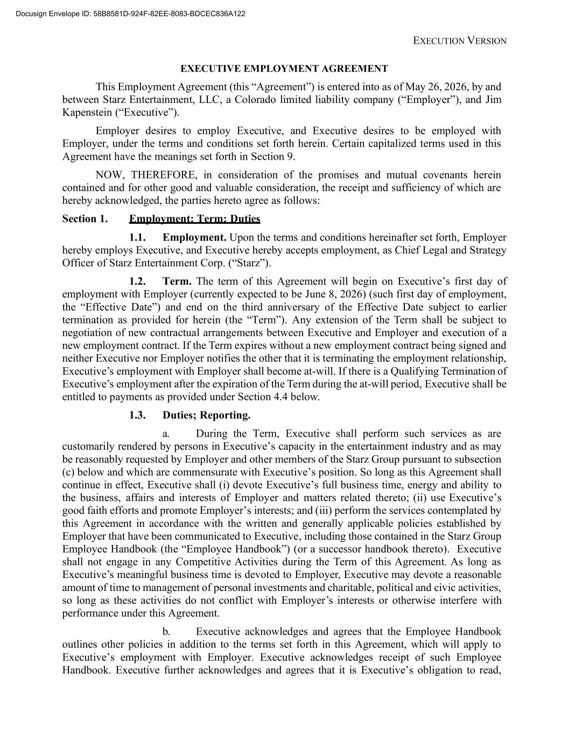
48
EXECUTION VERSION EXECUTIVE EMPLOYMENT AGREEMENT This Employment Agreement (this “Agreement”) is entered into as of May 26, 2026, by and between Starz Entertainment, LLC, a Colorado limited liability company (“Employer”), and Jim Kapenstein (“Executive”). Employer desires to employ Executive, and Executive desires to be employed with Employer, under the terms and conditions set forth herein. Certain capitalized terms used in this Agreement have the meanings set forth in Section 9. NOW, THEREFORE, in consideration of the promises and mutual covenants herein contained and for other good and valuable consideration, the receipt and sufficiency of which are hereby acknowledged, the parties hereto agree as follows: Section 1. Employment; Term; Duties 1.1. Employment. Upon the terms and conditions hereinafter set forth, Employer hereby employs Executive, and Executive hereby accepts employment, as Chief Legal and Strategy Officer of Starz Entertainment Corp. (“Starz”). 1.2. Term. The term of this Agreement will begin on Executive’s first day of employment with Employer (currently expected to be June 8, 2026) (such first day of employment, the “Effective Date”) and end on the third anniversary of the Effective Date subject to earlier termination as provided for herein (the “Term”). Any extension of the Term shall be subject to negotiation of new contractual arrangements between Executive and Employer and execution of a new employment contract. If the Term expires without a new employment contract being signed and neither Executive nor Employer notifies the other that it is terminating the employment relationship, Executive’s employment with Employer shall become at-will. If there is a Qualifying Termination of Executive’s employment after the expiration of the Term during the at-will period, Executive shall be entitled to payments as provided under Section 4.4 below. 1.3. Duties; Reporting. a. During the Term, Executive shall perform such services as are customarily rendered by persons in Executive’s capacity in the entertainment industry and as may be reasonably requested by Employer and other members of the Starz Group pursuant to subsection (c) below and which are commensurate with Executive’s position. So long as this Agreement shall continue in effect, Executive shall (i) devote Executive’s full business time, energy and ability to the business, affairs and interests of Employer and matters related thereto; (ii) use Executive’s good faith efforts and promote Employer’s interests; and (iii) perform the services contemplated by this Agreement in accordance with the written and generally applicable policies established by Employer that have been communicated to Executive, including those contained in the Starz Group Employee Handbook (the “Employee Handbook”) (or a successor handbook thereto). Executive shall not engage in any Competitive Activities during the Term of this Agreement. As long as Executive’s meaningful business time is devoted to Employer, Executive may devote a reasonable amount of time to management of personal investments and charitable, political and civic activities, so long as these activities do not conflict with Employer’s interests or otherwise interfere with performance under this Agreement. b. Executive acknowledges and agrees that the Employee Handbook outlines other policies in addition to the terms set forth in this Agreement, which will apply to Executive’s employment with Employer. Executive acknowledges receipt of such Employee Handbook. Executive further acknowledges and agrees that it is Executive’s obligation to read, ?"?%$??!??!&? "#??????? ? ? ????? ?? ???? ? ?????? ?????

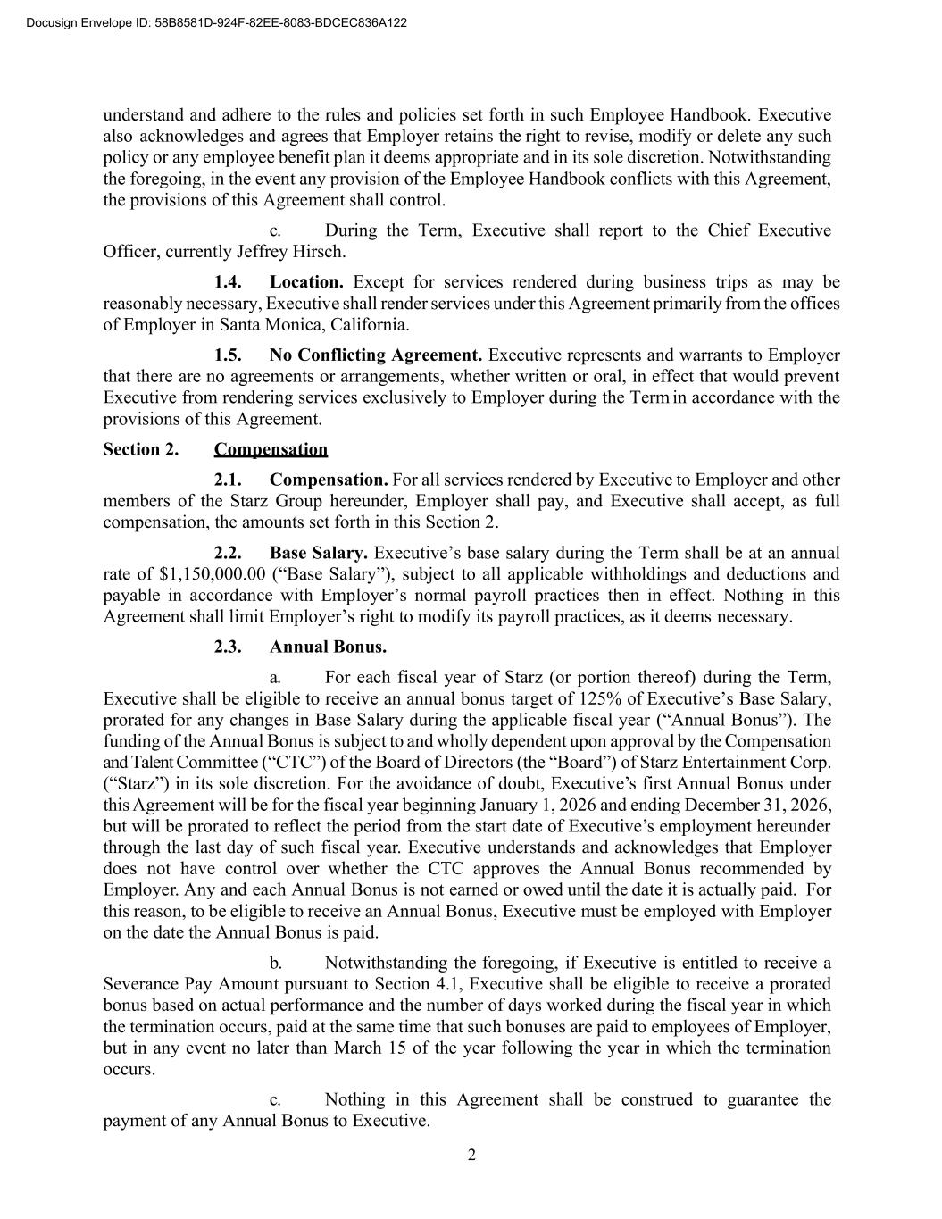
2 understand and adhere to the rules and policies set forth in such Employee Handbook. Executive also acknowledges and agrees that Employer retains the right to revise, modify or delete any such policy or any employee benefit plan it deems appropriate and in its sole discretion. Notwithstanding the foregoing, in the event any provision of the Employee Handbook conflicts with this Agreement, the provisions of this Agreement shall control. c. During the Term, Executive shall report to the Chief Executive Officer, currently Jeffrey Hirsch. 1.4. Location. Except for services rendered during business trips as may be reasonably necessary, Executive shall render services under this Agreement primarily from the offices of Employer in Santa Monica, California. 1.5. No Conflicting Agreement. Executive represents and warrants to Employer that there are no agreements or arrangements, whether written or oral, in effect that would prevent Executive from rendering services exclusively to Employer during the Term in accordance with the provisions of this Agreement. Section 2. Compensation 2.1. Compensation. For all services rendered by Executive to Employer and other members of the Starz Group hereunder, Employer shall pay, and Executive shall accept, as full compensation, the amounts set forth in this Section 2. 2.2. Base Salary. Executive’s base salary during the Term shall be at an annual rate of $1,150,000.00 (“Base Salary”), subject to all applicable withholdings and deductions and payable in accordance with Employer’s normal payroll practices then in effect. Nothing in this Agreement shall limit Employer’s right to modify its payroll practices, as it deems necessary. 2.3. Annual Bonus. a. For each fiscal year of Starz (or portion thereof) during the Term, Executive shall be eligible to receive an annual bonus target of 125% of Executive’s Base Salary, prorated for any changes in Base Salary during the applicable fiscal year (“Annual Bonus”). The funding of the Annual Bonus is subject to and wholly dependent upon approval by the Compensation and Talent Committee (“CTC”) of the Board of Directors (the “Board”) of Starz Entertainment Corp. (“Starz”) in its sole discretion. For the avoidance of doubt, Executive’s first Annual Bonus under this Agreement will be for the fiscal year beginning January 1, 2026 and ending December 31, 2026, but will be prorated to reflect the period from the start date of Executive’s employment hereunder through the last day of such fiscal year. Executive understands and acknowledges that Employer does not have control over whether the CTC approves the Annual Bonus recommended by Employer. Any and each Annual Bonus is not earned or owed until the date it is actually paid. For this reason, to be eligible to receive an Annual Bonus, Executive must be employed with Employer on the date the Annual Bonus is paid. b. Notwithstanding the foregoing, if Executive is entitled to receive a Severance Pay Amount pursuant to Section 4.1, Executive shall be eligible to receive a prorated bonus based on actual performance and the number of days worked during the fiscal year in which the termination occurs, paid at the same time that such bonuses are paid to employees of Employer, but in any event no later than March 15 of the year following the year in which the termination occurs. c. Nothing in this Agreement shall be construed to guarantee the payment of any Annual Bonus to Executive. ?"?%$??!??!&? "#??????? ? ? ????? ?? ???? ? ?????? ?????

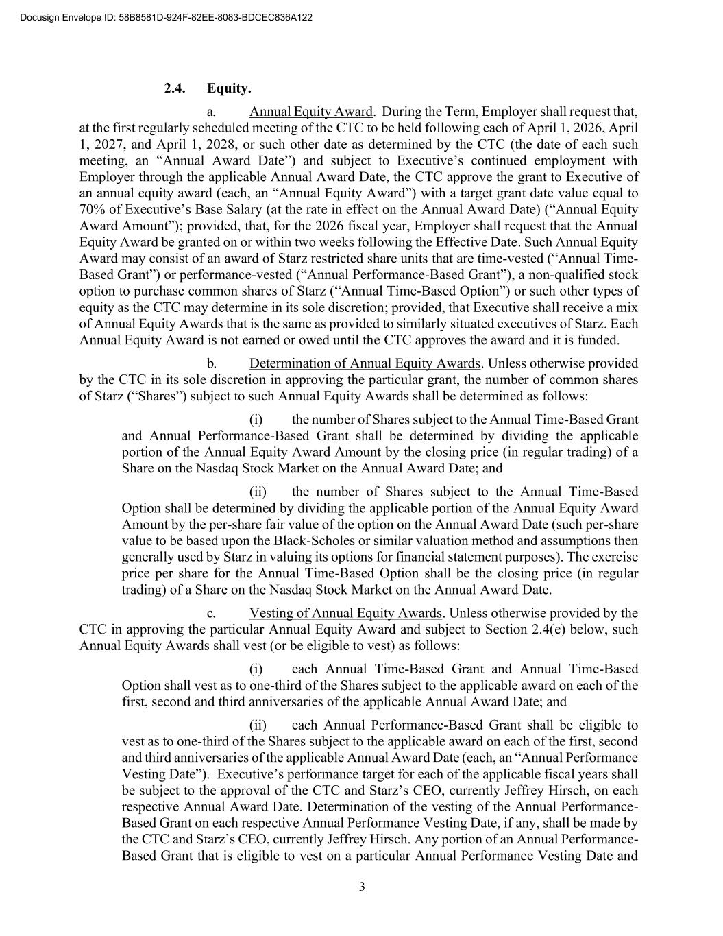
3 2.4. Equity. a. Annual Equity Award. During the Term, Employer shall request that, at the first regularly scheduled meeting of the CTC to be held following each of April 1, 2026, April 1, 2027, and April 1, 2028, or such other date as determined by the CTC (the date of each such meeting, an “Annual Award Date”) and subject to Executive’s continued employment with Employer through the applicable Annual Award Date, the CTC approve the grant to Executive of an annual equity award (each, an “Annual Equity Award”) with a target grant date value equal to 70% of Executive’s Base Salary (at the rate in effect on the Annual Award Date) (“Annual Equity Award Amount”); provided, that, for the 2026 fiscal year, Employer shall request that the Annual Equity Award be granted on or within two weeks following the Effective Date. Such Annual Equity Award may consist of an award of Starz restricted share units that are time-vested (“Annual Time- Based Grant”) or performance-vested (“Annual Performance-Based Grant”), a non-qualified stock option to purchase common shares of Starz (“Annual Time-Based Option”) or such other types of equity as the CTC may determine in its sole discretion; provided, that Executive shall receive a mix of Annual Equity Awards that is the same as provided to similarly situated executives of Starz. Each Annual Equity Award is not earned or owed until the CTC approves the award and it is funded. b. Determination of Annual Equity Awards. Unless otherwise provided by the CTC in its sole discretion in approving the particular grant, the number of common shares of Starz (“Shares”) subject to such Annual Equity Awards shall be determined as follows: (i) the number of Shares subject to the Annual Time-Based Grant and Annual Performance-Based Grant shall be determined by dividing the applicable portion of the Annual Equity Award Amount by the closing price (in regular trading) of a Share on the Nasdaq Stock Market on the Annual Award Date; and (ii) the number of Shares subject to the Annual Time-Based Option shall be determined by dividing the applicable portion of the Annual Equity Award Amount by the per-share fair value of the option on the Annual Award Date (such per-share value to be based upon the Black-Scholes or similar valuation method and assumptions then generally used by Starz in valuing its options for financial statement purposes). The exercise price per share for the Annual Time-Based Option shall be the closing price (in regular trading) of a Share on the Nasdaq Stock Market on the Annual Award Date. c. Vesting of Annual Equity Awards. Unless otherwise provided by the CTC in approving the particular Annual Equity Award and subject to Section 2.4(e) below, such Annual Equity Awards shall vest (or be eligible to vest) as follows: (i) each Annual Time-Based Grant and Annual Time-Based Option shall vest as to one-third of the Shares subject to the applicable award on each of the first, second and third anniversaries of the applicable Annual Award Date; and (ii) each Annual Performance-Based Grant shall be eligible to vest as to one-third of the Shares subject to the applicable award on each of the first, second and third anniversaries of the applicable Annual Award Date (each, an “Annual Performance Vesting Date”). Executive’s performance target for each of the applicable fiscal years shall be subject to the approval of the CTC and Starz’s CEO, currently Jeffrey Hirsch, on each respective Annual Award Date. Determination of the vesting of the Annual Performance- Based Grant on each respective Annual Performance Vesting Date, if any, shall be made by the CTC and Starz’s CEO, currently Jeffrey Hirsch. Any portion of an Annual Performance- Based Grant that is eligible to vest on a particular Annual Performance Vesting Date and ?"?%$??!??!&? "#??????? ? ? ????? ?? ???? ? ?????? ?????

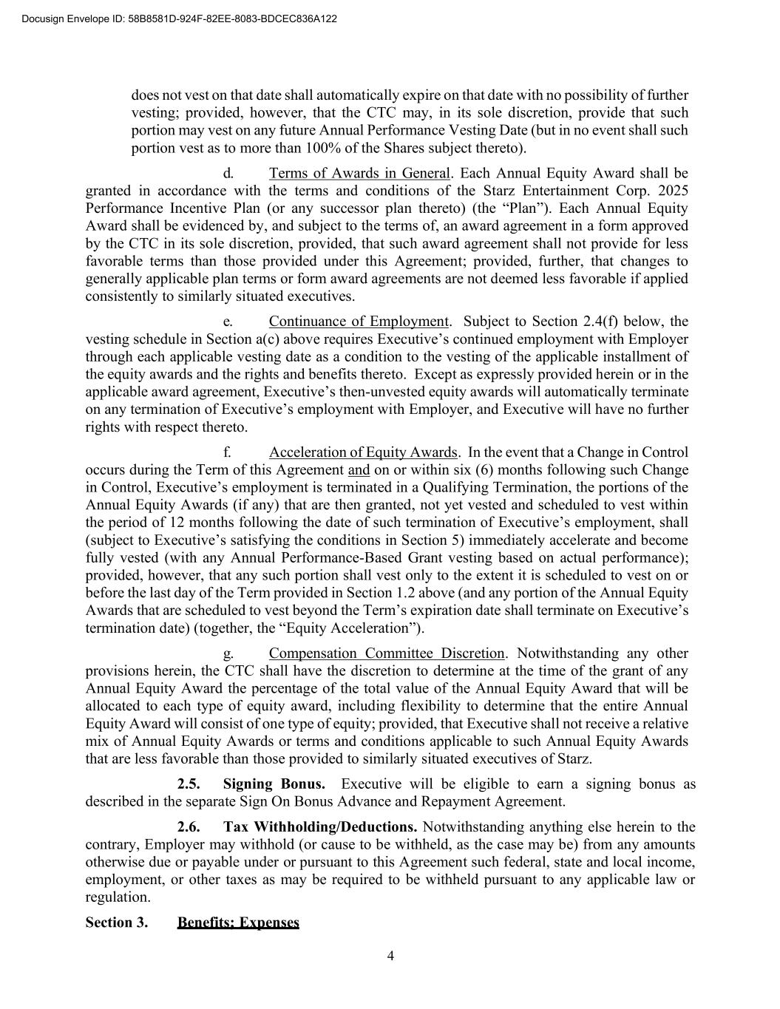
4 does not vest on that date shall automatically expire on that date with no possibility of further vesting; provided, however, that the CTC may, in its sole discretion, provide that such portion may vest on any future Annual Performance Vesting Date (but in no event shall such portion vest as to more than 100% of the Shares subject thereto). d. Terms of Awards in General. Each Annual Equity Award shall be granted in accordance with the terms and conditions of the Starz Entertainment Corp. 2025 Performance Incentive Plan (or any successor plan thereto) (the “Plan”). Each Annual Equity Award shall be evidenced by, and subject to the terms of, an award agreement in a form approved by the CTC in its sole discretion, provided, that such award agreement shall not provide for less favorable terms than those provided under this Agreement; provided, further, that changes to generally applicable plan terms or form award agreements are not deemed less favorable if applied consistently to similarly situated executives. e. Continuance of Employment. Subject to Section 2.4(f) below, the vesting schedule in Section a(c) above requires Executive’s continued employment with Employer through each applicable vesting date as a condition to the vesting of the applicable installment of the equity awards and the rights and benefits thereto. Except as expressly provided herein or in the applicable award agreement, Executive’s then-unvested equity awards will automatically terminate on any termination of Executive’s employment with Employer, and Executive will have no further rights with respect thereto. f. Acceleration of Equity Awards. In the event that a Change in Control occurs during the Term of this Agreement and on or within six (6) months following such Change in Control, Executive’s employment is terminated in a Qualifying Termination, the portions of the Annual Equity Awards (if any) that are then granted, not yet vested and scheduled to vest within the period of 12 months following the date of such termination of Executive’s employment, shall (subject to Executive’s satisfying the conditions in Section 5) immediately accelerate and become fully vested (with any Annual Performance-Based Grant vesting based on actual performance); provided, however, that any such portion shall vest only to the extent it is scheduled to vest on or before the last day of the Term provided in Section 1.2 above (and any portion of the Annual Equity Awards that are scheduled to vest beyond the Term’s expiration date shall terminate on Executive’s termination date) (together, the “Equity Acceleration”). g. Compensation Committee Discretion. Notwithstanding any other provisions herein, the CTC shall have the discretion to determine at the time of the grant of any Annual Equity Award the percentage of the total value of the Annual Equity Award that will be allocated to each type of equity award, including flexibility to determine that the entire Annual Equity Award will consist of one type of equity; provided, that Executive shall not receive a relative mix of Annual Equity Awards or terms and conditions applicable to such Annual Equity Awards that are less favorable than those provided to similarly situated executives of Starz. 2.5. Signing Bonus. Executive will be eligible to earn a signing bonus as described in the separate Sign On Bonus Advance and Repayment Agreement. 2.6. Tax Withholding/Deductions. Notwithstanding anything else herein to the contrary, Employer may withhold (or cause to be withheld, as the case may be) from any amounts otherwise due or payable under or pursuant to this Agreement such federal, state and local income, employment, or other taxes as may be required to be withheld pursuant to any applicable law or regulation. Section 3. Benefits; Expenses ?"?%$??!??!&? "#??????? ? ? ????? ?? ???? ? ?????? ?????

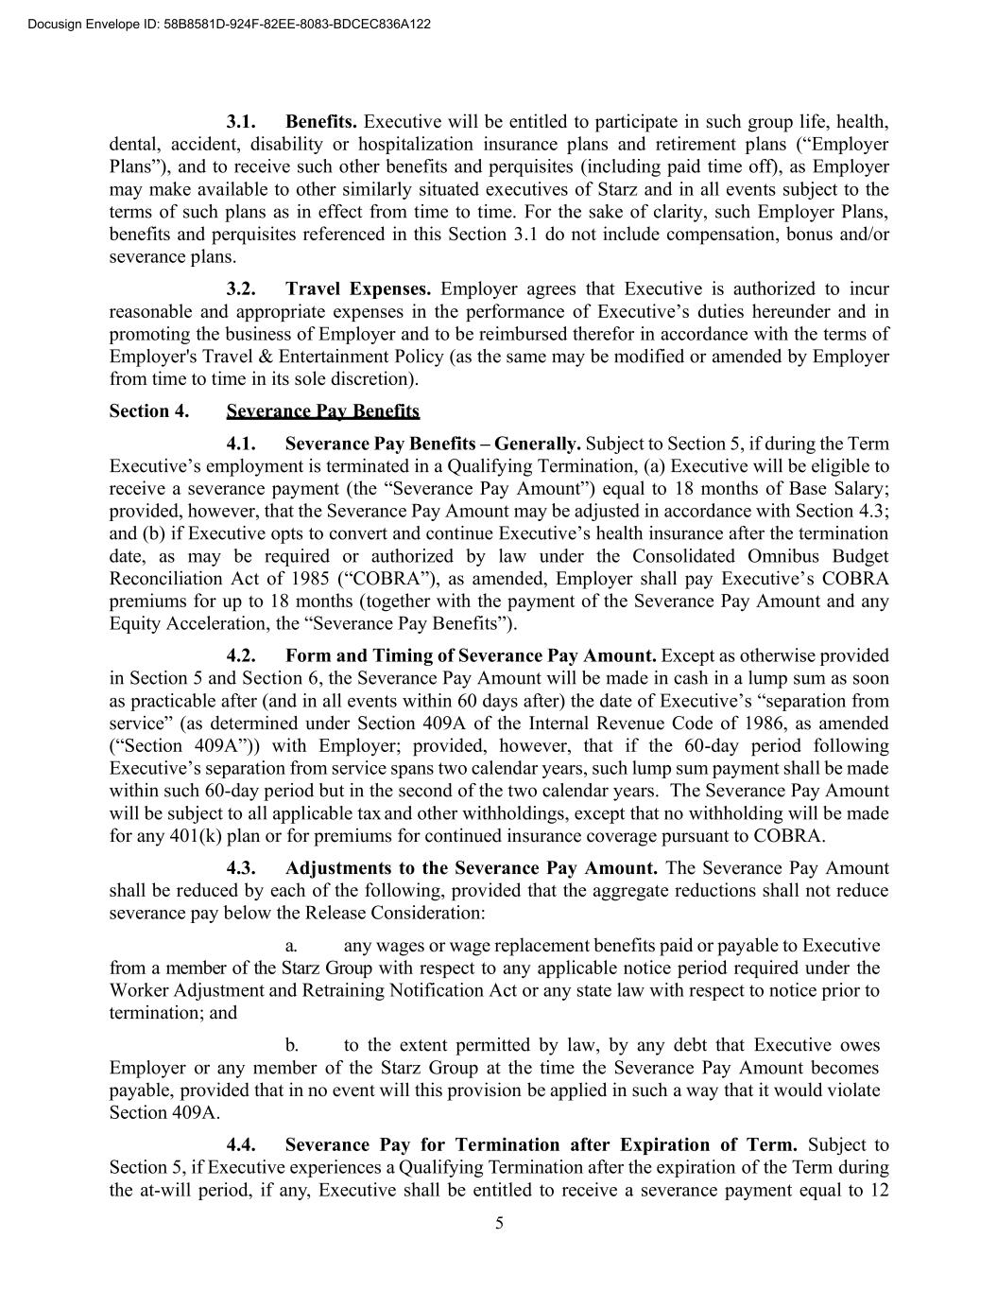
5 3.1. Benefits. Executive will be entitled to participate in such group life, health, dental, accident, disability or hospitalization insurance plans and retirement plans (“Employer Plans”), and to receive such other benefits and perquisites (including paid time off), as Employer may make available to other similarly situated executives of Starz and in all events subject to the terms of such plans as in effect from time to time. For the sake of clarity, such Employer Plans, benefits and perquisites referenced in this Section 3.1 do not include compensation, bonus and/or severance plans. 3.2. Travel Expenses. Employer agrees that Executive is authorized to incur reasonable and appropriate expenses in the performance of Executive’s duties hereunder and in promoting the business of Employer and to be reimbursed therefor in accordance with the terms of Employer's Travel & Entertainment Policy (as the same may be modified or amended by Employer from time to time in its sole discretion). Section 4. Severance Pay Benefits 4.1. Severance Pay Benefits – Generally. Subject to Section 5, if during the Term Executive’s employment is terminated in a Qualifying Termination, (a) Executive will be eligible to receive a severance payment (the “Severance Pay Amount”) equal to 18 months of Base Salary; provided, however, that the Severance Pay Amount may be adjusted in accordance with Section 4.3; and (b) if Executive opts to convert and continue Executive’s health insurance after the termination date, as may be required or authorized by law under the Consolidated Omnibus Budget Reconciliation Act of 1985 (“COBRA”), as amended, Employer shall pay Executive’s COBRA premiums for up to 18 months (together with the payment of the Severance Pay Amount and any Equity Acceleration, the “Severance Pay Benefits”). 4.2. Form and Timing of Severance Pay Amount. Except as otherwise provided in Section 5 and Section 6, the Severance Pay Amount will be made in cash in a lump sum as soon as practicable after (and in all events within 60 days after) the date of Executive’s “separation from service” (as determined under Section 409A of the Internal Revenue Code of 1986, as amended (“Section 409A”)) with Employer; provided, however, that if the 60-day period following Executive’s separation from service spans two calendar years, such lump sum payment shall be made within such 60-day period but in the second of the two calendar years. The Severance Pay Amount will be subject to all applicable tax and other withholdings, except that no withholding will be made for any 401(k) plan or for premiums for continued insurance coverage pursuant to COBRA. 4.3. Adjustments to the Severance Pay Amount. The Severance Pay Amount shall be reduced by each of the following, provided that the aggregate reductions shall not reduce severance pay below the Release Consideration: a. any wages or wage replacement benefits paid or payable to Executive from a member of the Starz Group with respect to any applicable notice period required under the Worker Adjustment and Retraining Notification Act or any state law with respect to notice prior to termination; and b. to the extent permitted by law, by any debt that Executive owes Employer or any member of the Starz Group at the time the Severance Pay Amount becomes payable, provided that in no event will this provision be applied in such a way that it would violate Section 409A. 4.4. Severance Pay for Termination after Expiration of Term. Subject to Section 5, if Executive experiences a Qualifying Termination after the expiration of the Term during the at-will period, if any, Executive shall be entitled to receive a severance payment equal to 12 ?"?%$??!??!&? "#??????? ? ? ????? ?? ???? ? ?????? ?????

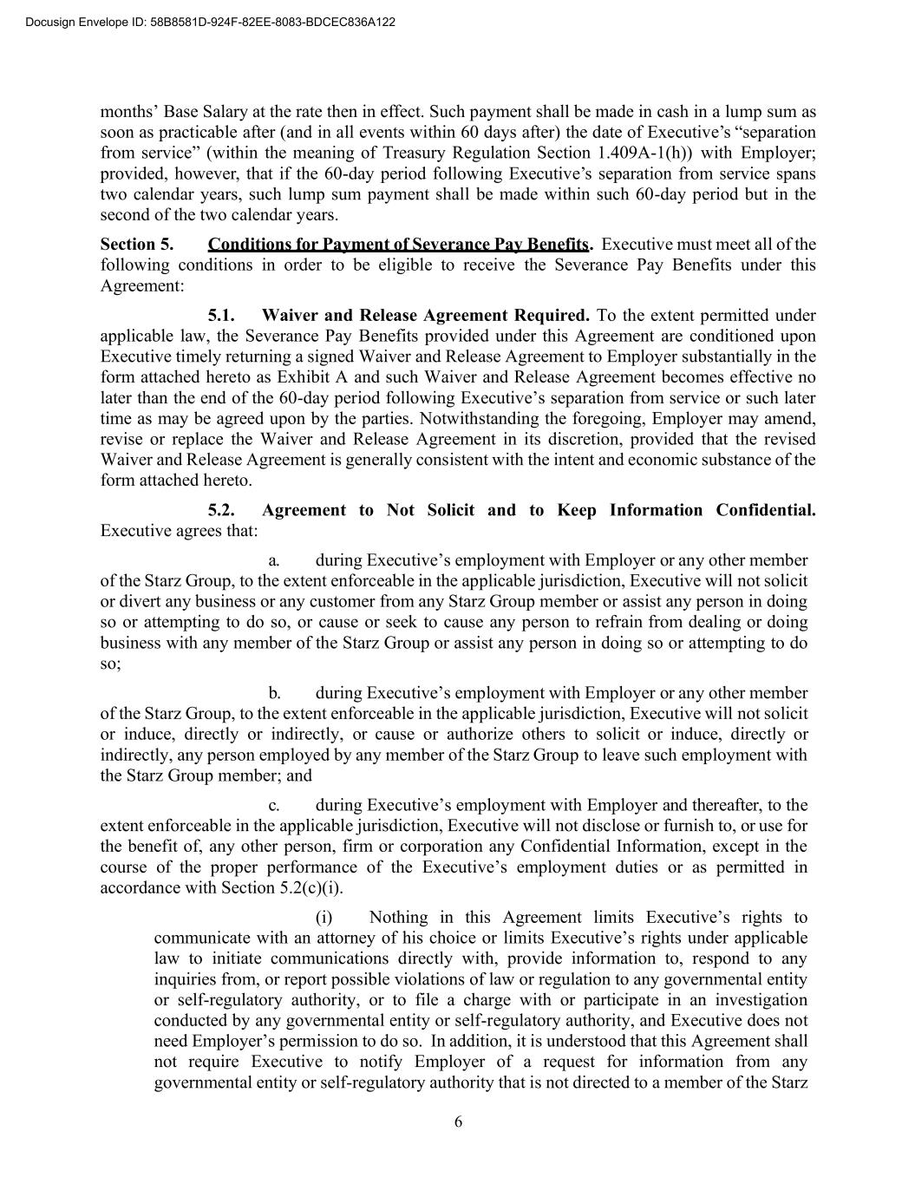
6 months’ Base Salary at the rate then in effect. Such payment shall be made in cash in a lump sum as soon as practicable after (and in all events within 60 days after) the date of Executive’s “separation from service” (within the meaning of Treasury Regulation Section 1.409A-1(h)) with Employer; provided, however, that if the 60-day period following Executive’s separation from service spans two calendar years, such lump sum payment shall be made within such 60-day period but in the second of the two calendar years. Section 5. Conditions for Payment of Severance Pay Benefits. Executive must meet all of the following conditions in order to be eligible to receive the Severance Pay Benefits under this Agreement: 5.1. Waiver and Release Agreement Required. To the extent permitted under applicable law, the Severance Pay Benefits provided under this Agreement are conditioned upon Executive timely returning a signed Waiver and Release Agreement to Employer substantially in the form attached hereto as Exhibit A and such Waiver and Release Agreement becomes effective no later than the end of the 60-day period following Executive’s separation from service or such later time as may be agreed upon by the parties. Notwithstanding the foregoing, Employer may amend, revise or replace the Waiver and Release Agreement in its discretion, provided that the revised Waiver and Release Agreement is generally consistent with the intent and economic substance of the form attached hereto. 5.2. Agreement to Not Solicit and to Keep Information Confidential. Executive agrees that: a. during Executive’s employment with Employer or any other member of the Starz Group, to the extent enforceable in the applicable jurisdiction, Executive will not solicit or divert any business or any customer from any Starz Group member or assist any person in doing so or attempting to do so, or cause or seek to cause any person to refrain from dealing or doing business with any member of the Starz Group or assist any person in doing so or attempting to do so; b. during Executive’s employment with Employer or any other member of the Starz Group, to the extent enforceable in the applicable jurisdiction, Executive will not solicit or induce, directly or indirectly, or cause or authorize others to solicit or induce, directly or indirectly, any person employed by any member of the Starz Group to leave such employment with the Starz Group member; and c. during Executive’s employment with Employer and thereafter, to the extent enforceable in the applicable jurisdiction, Executive will not disclose or furnish to, or use for the benefit of, any other person, firm or corporation any Confidential Information, except in the course of the proper performance of the Executive’s employment duties or as permitted in accordance with Section 5.2(c)(i). (i) Nothing in this Agreement limits Executive’s rights to communicate with an attorney of his choice or limits Executive’s rights under applicable law to initiate communications directly with, provide information to, respond to any inquiries from, or report possible violations of law or regulation to any governmental entity or self-regulatory authority, or to file a charge with or participate in an investigation conducted by any governmental entity or self-regulatory authority, and Executive does not need Employer’s permission to do so. In addition, it is understood that this Agreement shall not require Executive to notify Employer of a request for information from any governmental entity or self-regulatory authority that is not directed to a member of the Starz ?"?%$??!??!&? "#??????? ? ? ????? ?? ???? ? ?????? ?????

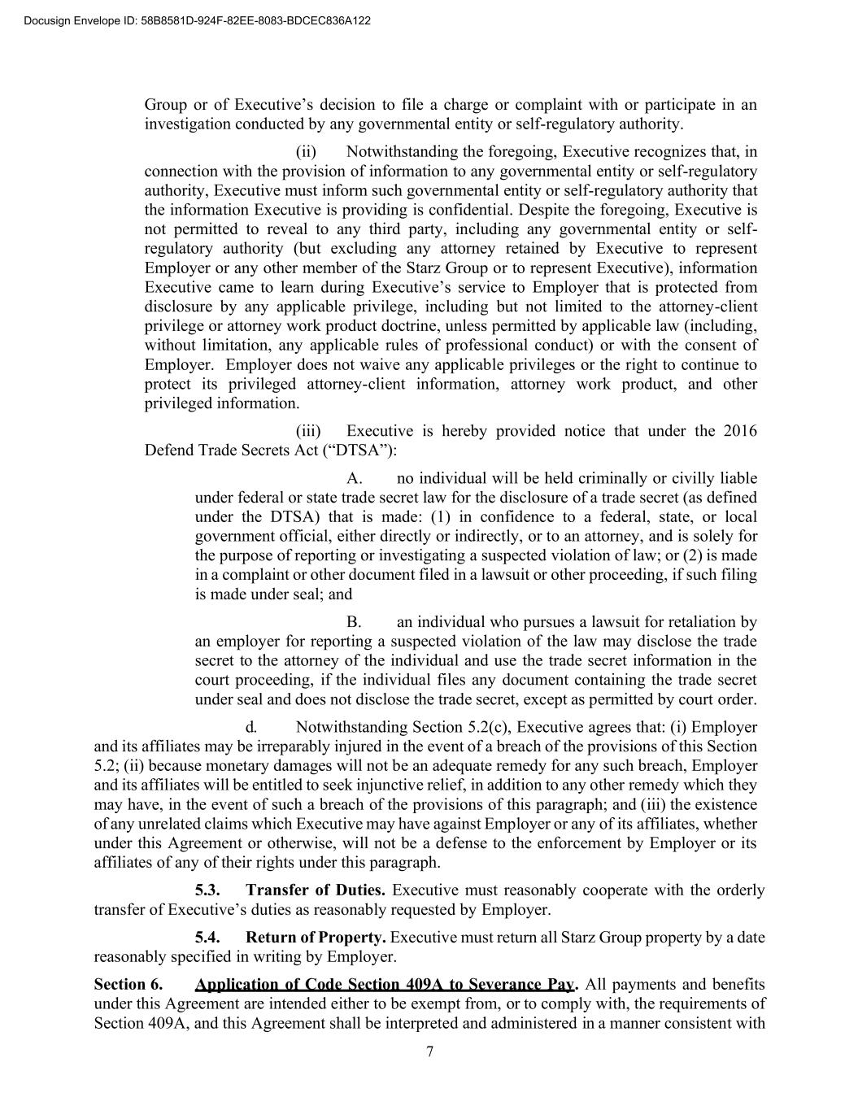
7 Group or of Executive’s decision to file a charge or complaint with or participate in an investigation conducted by any governmental entity or self-regulatory authority. (ii) Notwithstanding the foregoing, Executive recognizes that, in connection with the provision of information to any governmental entity or self-regulatory authority, Executive must inform such governmental entity or self-regulatory authority that the information Executive is providing is confidential. Despite the foregoing, Executive is not permitted to reveal to any third party, including any governmental entity or self- regulatory authority (but excluding any attorney retained by Executive to represent Employer or any other member of the Starz Group or to represent Executive), information Executive came to learn during Executive’s service to Employer that is protected from disclosure by any applicable privilege, including but not limited to the attorney-client privilege or attorney work product doctrine, unless permitted by applicable law (including, without limitation, any applicable rules of professional conduct) or with the consent of Employer. Employer does not waive any applicable privileges or the right to continue to protect its privileged attorney-client information, attorney work product, and other privileged information. (iii) Executive is hereby provided notice that under the 2016 Defend Trade Secrets Act (“DTSA”): A. no individual will be held criminally or civilly liable under federal or state trade secret law for the disclosure of a trade secret (as defined under the DTSA) that is made: (1) in confidence to a federal, state, or local government official, either directly or indirectly, or to an attorney, and is solely for the purpose of reporting or investigating a suspected violation of law; or (2) is made in a complaint or other document filed in a lawsuit or other proceeding, if such filing is made under seal; and B. an individual who pursues a lawsuit for retaliation by an employer for reporting a suspected violation of the law may disclose the trade secret to the attorney of the individual and use the trade secret information in the court proceeding, if the individual files any document containing the trade secret under seal and does not disclose the trade secret, except as permitted by court order. d. Notwithstanding Section 5.2(c), Executive agrees that: (i) Employer and its affiliates may be irreparably injured in the event of a breach of the provisions of this Section 5.2; (ii) because monetary damages will not be an adequate remedy for any such breach, Employer and its affiliates will be entitled to seek injunctive relief, in addition to any other remedy which they may have, in the event of such a breach of the provisions of this paragraph; and (iii) the existence of any unrelated claims which Executive may have against Employer or any of its affiliates, whether under this Agreement or otherwise, will not be a defense to the enforcement by Employer or its affiliates of any of their rights under this paragraph. 5.3. Transfer of Duties. Executive must reasonably cooperate with the orderly transfer of Executive’s duties as reasonably requested by Employer. 5.4. Return of Property. Executive must return all Starz Group property by a date reasonably specified in writing by Employer. Section 6. Application of Code Section 409A to Severance Pay. All payments and benefits under this Agreement are intended either to be exempt from, or to comply with, the requirements of Section 409A, and this Agreement shall be interpreted and administered in a manner consistent with ?"?%$??!??!&? "#??????? ? ? ????? ?? ???? ? ?????? ?????

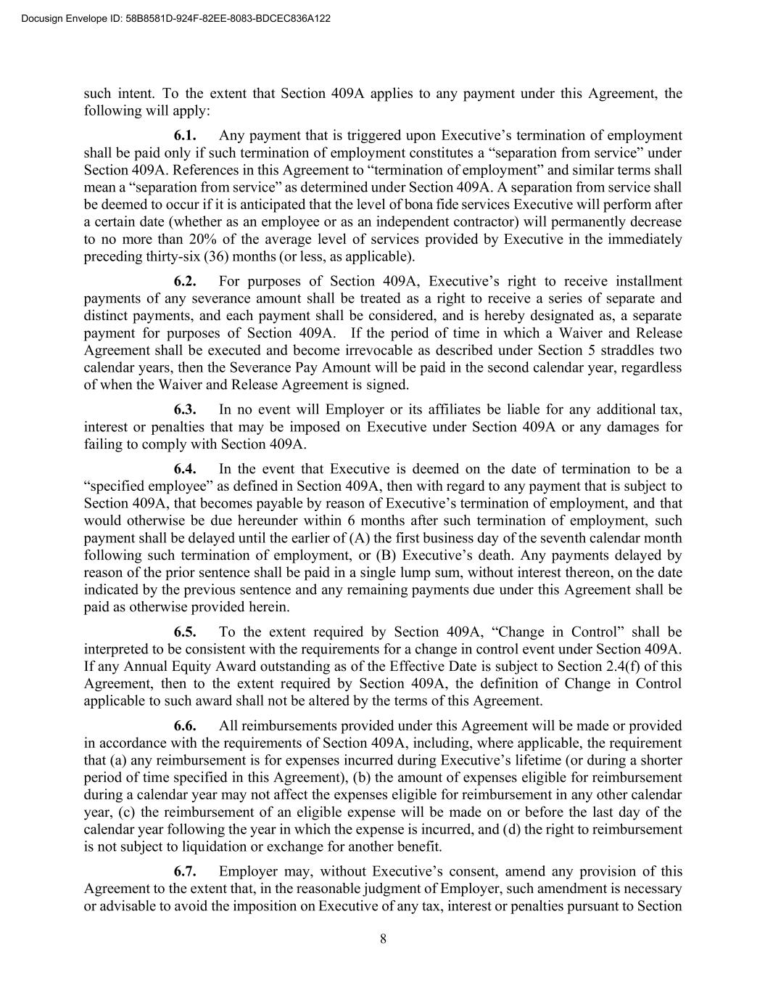
8 such intent. To the extent that Section 409A applies to any payment under this Agreement, the following will apply: 6.1. Any payment that is triggered upon Executive’s termination of employment shall be paid only if such termination of employment constitutes a “separation from service” under Section 409A. References in this Agreement to “termination of employment” and similar terms shall mean a “separation from service” as determined under Section 409A. A separation from service shall be deemed to occur if it is anticipated that the level of bona fide services Executive will perform after a certain date (whether as an employee or as an independent contractor) will permanently decrease to no more than 20% of the average level of services provided by Executive in the immediately preceding thirty-six (36) months (or less, as applicable). 6.2. For purposes of Section 409A, Executive’s right to receive installment payments of any severance amount shall be treated as a right to receive a series of separate and distinct payments, and each payment shall be considered, and is hereby designated as, a separate payment for purposes of Section 409A. If the period of time in which a Waiver and Release Agreement shall be executed and become irrevocable as described under Section 5 straddles two calendar years, then the Severance Pay Amount will be paid in the second calendar year, regardless of when the Waiver and Release Agreement is signed. 6.3. In no event will Employer or its affiliates be liable for any additional tax, interest or penalties that may be imposed on Executive under Section 409A or any damages for failing to comply with Section 409A. 6.4. In the event that Executive is deemed on the date of termination to be a “specified employee” as defined in Section 409A, then with regard to any payment that is subject to Section 409A, that becomes payable by reason of Executive’s termination of employment, and that would otherwise be due hereunder within 6 months after such termination of employment, such payment shall be delayed until the earlier of (A) the first business day of the seventh calendar month following such termination of employment, or (B) Executive’s death. Any payments delayed by reason of the prior sentence shall be paid in a single lump sum, without interest thereon, on the date indicated by the previous sentence and any remaining payments due under this Agreement shall be paid as otherwise provided herein. 6.5. To the extent required by Section 409A, “Change in Control” shall be interpreted to be consistent with the requirements for a change in control event under Section 409A. If any Annual Equity Award outstanding as of the Effective Date is subject to Section 2.4(f) of this Agreement, then to the extent required by Section 409A, the definition of Change in Control applicable to such award shall not be altered by the terms of this Agreement. 6.6. All reimbursements provided under this Agreement will be made or provided in accordance with the requirements of Section 409A, including, where applicable, the requirement that (a) any reimbursement is for expenses incurred during Executive’s lifetime (or during a shorter period of time specified in this Agreement), (b) the amount of expenses eligible for reimbursement during a calendar year may not affect the expenses eligible for reimbursement in any other calendar year, (c) the reimbursement of an eligible expense will be made on or before the last day of the calendar year following the year in which the expense is incurred, and (d) the right to reimbursement is not subject to liquidation or exchange for another benefit. 6.7. Employer may, without Executive’s consent, amend any provision of this Agreement to the extent that, in the reasonable judgment of Employer, such amendment is necessary or advisable to avoid the imposition on Executive of any tax, interest or penalties pursuant to Section ?"?%$??!??!&? "#??????? ? ? ????? ?? ???? ? ?????? ?????

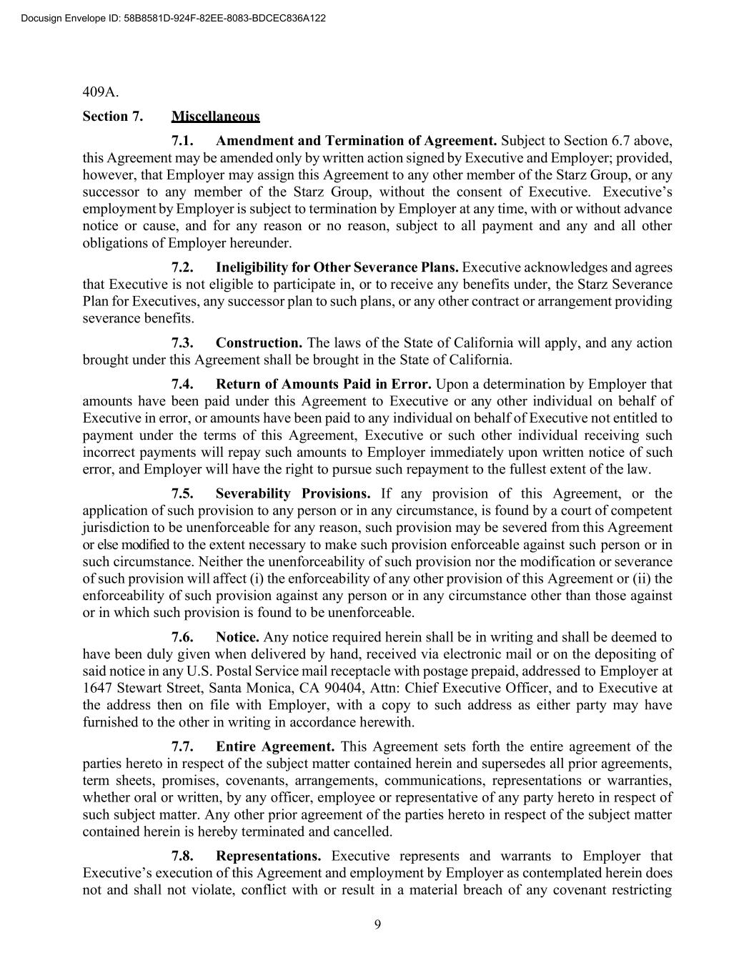
9 409A. Section 7. Miscellaneous 7.1. Amendment and Termination of Agreement. Subject to Section 6.7 above, this Agreement may be amended only by written action signed by Executive and Employer; provided, however, that Employer may assign this Agreement to any other member of the Starz Group, or any successor to any member of the Starz Group, without the consent of Executive. Executive’s employment by Employer is subject to termination by Employer at any time, with or without advance notice or cause, and for any reason or no reason, subject to all payment and any and all other obligations of Employer hereunder. 7.2. Ineligibility for Other Severance Plans. Executive acknowledges and agrees that Executive is not eligible to participate in, or to receive any benefits under, the Starz Severance Plan for Executives, any successor plan to such plans, or any other contract or arrangement providing severance benefits. 7.3. Construction. The laws of the State of California will apply, and any action brought under this Agreement shall be brought in the State of California. 7.4. Return of Amounts Paid in Error. Upon a determination by Employer that amounts have been paid under this Agreement to Executive or any other individual on behalf of Executive in error, or amounts have been paid to any individual on behalf of Executive not entitled to payment under the terms of this Agreement, Executive or such other individual receiving such incorrect payments will repay such amounts to Employer immediately upon written notice of such error, and Employer will have the right to pursue such repayment to the fullest extent of the law. 7.5. Severability Provisions. If any provision of this Agreement, or the application of such provision to any person or in any circumstance, is found by a court of competent jurisdiction to be unenforceable for any reason, such provision may be severed from this Agreement or else modified to the extent necessary to make such provision enforceable against such person or in such circumstance. Neither the unenforceability of such provision nor the modification or severance of such provision will affect (i) the enforceability of any other provision of this Agreement or (ii) the enforceability of such provision against any person or in any circumstance other than those against or in which such provision is found to be unenforceable. 7.6. Notice. Any notice required herein shall be in writing and shall be deemed to have been duly given when delivered by hand, received via electronic mail or on the depositing of said notice in any U.S. Postal Service mail receptacle with postage prepaid, addressed to Employer at 1647 Stewart Street, Santa Monica, CA 90404, Attn: Chief Executive Officer, and to Executive at the address then on file with Employer, with a copy to such address as either party may have furnished to the other in writing in accordance herewith. 7.7. Entire Agreement. This Agreement sets forth the entire agreement of the parties hereto in respect of the subject matter contained herein and supersedes all prior agreements, term sheets, promises, covenants, arrangements, communications, representations or warranties, whether oral or written, by any officer, employee or representative of any party hereto in respect of such subject matter. Any other prior agreement of the parties hereto in respect of the subject matter contained herein is hereby terminated and cancelled. 7.8. Representations. Executive represents and warrants to Employer that Executive’s execution of this Agreement and employment by Employer as contemplated herein does not and shall not violate, conflict with or result in a material breach of any covenant restricting ?"?%$??!??!&? "#??????? ? ? ????? ?? ???? ? ?????? ?????

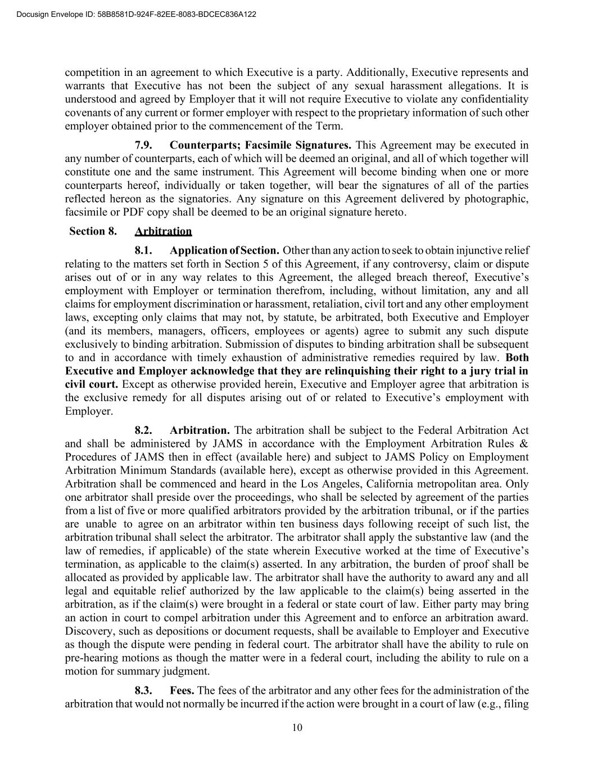
10 competition in an agreement to which Executive is a party. Additionally, Executive represents and warrants that Executive has not been the subject of any sexual harassment allegations. It is understood and agreed by Employer that it will not require Executive to violate any confidentiality covenants of any current or former employer with respect to the proprietary information of such other employer obtained prior to the commencement of the Term. 7.9. Counterparts; Facsimile Signatures. This Agreement may be executed in any number of counterparts, each of which will be deemed an original, and all of which together will constitute one and the same instrument. This Agreement will become binding when one or more counterparts hereof, individually or taken together, will bear the signatures of all of the parties reflected hereon as the signatories. Any signature on this Agreement delivered by photographic, facsimile or PDF copy shall be deemed to be an original signature hereto. Section 8. Arbitration 8.1. Application of Section. Other than any action to seek to obtain injunctive relief relating to the matters set forth in Section 5 of this Agreement, if any controversy, claim or dispute arises out of or in any way relates to this Agreement, the alleged breach thereof, Executive’s employment with Employer or termination therefrom, including, without limitation, any and all claims for employment discrimination or harassment, retaliation, civil tort and any other employment laws, excepting only claims that may not, by statute, be arbitrated, both Executive and Employer (and its members, managers, officers, employees or agents) agree to submit any such dispute exclusively to binding arbitration. Submission of disputes to binding arbitration shall be subsequent to and in accordance with timely exhaustion of administrative remedies required by law. Both Executive and Employer acknowledge that they are relinquishing their right to a jury trial in civil court. Except as otherwise provided herein, Executive and Employer agree that arbitration is the exclusive remedy for all disputes arising out of or related to Executive’s employment with Employer. 8.2. Arbitration. The arbitration shall be subject to the Federal Arbitration Act and shall be administered by JAMS in accordance with the Employment Arbitration Rules & Procedures of JAMS then in effect (available here) and subject to JAMS Policy on Employment Arbitration Minimum Standards (available here), except as otherwise provided in this Agreement. Arbitration shall be commenced and heard in the Los Angeles, California metropolitan area. Only one arbitrator shall preside over the proceedings, who shall be selected by agreement of the parties from a list of five or more qualified arbitrators provided by the arbitration tribunal, or if the parties are unable to agree on an arbitrator within ten business days following receipt of such list, the arbitration tribunal shall select the arbitrator. The arbitrator shall apply the substantive law (and the law of remedies, if applicable) of the state wherein Executive worked at the time of Executive’s termination, as applicable to the claim(s) asserted. In any arbitration, the burden of proof shall be allocated as provided by applicable law. The arbitrator shall have the authority to award any and all legal and equitable relief authorized by the law applicable to the claim(s) being asserted in the arbitration, as if the claim(s) were brought in a federal or state court of law. Either party may bring an action in court to compel arbitration under this Agreement and to enforce an arbitration award. Discovery, such as depositions or document requests, shall be available to Employer and Executive as though the dispute were pending in federal court. The arbitrator shall have the ability to rule on pre-hearing motions as though the matter were in a federal court, including the ability to rule on a motion for summary judgment. 8.3. Fees. The fees of the arbitrator and any other fees for the administration of the arbitration that would not normally be incurred if the action were brought in a court of law (e.g., filing ?"?%$??!??!&? "#??????? ? ? ????? ?? ???? ? ?????? ?????

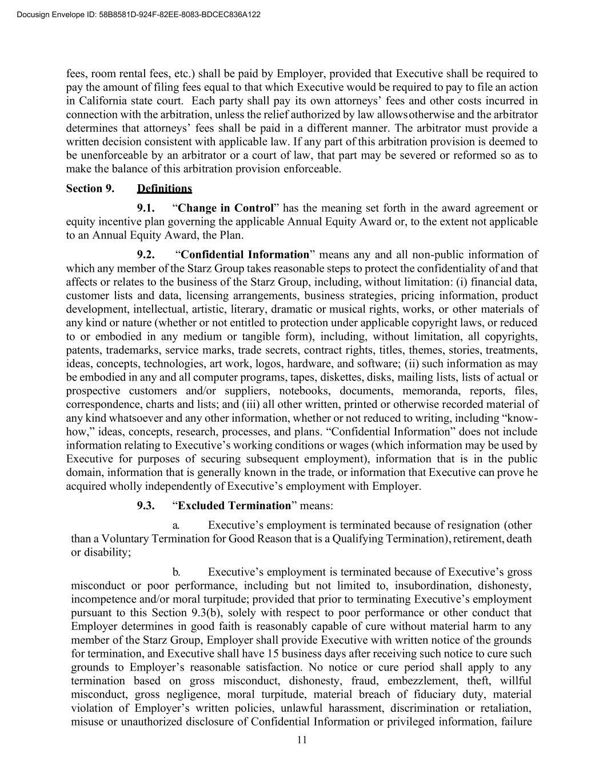
11 fees, room rental fees, etc.) shall be paid by Employer, provided that Executive shall be required to pay the amount of filing fees equal to that which Executive would be required to pay to file an action in California state court. Each party shall pay its own attorneys’ fees and other costs incurred in connection with the arbitration, unless the relief authorized by law allows otherwise and the arbitrator determines that attorneys’ fees shall be paid in a different manner. The arbitrator must provide a written decision consistent with applicable law. If any part of this arbitration provision is deemed to be unenforceable by an arbitrator or a court of law, that part may be severed or reformed so as to make the balance of this arbitration provision enforceable. Section 9. Definitions 9.1. “Change in Control” has the meaning set forth in the award agreement or equity incentive plan governing the applicable Annual Equity Award or, to the extent not applicable to an Annual Equity Award, the Plan. 9.2. “Confidential Information” means any and all non-public information of which any member of the Starz Group takes reasonable steps to protect the confidentiality of and that affects or relates to the business of the Starz Group, including, without limitation: (i) financial data, customer lists and data, licensing arrangements, business strategies, pricing information, product development, intellectual, artistic, literary, dramatic or musical rights, works, or other materials of any kind or nature (whether or not entitled to protection under applicable copyright laws, or reduced to or embodied in any medium or tangible form), including, without limitation, all copyrights, patents, trademarks, service marks, trade secrets, contract rights, titles, themes, stories, treatments, ideas, concepts, technologies, art work, logos, hardware, and software; (ii) such information as may be embodied in any and all computer programs, tapes, diskettes, disks, mailing lists, lists of actual or prospective customers and/or suppliers, notebooks, documents, memoranda, reports, files, correspondence, charts and lists; and (iii) all other written, printed or otherwise recorded material of any kind whatsoever and any other information, whether or not reduced to writing, including “know- how,” ideas, concepts, research, processes, and plans. “Confidential Information” does not include information relating to Executive’s working conditions or wages (which information may be used by Executive for purposes of securing subsequent employment), information that is in the public domain, information that is generally known in the trade, or information that Executive can prove he acquired wholly independently of Executive’s employment with Employer. 9.3. “Excluded Termination” means: a. Executive’s employment is terminated because of resignation (other than a Voluntary Termination for Good Reason that is a Qualifying Termination), retirement, death or disability; b. Executive’s employment is terminated because of Executive’s gross misconduct or poor performance, including but not limited to, insubordination, dishonesty, incompetence and/or moral turpitude; provided that prior to terminating Executive’s employment pursuant to this Section 9.3(b), solely with respect to poor performance or other conduct that Employer determines in good faith is reasonably capable of cure without material harm to any member of the Starz Group, Employer shall provide Executive with written notice of the grounds for termination, and Executive shall have 15 business days after receiving such notice to cure such grounds to Employer’s reasonable satisfaction. No notice or cure period shall apply to any termination based on gross misconduct, dishonesty, fraud, embezzlement, theft, willful misconduct, gross negligence, moral turpitude, material breach of fiduciary duty, material violation of Employer’s written policies, unlawful harassment, discrimination or retaliation, misuse or unauthorized disclosure of Confidential Information or privileged information, failure ?"?%$??!??!&? "#??????? ? ? ????? ?? ???? ? ?????? ?????

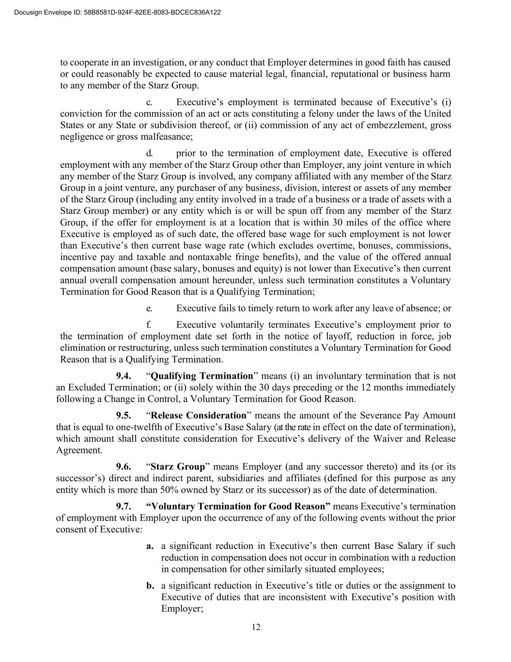
12 to cooperate in an investigation, or any conduct that Employer determines in good faith has caused or could reasonably be expected to cause material legal, financial, reputational or business harm to any member of the Starz Group. c. Executive’s employment is terminated because of Executive’s (i) conviction for the commission of an act or acts constituting a felony under the laws of the United States or any State or subdivision thereof, or (ii) commission of any act of embezzlement, gross negligence or gross malfeasance; d. prior to the termination of employment date, Executive is offered employment with any member of the Starz Group other than Employer, any joint venture in which any member of the Starz Group is involved, any company affiliated with any member of the Starz Group in a joint venture, any purchaser of any business, division, interest or assets of any member of the Starz Group (including any entity involved in a trade of a business or a trade of assets with a Starz Group member) or any entity which is or will be spun off from any member of the Starz Group, if the offer for employment is at a location that is within 30 miles of the office where Executive is employed as of such date, the offered base wage for such employment is not lower than Executive’s then current base wage rate (which excludes overtime, bonuses, commissions, incentive pay and taxable and nontaxable fringe benefits), and the value of the offered annual compensation amount (base salary, bonuses and equity) is not lower than Executive’s then current annual overall compensation amount hereunder, unless such termination constitutes a Voluntary Termination for Good Reason that is a Qualifying Termination; e. Executive fails to timely return to work after any leave of absence; or f. Executive voluntarily terminates Executive’s employment prior to the termination of employment date set forth in the notice of layoff, reduction in force, job elimination or restructuring, unless such termination constitutes a Voluntary Termination for Good Reason that is a Qualifying Termination. 9.4. “Qualifying Termination” means (i) an involuntary termination that is not an Excluded Termination; or (ii) solely within the 30 days preceding or the 12 months immediately following a Change in Control, a Voluntary Termination for Good Reason. 9.5. “Release Consideration” means the amount of the Severance Pay Amount that is equal to one-twelfth of Executive’s Base Salary (at the rate in effect on the date of termination), which amount shall constitute consideration for Executive’s delivery of the Waiver and Release Agreement. 9.6. “Starz Group” means Employer (and any successor thereto) and its (or its successor’s) direct and indirect parent, subsidiaries and affiliates (defined for this purpose as any entity which is more than 50% owned by Starz or its successor) as of the date of determination. 9.7. “Voluntary Termination for Good Reason” means Executive’s termination of employment with Employer upon the occurrence of any of the following events without the prior consent of Executive: a. a significant reduction in Executive’s then current Base Salary if such reduction in compensation does not occur in combination with a reduction in compensation for other similarly situated employees; b. a significant reduction in Executive’s title or duties or the assignment to Executive of duties that are inconsistent with Executive’s position with Employer; ?"?%$??!??!&? "#??????? ? ? ????? ?? ???? ? ?????? ?????

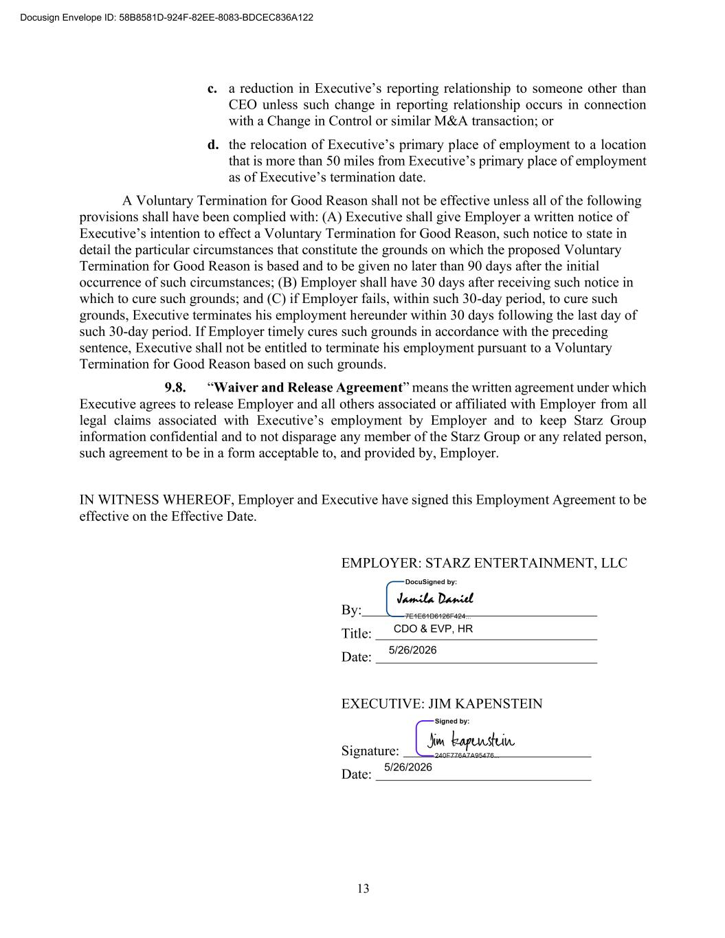
13 c. a reduction in Executive’s reporting relationship to someone other than CEO unless such change in reporting relationship occurs in connection with a Change in Control or similar M&A transaction; or d. the relocation of Executive’s primary place of employment to a location that is more than 50 miles from Executive’s primary place of employment as of Executive’s termination date. A Voluntary Termination for Good Reason shall not be effective unless all of the following provisions shall have been complied with: (A) Executive shall give Employer a written notice of Executive’s intention to effect a Voluntary Termination for Good Reason, such notice to state in detail the particular circumstances that constitute the grounds on which the proposed Voluntary Termination for Good Reason is based and to be given no later than 90 days after the initial occurrence of such circumstances; (B) Employer shall have 30 days after receiving such notice in which to cure such grounds; and (C) if Employer fails, within such 30-day period, to cure such grounds, Executive terminates his employment hereunder within 30 days following the last day of such 30-day period. If Employer timely cures such grounds in accordance with the preceding sentence, Executive shall not be entitled to terminate his employment pursuant to a Voluntary Termination for Good Reason based on such grounds. 9.8. “Waiver and Release Agreement” means the written agreement under which Executive agrees to release Employer and all others associated or affiliated with Employer from all legal claims associated with Executive’s employment by Employer and to keep Starz Group information confidential and to not disparage any member of the Starz Group or any related person, such agreement to be in a form acceptable to, and provided by, Employer. IN WITNESS WHEREOF, Employer and Executive have signed this Employment Agreement to be effective on the Effective Date. EMPLOYER: STARZ ENTERTAINMENT, LLC By: Title: Date: EXECUTIVE: JIM KAPENSTEIN Signature: Date: ?"?%$??!??!&? "#??????? ? ? ????? ?? ???? ? ?????? ????? ????????? ????????????? ?????????

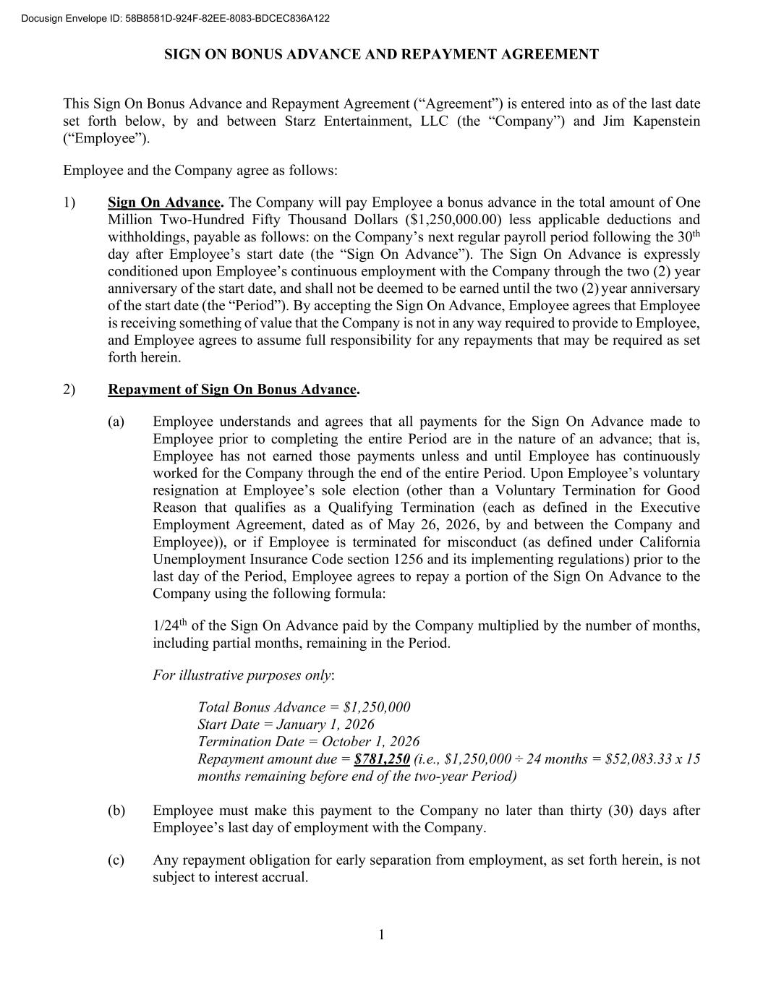
SIGN ON BONUS ADVANCE AND REPAYMENT AGREEMENT 1 This Sign On Bonus Advance and Repayment Agreement (“Agreement”) is entered into as of the last date set forth below, by and between Starz Entertainment, LLC (the “Company”) and Jim Kapenstein (“Employee”). Employee and the Company agree as follows: 1) Sign On Advance. The Company will pay Employee a bonus advance in the total amount of One Million Two-Hundred Fifty Thousand Dollars ($1,250,000.00) less applicable deductions and withholdings, payable as follows: on the Company’s next regular payroll period following the 30th day after Employee’s start date (the “Sign On Advance”). The Sign On Advance is expressly conditioned upon Employee’s continuous employment with the Company through the two (2) year anniversary of the start date, and shall not be deemed to be earned until the two (2) year anniversary of the start date (the “Period”). By accepting the Sign On Advance, Employee agrees that Employee is receiving something of value that the Company is not in any way required to provide to Employee, and Employee agrees to assume full responsibility for any repayments that may be required as set forth herein. 2) Repayment of Sign On Bonus Advance. (a) Employee understands and agrees that all payments for the Sign On Advance made to Employee prior to completing the entire Period are in the nature of an advance; that is, Employee has not earned those payments unless and until Employee has continuously worked for the Company through the end of the entire Period. Upon Employee’s voluntary resignation at Employee’s sole election (other than a Voluntary Termination for Good Reason that qualifies as a Qualifying Termination (each as defined in the Executive Employment Agreement, dated as of May 26, 2026, by and between the Company and Employee)), or if Employee is terminated for misconduct (as defined under California Unemployment Insurance Code section 1256 and its implementing regulations) prior to the last day of the Period, Employee agrees to repay a portion of the Sign On Advance to the Company using the following formula: 1/24th of the Sign On Advance paid by the Company multiplied by the number of months, including partial months, remaining in the Period. For illustrative purposes only: Total Bonus Advance = $1,250,000 Start Date = January 1, 2026 Termination Date = October 1, 2026 Repayment amount due = $781,250 (i.e., $1,250,000 ÷ 24 months = $52,083.33 x 15 months remaining before end of the two-year Period) (b) Employee must make this payment to the Company no later than thirty (30) days after Employee’s last day of employment with the Company. (c) Any repayment obligation for early separation from employment, as set forth herein, is not subject to interest accrual. ?"?%$??!??!&? "#??????? ? ? ????? ?? ???? ? ?????? ?????

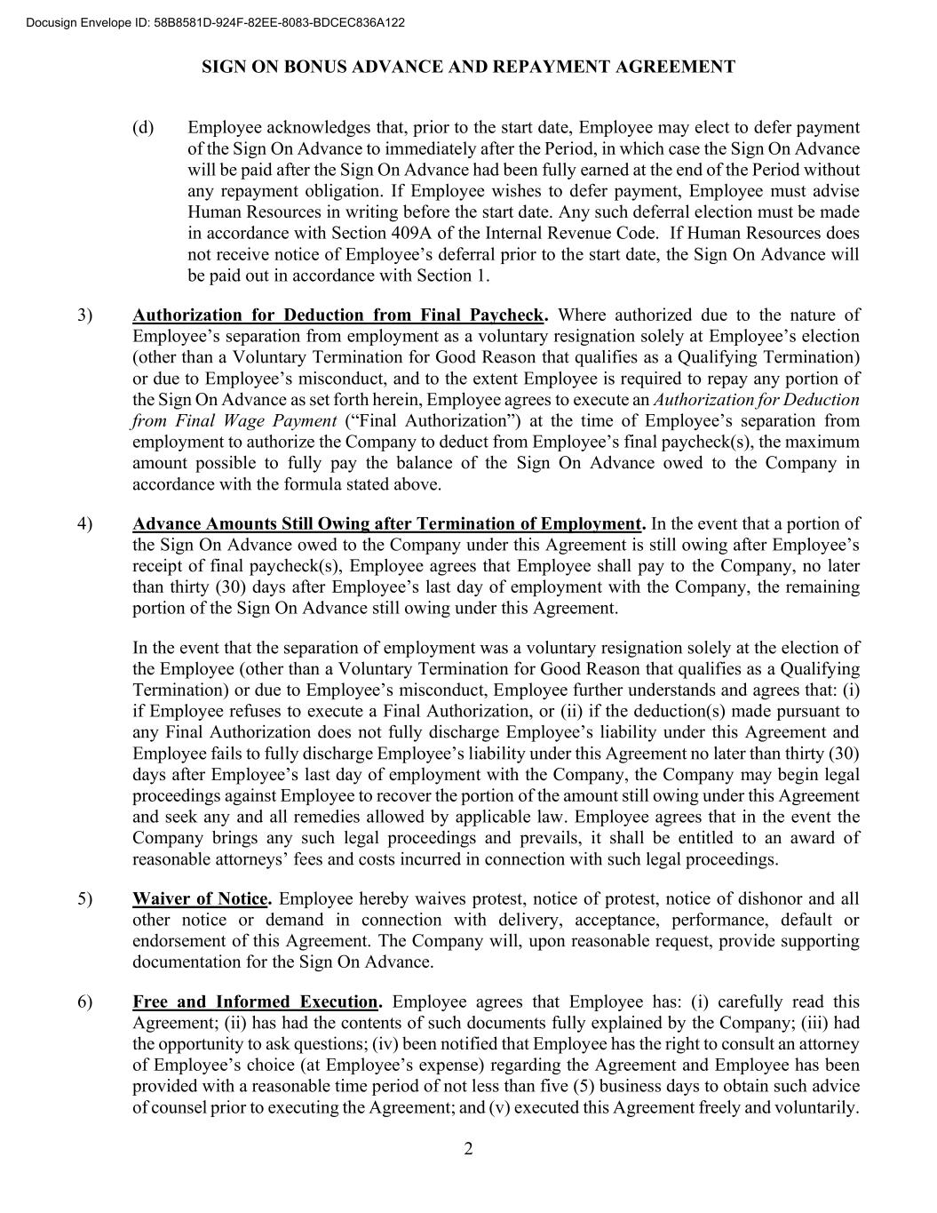
SIGN ON BONUS ADVANCE AND REPAYMENT AGREEMENT 2 (d) Employee acknowledges that, prior to the start date, Employee may elect to defer payment of the Sign On Advance to immediately after the Period, in which case the Sign On Advance will be paid after the Sign On Advance had been fully earned at the end of the Period without any repayment obligation. If Employee wishes to defer payment, Employee must advise Human Resources in writing before the start date. Any such deferral election must be made in accordance with Section 409A of the Internal Revenue Code. If Human Resources does not receive notice of Employee’s deferral prior to the start date, the Sign On Advance will be paid out in accordance with Section 1. 3) Authorization for Deduction from Final Paycheck. Where authorized due to the nature of Employee’s separation from employment as a voluntary resignation solely at Employee’s election (other than a Voluntary Termination for Good Reason that qualifies as a Qualifying Termination) or due to Employee’s misconduct, and to the extent Employee is required to repay any portion of the Sign On Advance as set forth herein, Employee agrees to execute an Authorization for Deduction from Final Wage Payment (“Final Authorization”) at the time of Employee’s separation from employment to authorize the Company to deduct from Employee’s final paycheck(s), the maximum amount possible to fully pay the balance of the Sign On Advance owed to the Company in accordance with the formula stated above. 4) Advance Amounts Still Owing after Termination of Employment. In the event that a portion of the Sign On Advance owed to the Company under this Agreement is still owing after Employee’s receipt of final paycheck(s), Employee agrees that Employee shall pay to the Company, no later than thirty (30) days after Employee’s last day of employment with the Company, the remaining portion of the Sign On Advance still owing under this Agreement. In the event that the separation of employment was a voluntary resignation solely at the election of the Employee (other than a Voluntary Termination for Good Reason that qualifies as a Qualifying Termination) or due to Employee’s misconduct, Employee further understands and agrees that: (i) if Employee refuses to execute a Final Authorization, or (ii) if the deduction(s) made pursuant to any Final Authorization does not fully discharge Employee’s liability under this Agreement and Employee fails to fully discharge Employee’s liability under this Agreement no later than thirty (30) days after Employee’s last day of employment with the Company, the Company may begin legal proceedings against Employee to recover the portion of the amount still owing under this Agreement and seek any and all remedies allowed by applicable law. Employee agrees that in the event the Company brings any such legal proceedings and prevails, it shall be entitled to an award of reasonable attorneys’ fees and costs incurred in connection with such legal proceedings. 5) Waiver of Notice. Employee hereby waives protest, notice of protest, notice of dishonor and all other notice or demand in connection with delivery, acceptance, performance, default or endorsement of this Agreement. The Company will, upon reasonable request, provide supporting documentation for the Sign On Advance. 6) Free and Informed Execution. Employee agrees that Employee has: (i) carefully read this Agreement; (ii) has had the contents of such documents fully explained by the Company; (iii) had the opportunity to ask questions; (iv) been notified that Employee has the right to consult an attorney of Employee’s choice (at Employee’s expense) regarding the Agreement and Employee has been provided with a reasonable time period of not less than five (5) business days to obtain such advice of counsel prior to executing the Agreement; and (v) executed this Agreement freely and voluntarily. ?"?%$??!??!&? "#??????? ? ? ????? ?? ???? ? ?????? ?????

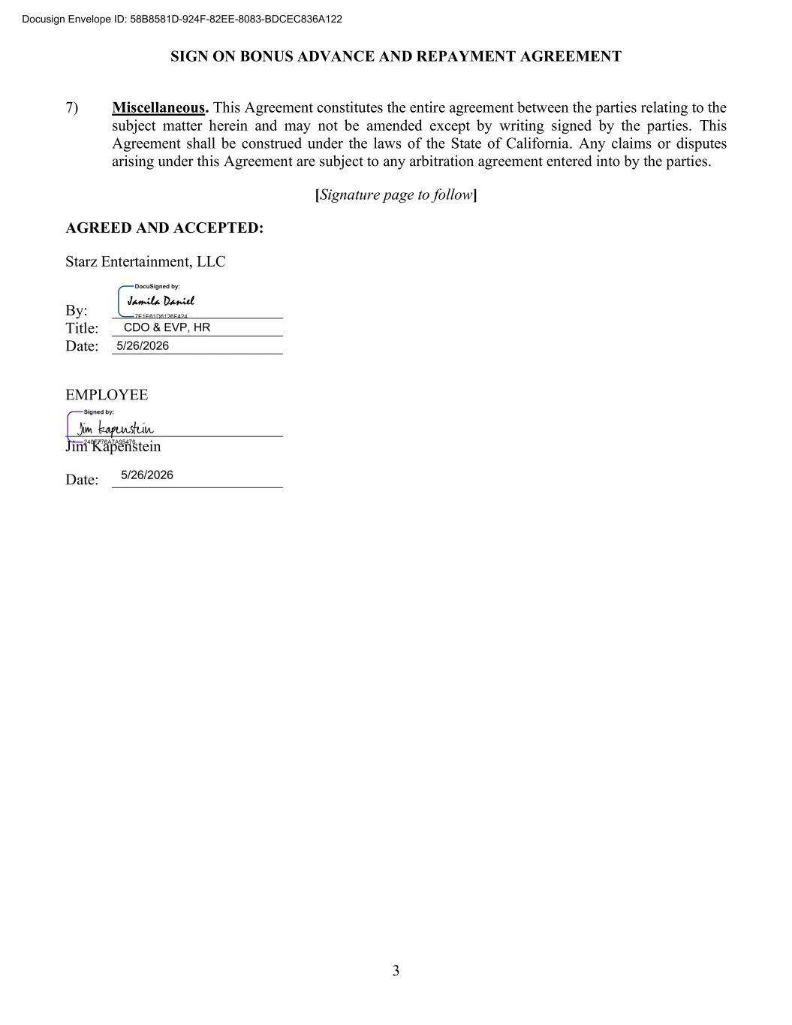
SIGN ON BONUS ADVANCE AND REPAYMENT AGREEMENT 3 7) Miscellaneous. This Agreement constitutes the entire agreement between the parties relating to the subject matter herein and may not be amended except by writing signed by the parties. This Agreement shall be construed under the laws of the State of California. Any claims or disputes arising under this Agreement are subject to any arbitration agreement entered into by the parties. [Signature page to follow] AGREED AND ACCEPTED: Starz Entertainment, LLC By: ______________________ Title: ______________________ Date: ______________________ EMPLOYEE ____________________________ Jim Kapenstein Date: ______________________ ?"?%$??!??!&? "#??????? ? ? ????? ?? ???? ? ?????? ????? ????????? ????????????? ?????????

Exhibit 31.1

CERTIFICATION

I, Jeffrey A. Hirsch certify that:
1.I have reviewed this quarterly report on Form 10-Q of Starz Entertainment Corp.;
2.Based on my knowledge, this report does not contain any untrue statement of a material fact or omit to state a material fact necessary to make the statements made, in light of the circumstances under which such statements were made, not misleading with respect to the period covered by this report;
3.Based on my knowledge, the financial statements, and other financial information included in this report, fairly present in all material respects the financial condition, results of operations and cash flows of the registrant as of, and for, the periods presented in this report;
4.The registrant’s other certifying officer and I are responsible for establishing and maintaining disclosure controls and procedures (as defined in Exchange Act Rules 13a-15(e) and 15d-15(e)) and internal control over financial reporting (as defined in Exchange Act Rules 13a-15(f) and 15d-15(f)) for the registrant and have:
a.Designed such disclosure controls and procedures, or caused such disclosure controls and procedures to be designed under our supervision, to ensure that material information relating to the registrant, including its consolidated subsidiaries, is made known to us by others within those entities, particularly during the period in which this report is being prepared;
b.Designed such internal control over financial reporting, or caused such internal control over financial reporting to be designed under our supervision, to provide reasonable assurance regarding the reliability of financial reporting and the preparation of financial statements for external purposes in accordance with generally accepted accounting principles;
c.Evaluated the effectiveness of the registrant’s disclosure controls and procedures and presented in this report our conclusions about the effectiveness of the disclosure controls and procedures, as of the end of the period covered by this report based on such evaluation; and
d.Disclosed in this report any change in the registrant’s internal control over financial reporting that occurred during the registrant’s most recent fiscal quarter (the registrant’s fourth fiscal quarter in the case of an annual report) that has materially affected, or is reasonably likely to materially affect, the registrant’s internal control over financial reporting; and
5.The registrant’s other certifying officer and I have disclosed, based on our most recent evaluation of internal control over financial reporting, to the registrant’s auditors and the audit committee of the registrant’s board of directors (or persons performing the equivalent function):
a.All significant deficiencies and material weaknesses in the design or operation of internal control over financial reporting which are reasonably likely to adversely affect the registrant’s ability to record, process, summarize and report financial information; and
b.Any fraud, whether or not material, that involves management or other employees who have a significant role in the registrant’s internal control over financial reporting.

/s/ JEFFREY A. HIRSCH
Jeffrey A. Hirsch
Chief Executive Officer
Date: August 7, 2026

Exhibit 31.2

CERTIFICATION

I, Scott D. Macdonald certify that:
1.I have reviewed this quarterly report on Form 10-Q of Starz Entertainment Corp.;
2.Based on my knowledge, this report does not contain any untrue statement of a material fact or omit to state a material fact necessary to make the statements made, in light of the circumstances under which such statements were made, not misleading with respect to the period covered by this report;
3.Based on my knowledge, the financial statements, and other financial information included in this report, fairly present in all material respects the financial condition, results of operations and cash flows of the registrant as of, and for, the periods presented in this report;
4.The registrant’s other certifying officer and I are responsible for establishing and maintaining disclosure controls and procedures (as defined in Exchange Act Rules 13a-15(e) and 15d-15(e)) and internal control over financial reporting (as defined in Exchange Act Rules 13a-15(f) and 15d-15(f)) for the registrant and have:
a.Designed such disclosure controls and procedures, or caused such disclosure controls and procedures to be designed under our supervision, to ensure that material information relating to the registrant, including its consolidated subsidiaries, is made known to us by others within those entities, particularly during the period in which this report is being prepared;
b.Designed such internal control over financial reporting, or caused such internal control over financial reporting to be designed under our supervision, to provide reasonable assurance regarding the reliability of financial reporting and the preparation of financial statements for external purposes in accordance with generally accepted accounting principles;
c.Evaluated the effectiveness of the registrant’s disclosure controls and procedures and presented in this report our conclusions about the effectiveness of the disclosure controls and procedures, as of the end of the period covered by this report based on such evaluation; and
d.Disclosed in this report any change in the registrant’s internal control over financial reporting that occurred during the registrant’s most recent fiscal quarter (the registrant’s fourth fiscal quarter in the case of an annual report) that has materially affected, or is reasonably likely to materially affect, the registrant’s internal control over financial reporting; and
5.The registrant’s other certifying officer and I have disclosed, based on our most recent evaluation of internal control over financial reporting, to the registrant’s auditors and the audit committee of the registrant’s board of directors (or persons performing the equivalent function):
a.All significant deficiencies and material weaknesses in the design or operation of internal control over financial reporting which are reasonably likely to adversely affect the registrant’s ability to record, process, summarize and report financial information; and
b.Any fraud, whether or not material, that involves management or other employees who have a significant role in the registrant’s internal control over financial reporting.

/s/ SCOTT D. MACDONALD
Scott D. Macdonald
Chief Financial Officer
Date: August 7, 2026

Exhibit 32.1

WRITTEN STATEMENT
PURSUANT TO
18 U.S.C. SECTION 1350

The undersigned officers of Starz Entertainment Corp. (the “Company”), pursuant to 18 U.S.C. § 1350, as adopted pursuant to Section 906 of the Sarbanes Oxley Act of 2002, hereby certify that, to their knowledge:
(i)the Form 10-Q of the Company (the “Report”) for the period ended June 30, 2026, fully complies with the requirements of Sections 13(a) and 15(d) of the Securities Exchange Act of 1934; and

(ii)the information contained in the Report fairly presents, in all material respects, the financial condition and results of operations of the Company as of, and for the periods presented in this report.

/s/ JEFFREY A. HIRSCH
Jeffrey A. Hirsch
Chief Executive Officer
Date: August 7, 2026

/s/ SCOTT D. MACDONALD
Scott D. Macdonald
Chief Financial Officer
Date: August 7, 2026

